Theme/Term | Autumn 1 |  |  |  | Autumn 2
Writing Root /  Spelling Seed Text | 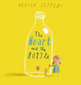  The Heart and the Bottle  Oliver Jeffers  Theme-Magic and Wonder | 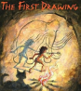  The First Drawing Mordicai Gerstein  Theme-Magic and Wonder |  |  | 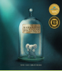  The Barnabus Project  The Fan Brothers  Theme-Dreams and Curiosity | 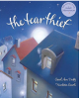  The Tear Thief  Carol Ann Duffy  Theme-Dreams and Curiosity
Length | 15 sessions, 3 weeks | 10 sessions, 2 weeks |  |  | 15 sessions, 3 weeks | 15 sessions, 3 weeks
Outcomes | Own version ‘dilemma’ narratives Dialogue, postcards, character descriptions, diary entries, poetry, letters of advice | Own historical narratives Character descriptions, diaries, recounts |  |  | Brochures Instructional writing (escape plan, experiment), descriptions, advertisements, letters of advice, dialogue | Newspaper articles Shared poems, diary entries, persuasive posters, letters of explanation, discussions
Theme/Term | Spring 1 |  |  |  | Spring 2
Writing Root /  Spelling Seed Text | 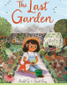  The Last Garden Rachel Ip  Theme-Hope and Healing |  | 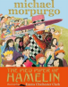  The Pied Piper of Hamelin  Michael Morpurgo  Theme-Hope and Healing |  | 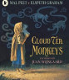  Cloud Tea Monkeys Mal Peet & Elspeth Graham  Theme-Overcoming Adversity | 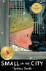  Small in the City  Sydney Smith  Theme-Overcoming Adversity
Length | 15 sessions, 3 weeks |  | 15 sessions, 3 weeks |  | 15 sessions, 3 weeks | 15 sessions, 3 weeks
Outcomes | Own version extended narratives Setting descriptions, advertisement/ poster, retelling, instructional flyer, social media updates, dialogue |  | Own version myths/legends Writing in role, information reports, adverts, formal letters |  | Non-chronological reports Descriptions, ‘how to’ guides (instructions), letters, discussions | Extended narratives from alternative perspective Setting description, poem, diary entry, dialogue, letter of advice, lost poster
Theme/Term | Summer 1 |  |  |  | Summer 2
Writing Root /  Spelling Seed Text | 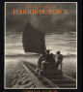  The Mysteries of Harris Burdick Chris Van Allsberg  Theme-From Mystery to Discovery |  |  | 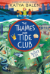  The Thames and Tide Club  Katya Balen  Theme-From Mystery to Discovery | 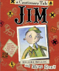  Jim, A Cautionary Tale Hilaire Belloc  Theme-Confidence and Caution | 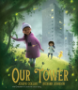  Our Tower  Joseph Coelho  Theme-Confidence and Caution
Length | 15 sessions, 3 weeks |  |  | 15 sessions, 3 weeks | 15 sessions, 3 weeks | 15 sessions, 3 weeks
Outcomes | Own version mystery narratives Diary entries, dialogue, setting descriptions (atmospheric descriptions), captions and titles |  |  | Coming soon as per Literacy Tree | Narrative poems Warning posters, warning announcements, alternative endings, performance poetry, letters of apology | Extended fantasy narratives Poems, setting descriptions, diary entries, dialogue, letters of thanks

