Design and Technology at St Ignatius – Yearly Overview
 | Autumn | Spring | Summer
Year 1 | Split pin puppets  Purpose: Making puppets for storytelling  Outcomes: Children will investigate various types of puppets, evaluating what makes them appealing and functional. They will practise using split pins to make a moving joint (wolf knocking on door). They will then design their own split pin animal puppet, planning separate body parts and where they will join. They will go on to make their puppet with card and decorative materials. | 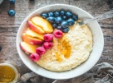  Food for Living:  Making porridge  Purpose: Story time snack  Outcomes: Children will make porridge with different liquids and evaluate. They will learn where fruit comes from and how it is an important part of a healthy diet. They will learn how to chop safely and will then plan and make their own porridge with fruit toppings, to enjoy together during story time. | Moving vehicles  Purpose: Making vehicles for a race  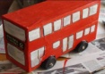  Outcomes: Children will look at deconstructed toy vehicles and learn about wheels, axles, chassis, body, cab. They will discuss the purpose of wheels. They will practise joining wheels and axles, and try out different axle holders (straws, pegs, holes in boxes). They will go on to design and make a vehicle, adding paper detail such as windows, headlights, logos, number plates. They will then have a race – whose travels furthest/fastest?
 | Links: The Three Little Pigs (English), animal body parts (science) | Links: The Magic Porridge Pot (English) | Links: Everyday materials (science), wheels and wings (history)
Year 2 | 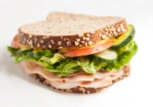  Food for Living:  Making Sandwiches  Purpose: Packed Lunch Day  Outcomes: Children will look at food groups and how to ensure a balanced diet. They will research sandwich fillings and types of bread. They will build on chopping, mixing and spreading skills, and then make their own sandwich. Along with other healthy options brought in from home, children will enjoy a packed lunch together. | 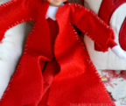  An explorer’s coat  Purpose: Making a coat for a toy ‘explorer’  Outcomes: Children will look at a simple T-shaped coat made from 2 pieces of paper. They will make their own paper coat. They will investigate animal pattern and camouflage. They will try out different methods of joining fabric e.g. stitching, gluing, stapling. They will go on to make a coat for an explorer, attaching more fabric to make a pattern. | Moving pictures  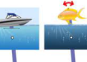  Purpose: Retelling the story of the Great Fire of London to a younger child  Outcomes: Children will look at books, cards etc with moving parts. They will make simple levers with card and split pins, and also practise making a sliding picture. They will design and make a picture of the Great Fire of London, incorporating a lever (e.g. person pouring bucket of water on fire) and a slider (e.g. rats running or fire spreading).
 | Links: Diet and health (science) | Links: Time to explore (history) | Links: The Great Fire of London (history)
Year 3 | Packaging  Purpose: Making a box for a Christmas product  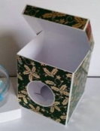  Outcomes: Children will evaluate various commercial packets, looking at shape, material, how material is reinforced, impact of graphics etc. They will deconstruct boxes and look at nets and the need for tabs. They will go on to design a box for a Christmas product, considering who it is for and any additional features needed such as windows or reinforced corners. They will make a mock up with paper, evaluate, adapt their design if necessary and then make their final product. | 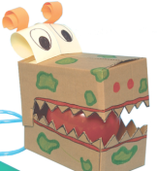  Moving monsters  Purpose: Creating a toy for a younger sibling/friend  Outcomes: Children will look at everyday objects that use air (balloon, bicycle pump, whistle). They will make simple pneumatic mechanisms with balloon, tubes and syringes. They will design and make a toy for a younger sibling or friend, based on Sobek (or other Egyptian gods/monsters), using a simple pneumatic mechanism to make a moving body part such as an opening mouth/ beak or a flapping wing. | 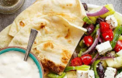  Food for Living:  Making a Greek Feast  Purpose: End of history topic celebration  Outcomes: Children will research traditional foods of Greece. They will find recipes for Greek salad and conduct class surveys to inform changes to recipe. They will learn about growing tomatoes, including climate needed. They will research where flour comes from and how it is processed. They will build on food preparation skills as well as learning to knead dough. They will make flatbread, Greek salad and tzatziki to enjoy together as a celebration of their history topic.
 | Links: Christmas (RE), 3D shape and nets (maths) | Links: Ancient Egyptian gods (history) | Links: Ancient Greece (history)
Year 4 | Food for Living:  Pasta salad  Purpose: Family weekend lunch  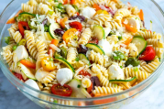  Outcomes: Children will research traditional food of Italy, looking at the climate and how this affects vegetables grown. They will look at a few cheeses, focussing on taste and origin. They will investigate various fresh herbs and experiment with combining flavours. Children will learn to use graters, peelers and knives safely. They will go on to use what they have learnt to plan and make a pasta salad which they will share with their family. | 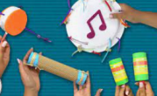  Musical instruments  Purpose: Making instruments to accompany some drama  Outcomes: Children will evaluate a range of musical instruments, looking at the materials they are made from, how they make sound, which parts need to be strong etc. They will make links with traditional instruments from different parts of the world. Children will experiment with using different materials as drum skins – which work best? They will go on to design and make a simple musical instrument using what they have learnt. | 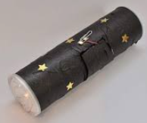  Torches  Purpose: Making a torch as a gift  Outcomes: Children will look at various lights – head torches, hand held torches, bike lights etc and identify parts (bulb, reflector, switch, casing). They will deconstruct a torch and look at how it works. They will investigate possible materials for a reflector, and link with their science topic to make simple circuits, including trying out various homemade switches. Children will do a survey of head/hand sizes to inform the size of their hand held or head torch. They will go on to design and make a torch.
 | Links: Romans (history) | Links: Sound (science), we are musicians (computing) | Links: Electricity (science)
Year 5 | Bags  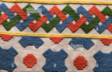  Purpose: Making a bag for themselves to reflect learning about Anglo-Saxons  Outcomes: Children will look at some small, simple bags, identifying how the fabric joined. They will test out various stitches and look at seam allowance. They will try out designs based on Anglo Saxon learning on the computer. They will make a pattern using paper. They will go on to make their own simple bag and decorate it. | 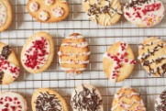  Food for Living:  Making biscuits  Purpose: Easter Sunday with family  Outcomes: Children will look at various types of biscuits and their appeal to different age groups. Look at cost, ingredients (packaging), design, texture, flavour. They will design, make and decorate biscuits for their family, taking into account healthier choices and appeal to different family members. | Classroom helper  Purpose: Adapting a robot to create a classroom helper  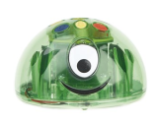  Outcomes: Children will experiment with moving EaRL around the classroom through simple programming, both on the robot and through Scratch. They will work in groups to modify the robot so it can carry things. They will go on to programming in specific routes to allow EaRL to do specific jobs.
 | Links: Anglo Saxons (history) | Links: Advertisements (IT) | Links: Cooperation and teamwork (PSHE)
Year 6 | 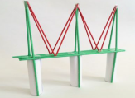  Building bridges  Purpose: Class competition – who can build a bridge to hold a tin can?  Outcomes: Children will start with a challenge – how can we strengthen a piece of paper to allow it to hold a toy car? They will look at zig zag folding and then at paper straw shapes e.g. triangles are stronger that squares – using diagonals to strengthen squares. They will learn about the work of Brunel and discuss forces of tension and compresssion. They will go on to work in small groups to design, make, test and adapt a paper straw bridge. They will evaluate their own and each others’ work. | 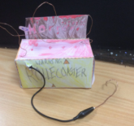  Steady Hand Game  Purpose: Designing a game to play with family  Outcomes: Children will look at a few games in which there are electrical components. They will identify where the power comes from and how the games work. They will explore simple electrical circuits, making bulbs and buzzers light up and sound. They will then design and build a steady hand game, applying their knowledge of circuits and choosing a light bulb or buzzer to show a complete circuit. They will think about their audience and how they can decorate their game to make it appealing. | Food for Living:  Making smoothies  Purpose: Sports Day refreshment  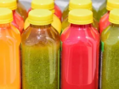  Outcomes: Children will research different fruits and their benefits to health. They will consider which fruits would work well in a non-blended smoothie, testing which mash easily, which can be peeled etc, what colour they make when mixed. Children will learn about the seasonality of fruits and look at country of origin on packaging. They will consider cost. They will go on to plan, make and bottle their smoothie for Sports Day, choosing fruit based on their knowledge from the unit.
 | Links: Local history – the growth of railways (history) | Links: Electricity (science) | Links: Colour mixing (art), food and drink (Spanish)

