EYFS and Key Stage 1
Prayer Booklet
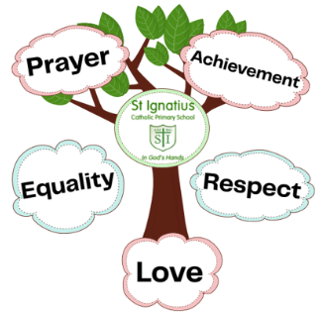


Sign of the Cross
In the name of the Father, and of the son,
and of the Holy Spirit, Amen.

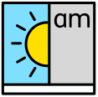
Morning Prayer
Father in Heaven you love me, you ’re with me night and day.
I want to love you always in all I do and say.
I’ll try to please you Father, bless me through this day.
Amen

Grace before meals
Bless us, O Lord, and these your gifts which we are about to receive from your bounty. Through Christ our Lord. Amen.

Grace after meals
We give you thanks, Almighty God, for all your benefits, who live and reign, world without end. Amen.


Home time Prayer
Now the busy day is done, Father bless us everyone. Keep me safely through the night, until we see the morning light. Amen


The Lord’s Prayer
Our Father who art in heaven, hallowed be thy name. Thy kingdom come. Thy will be done on earth, as it is in heaven. Give us this day our daily bread, and forgive us our trespasses, as we forgive those who trespass against us, and lead us not into temptation, but deliver us from evil. Amen.


Glory Be
Glory be to the Father and to the Son and to the Holy Spirit, as it was in the beginning is now, and ever shall be world without end. Amen.


Hail Mary
Hail, Mary, full of grace, the Lord is with thee. Blessed art thou among women and blessed is the fruit of thy womb, Jesus. Holy Mary, Mother of God, pray for us sinners, now and at the hour of our death. Amen.


Angel of God
Angel of God, my guardian dear, to whom God’s love commits me here, ever this day be at my side, to light and guard, to rule and guide. Amen.

Our School Prayer
Lord Jesus,
Help us to recognise that we are all made in God’s image.
Help us to celebrate our achievements.
Help us to show respect to everybody that we meet.
Teach us to love others, as you have loved us.
Saint Ignatius of Loyola, pray for us.
Amen.

