Faith
As we celebrate the Feast of St Peter and St Paul this Sunday, we think about the church as one important way to stay connected to God. Having faith is to believe and trust in God’s love for us. Faith is a great blessing and it is a gift to be shared. The church exists to help people grow in their faith and there is no better time than now to explore and refresh our faith.

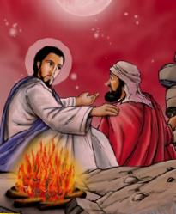
Adapted from Matthew 16:13-19
Jesus asked his disciples, “Who do you say I am?” Simon Peter spoke up and said, “You are the Christ, the Son of the living God.” Jesus replied, “Simon, you are a happy man because this was made known to you by my Father in heaven. So from now on you will be called Peter, which means ‘rock’, and on this rock I will build my Church. I will give you the keys to the kingdom of heaven.”

Activity:
Jesus likened Peter to a rock because of the strength of his faith and his relationship with God. Next time you go out for a walk, find a stone and write the word ‘Faith’ on it. Decorate it to make it extra special. You can keep this stone somewhere safe and, whenever you want to feel closer to God, feel the stone in your hand and remember your faith.

Prayer:

Lord Jesus,
Thank you for the special gift of faith. Please help the faith of our family to keep growing, so that we may know you more closely.
Amen
Challenge
Can you think about the people in your life who show a strong faith? Who helps you with your belief in God? See if you can help others to strengthen their faith by showing God’s love through your actions.

Ask a grown up to help you stick a pin through the centre and attach to a straw or stick. Then blow and watch your windmill spin!

