Reflection and Prayer Opportunities
Finding the good in difficult times
At the moment we are all living through a very difficult time. Each family has their own worries and it can sometimes feel a bit scary and sad when we think about how the Coronavirus is affecting us, as well as many people around the world. One thing we can try to do to feel a bit better is to find the good things that are happening at this time – to see the positives. This is a story about a man who was blinded, but this made him see his life in a new, positive way. What seemed like a bad thing ended up making him a better, happier person.
The Conversion of Saul
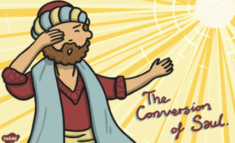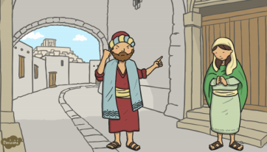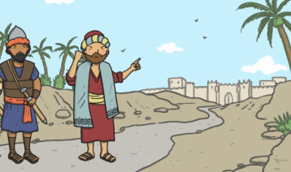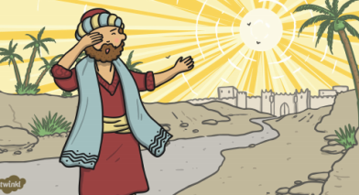
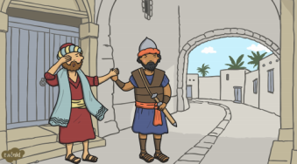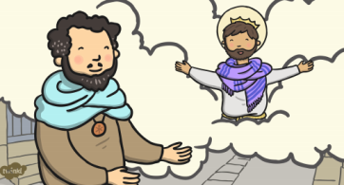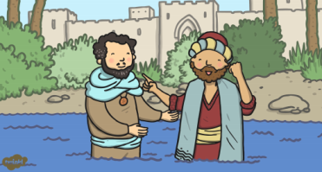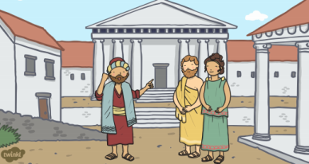
Saul was an angry man who hated Christians. He used to treat them badly and hurt them. Saul heard that in Damascus, there was a group of Christians who were telling others about Jesus, so he decided to go there and stop them. As he travelled along the road an extremely bright light shone from the sky and blinded him. He heard God asking him: “Saul, why are you hurting me? Go to Damascus and I will tell you what to do.” Saul couldn’t believe it, but he carried on and arrived in Damascus. Meanwhile a man called Ananias had a dream in which Jesus appeared and told him he should go and see Saul. When Ananias put his hands on Saul, God healed him and he could see again. Full of joy, Saul was baptised and became a follower of Jesus. He changed his name to Paul to show he was putting his old ways behind him, and he spent the rest of his life travelling the world speaking of the greatness of God and teaching people about Jesus.
Activity:
What good things can you see around you at the moment? Maybe you can see NHS workers caring for others. Maybe you can see people making videos to make others smile. Maybe you can see that the sky is quieter and more beautiful without aeroplanes. Whatever good things you see, show these on a poster by drawing/painting a picture and writing the message: ‘What a wonderful world’.

Prayer:

Almighty God,
During this difficult time please send us the vision to see the goodness all around us. Give us hope when we are in darkness and guide us towards gratitude when we emerge.
Amen

Challenge

Today make some time to sit quietly and think of all the good things that you have.
Use your own words to thank God for your blessings.

