Reflection and Prayer Opportunities
God’s Gift – The Kingdom of Heaven
This is a story that Jesus told to explain to his followers how lucky we are to be invited to listen to and love God. If we make time to pray and show our love for God, we will live an eternal life in Heaven.
The Parable of the Great Feast Luke 14:15-24
Watch the video of the story
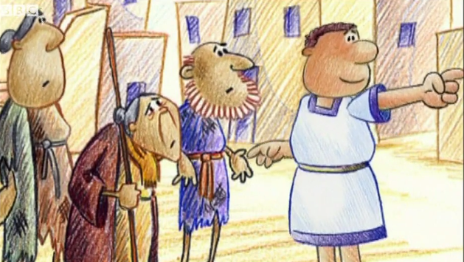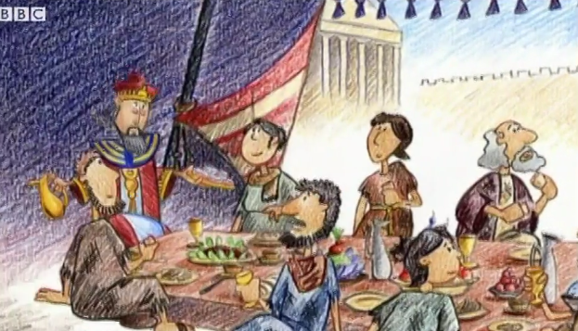
One man said to Jesus: “How happy are those who will sit down at the feast in the Kingdom of God!”
Jesus said to him, “There was once a man who was giving a great feast to which he invited many people. When it was time for the feast, he sent his servant to tell the guests, ‘Come, everything is ready!’ But they all began, one after another, to make excuses. The first told the servant, ‘I have bought a field and I must go and look at it. Please accept my apologies.’ Another one said, ‘I have bought five pairs of oxen and am on my way to try them out. Please accept my apologies.’ Another one said, ‘I have just got married and for that reason I cannot come.’
“The servant went back and told all this to his master. The master was furious and said to the servant, ‘Hurry out to the streets and the alleys of the town, and bring back the people who are poor and sick.’ Soon the servant said, ‘Your order has been carried out, sir, but there is room for more.’ So the master said to the servant, ‘Go out to the country roads and lanes and make people come in, so that my house will be full. I tell you all that none of those men who were invited will taste my dinner!’”

Activity:
Think about different ways in which you can please God. You could help your brother or sister when they are stuck, you could do something kind for your parents, you could say a special prayer of thanks, you could make sure you only say kind things, you could forgive someone when they say ‘sorry’, you could do something to make your family smile. Write or draw each one on a small piece of paper and put them in a bowl or box. Each day this week, pick one out and see if you can do it.

Loving Father,
You have offered us the gift of your Kingdom. You do not worry about who we are or what we have, only that we love you. Please teach us how to show this love everyday so that, one day, we might experience the joy of your gift, Heaven.
Amen

Prayer:
Challenge

Today make some time to sit quietly and think of the gifts that God has given you.
Which do you see as the most important of these gifts?

