Handwriting at St Ignatius
At St Ignatius we have adopted a cursive, or ‘joined-up’ style for handwriting throughout the school. We believe this raises standards in writing across the whole school, developing confidence, accuracy and fluency and improved presentation. As a school we follow the Nelson Handwriting Scheme.

The cursive handwriting style helps:
• To minimise confusion for the child as every letter starts on the line with an entry stroke and leads out with an exit stroke
• As letters naturally flow into each other, this helps children to join their handwriting
• Form spacing between words as the child develops whole word awareness
• To develop a child's visual memory
• All children's writing skills regardless of academic ability
• To develop skills of punctuation and grammar.

The National Curriculum specifies that primary school children should work towards mastering handwriting that is fluent, legible and, eventually, speedy.
There are specific targets for each year group.
In Year 1, pupils should be taught to:
- Sit correctly at the table, holding a pencil comfortably and correctly.
- Begin to form lower case letters in the correct direction, starting and finishing in the right place.
- Form capital letters.
- Form the digits 0 to 9.
- Understand which letters belong to which handwriting ‘family’ (a group of letters that are formed in the same way).

In Year 2, pupils are expected to:
- Form lower case letters of the correct size, relative to one another.
- Start using some of the diagonal and horizontal strokes needed to join letters, and understand which letters are best left un joined.
- Write capital letters and digits of the correct size, orientation and relationship to one another.
- Use spacing between words that is appropriate for the size of the letters.

In Years 3 and 4, children should:
- Continue to develop their joined-up handwriting.
- Increase the legibility, consistency and quality of their handwriting – for example, ensuring that downstrokes of letters are straight and parallel, not sloping.

In Years 5 and 6, children are taught to:
- Write with increasing legibility, fluency and speed.
- Choose which shape of a letter to use, and decide whether or not to join specific letters.
- Choose the writing implement that is best suited for a task.

Handwriting and SATs
Handwriting Development
Young children develop the skills needed to write through both gross and fine motor movements. It is therefore important that our very youngest children continue to get opportunities to climb and scramble as well as having access to a range of chunky and fine mark making equipment. If you are able to take your child to a play area with climbing equipment this will be just as beneficial to their writing development as sitting down with pens and paper!

Our children in EYFS/KS1 are introduced to actual letter formation through the Read, Write Inc programme as well as focused classroom and practical activities. In particular, children are encouraged to write their first names correctly, using capital letter for the first letter only.

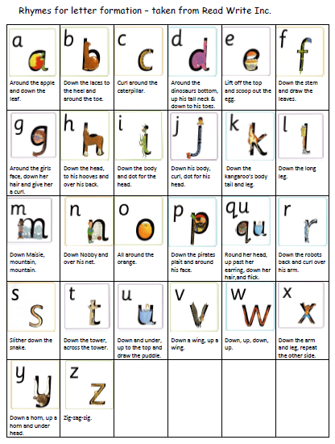

Children learn to write with a pencil. The most appropriate grip is the ‘tripod grip’ which allows both control and fluid movement. If your child finds it difficult to hold a thin pencil it may be worth investing in something chunkier or pencil grips which are designed to encourage a tripod grip. We encourage our children to take care with presentation. When children enter Key Stage 2, they have the chance to earn a pen license.

Important Points To Remember

- Always start forming the letters on the line
- “Tall letters,” will touch the line above (b d h k l t )
- “Middle letters,” are all the same height and stop at the midpoint of the line ( a c e I m n o r s u v w x y z )
- Some letters stretch down below the line. The top of these letters touch the midpoint (f g j p q y )
- Capital letters never join to the rest of a word
In Reception and at the beginning of Year 1 the children learn to form each letter separately. As the children are introduced to digraphs and trigraphs they begin to join certain letter combinations.
For example: ch sh th ee ea igh

Towards the end of Year 1 and moving onto Year 2 the children begin to join whol.

Key Stage 2
During this stage the children continue to have direct teaching and regular practice of handwriting. We aim for them to develop a clear, fluent style and by the end of Year 6 be able to adapt their handwriting for the for different purposes, such as: a neat, legible hand for finished, presented work, a faster script for note making and the ability to print for labelling diagrams etc.
Capital letters
Capital letters stand alone and are not joined to the next letter. Children must practice starting sentences and writing names using a capital letter and not joining the subsequent letter. This should be modelled by the teacher during Literacy and Phonics sessions.
The Learning Environment
In all classes, pencil pots with suitable materials are available for pupils to work at their own tables. Classrooms are equipped with a range of writing implements, line guides, word lists and dictionaries.
Lower case letters
Capitals
ABCDEFGHIJKLMNOPQRSTUVWXYZ

The Four Joins
1. to letters without ascenders
2. to letters with ascenders
3. horizontal joins
4. horizontal joins to letters with ascenders
The break letters (letters that aren’t joined from) are: bgjpqxyzs
NB children must be taught individual letters first so that they see them as individual units BEFORE learning to join.
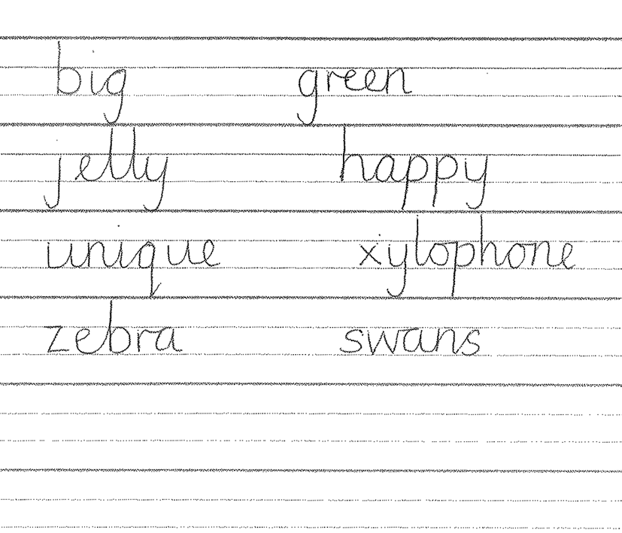

Year 2
The majority of children should be ready to start the year using handwriting books.
All children should be allowed to use unlined paper from time to time so that they can apply skills and consider issues of presentation and aesthetics. Handwriting should be timetabled and where appropriate link with revision of phonics.
In Key Stage 2 all pupils will have access to a minimum of 2 x 15 minute discrete sessions to develop handwriting.
Teaching Sequence
To develop independence the following teaching technique would be seen across Key Stage One.
• Hand and finger strength activities
• Tracing
• Pattern work
Year 3 and Key Stage 2
In Key Stage 2 all pupils will have access to a minimum of 2 x 15 minute discrete sessions to develop handwriting.
For the order of teaching letters and joins see Appendix 1 Techniques for teaching letter formation
• Model good handwriting all the time
• Demonstrate
• Encourage children to verbalise the process
• Children form letters in the air
• Write over highlighter pen (or dotted letters)
• Draw round templates
• Write in sand with finger or stick
• Write with chalk on chalkboard
• Wax resist letters
• Form letters with pegs on pegboard
• Form letters with beads in plasticine
• Finger trace the outline of letters on the back of the person in front of you Seating and posture
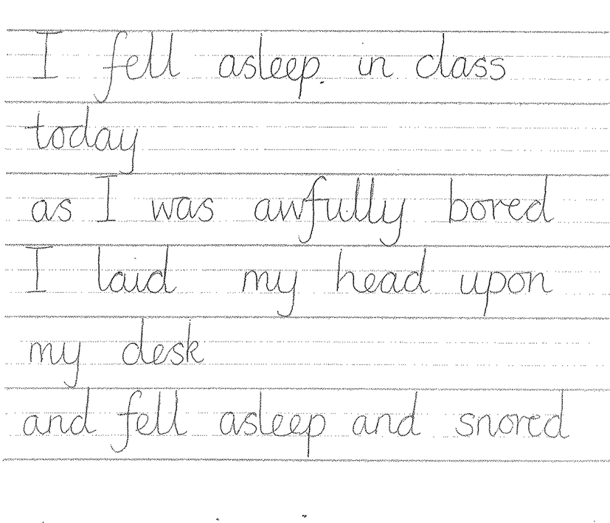
• Chair and table should be at a comfortable height
• The table should support the forearm so that it rests lightly on the surface and is parallel to the floor
• Encourage children to sit up straight and not slouch
• The height of the chair should be such that the thighs are horizontal and feet flat on the floor
• Tables should be free of clutter
• Rooms should be well lit
• Left handed pupils should sit on the left of their partners

Pencil grip
• Children should write with a pencil (or pen when introduced in Y6) with a rounded nib. Pencils should be reasonably sharp.
• A tripod grip is the most efficient way of holding a pencil
For right handers
• Hold lightly between the thumb and forefinger about 3cm away from the point • The paper should be placed to the right tilted slightly to the left
• Use the left hand to steady the paper

For left handers
• Hold lightly between thumb and forefinger resting on the first knuckle of the middle finger
• Hold about 3cm from the tip
• The hand should be kept below the writing line
• The paper should be tilted slightly to the right at about 20 - 30° • Use the right hand to steady the paper
NB It is very important that a right-handed child is NOT seated on the left hand side of a left handed child as their elbows will collide!
Teachers should demonstrate writing with their left hand wherever possible or use the expertise of left-handed writers.
Assessment
Phase leaders in team meetings and senior leaders should monitor children’s writing and presentation in books regularly (at least termly). The following should be considered:
• Is the writing generally legible?
• Are the letters correctly shaped and proportioned?
• Are the joins made correctly?
• Are the spaces between the letters, words and lines appropriate?
• Is the size of the writing appropriate?
• Is the writing properly aligned?
• Are the writing standards achieved by the majority of pupils in line with age related expectations?
Individual assessment
Children should be observed as they write during handwriting lessons – the teacher must circulate, monitor and intervene. Teachers also need to monitor and mark whole pieces of writing. The following should be considered:
• Is the posture correct?
• Does the child hold the pencil correctly?
• Does the child use the correct movement when forming and or joining letters?
• Are any letters reversed or inverted?
• Does the child write fluently and rhythmically?
• Is the writing easily legible?
• Is the pupil’s handwriting development should be in line with age related expectations

IMPACT

The impact of using the full range of Read write Inc and Nelson Handwriting resources, including display, will be seen across the school with an increase in the profile of handwriting. Following the scheme, will give our school a consistent approach where handwriting expectations are clear and the same technical vocabulary is used with, and spoken by, all teaching staff and learners. Whole school and parental engagement can also be improved through the use of Nelson Handwriting resources as home learning tasks.
Handwriting lessons should not feel like a chore for teachers and pupils and should encourage a sense of pride in pupils’ written work.
Our children’s handwriting will become automatic and to a high standard so that they are able to focus on the content of their writing rather than the presentation. The impact of the scheme should be noticeable within written work in all areas of the curriculum.

