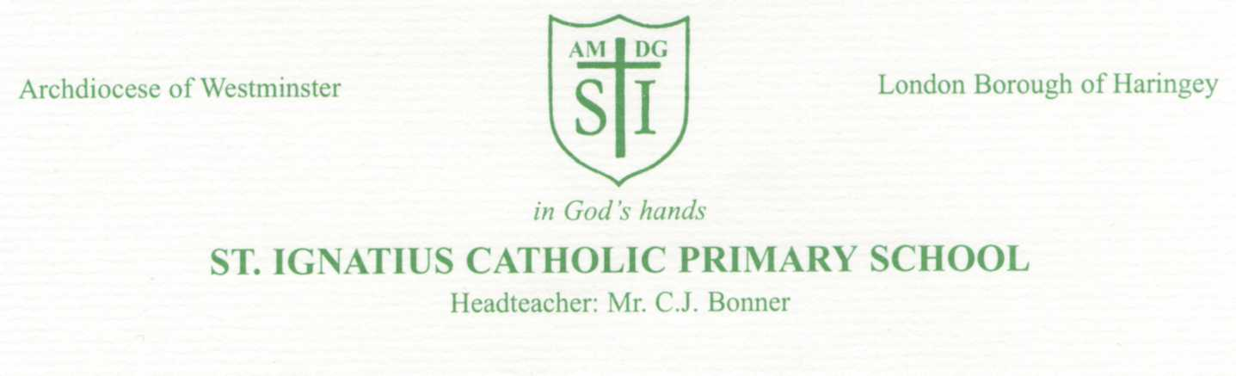3rd September 2020
Dear Parents,
I am very pleased to be able to welcome everyone back to school from Monday 7th September 2020.
This is something we have been all looking forward to but school will be different and the ‘new normal’ will present challenges for children and adults alike. There will be a number of changes taking place so that we can keep school safe and stay open in the months ahead.
We can only achieve this with your help and support-we will be asking you to make changes to your routine that may be inconvenient and sometimes we will have to alter them with little notice. This is only happening as we are trying to do everything we can to keep everyone safe and well - please be patient and understanding when staff ask for your help and cooperation.
Attached you will find an information sheet outlining some of the new procedures for the children’s return.
Please help us by minimising the time you spend on the school site and try not to crowd the pavement outside school.
It is very important that if your child is unwell or has as a cough, raised temperature or flu-like symptoms that they do not come to school. It is also important that you follow the guidance related to the wellbeing of your household members too. Please see Flowchart for parents: what to do if someone has symptoms of COVID-19 @ https://stignatiuscatholicprimary.co.uk/our-news/school-return-Sept-2020
Please continue to communicate with staff via the Class Dojo system and not by approaching them at the start or the end of the day. If you need to contact the school office please do so by phone and not in person.
Later this month we will arrange a ‘Meet the teacher’ session whereby your child’s teacher will upload a video to Dojo to introduce themselves and share with you lots of information about your child’s new class, routines and procedures. We will also share more information with you about their learning and the curriculum for the coming term. All of our staff are committed to doing everything they can to make sure the children are happy back in school and quickly address any gaps in their learning.
We all know it will take time to become familiar with the ‘new normal’ and once again I am asking for your help, patience and support as we ensure the school is a safe environment for everyone.
Yours sincerely,
C.J.Bonner
God our Father,
We pray for your guidance and love to lead us all through the year ahead,
May your grace be present throughout our school community
In all we do and say
Return to school arrangements
As you will be aware, following government advice and guidance, schools are fully re-opening for ALL pupils.

All pupils in Y1 Y 2 Y3 Y4 Y5 Y6 at St Ignatius Primary School, provided they are in good health, are expected to return to school on Monday 7th September 2020.
Separate arrangements are in place for Reception and Nursery pupils to start over the course of the next weeks.
One of the most effective ways to support the arrival and departure of pupils in school is to have staggered times. We informed you in our July 2020 Stay Connected newsletter, how we have planned this:

Year group | Start time | Finish time
Year 6 | 8.45am – 9.00am | 2.45am
Year 5 | 8.45am – 9.00am | 2.45am
Year 4 | 9.00am – 9.15am | 3.00pm
Year 3 | 9.00am – 9.15am | 3.00pm
Year 2 | 9.15am – 9.30am | 3.15am
Year 1 | 9.15am – 9.30am | 3.15am

We ask parents to ensure your child arrives at school within the 15 minutes timeslot for each year group.
Please do not arrive too early and do not be late.
If you do arrive ahead of your start time, please find an area to wait, away from our school entrance that allows pupils to enter freely and safely and allows our community to maintain social distance.

It is also essential that your child is picked up on time at the end of the day.
We would like to ask parents of pupils in Y5 and Y6, if you feel it is appropriate, to make arrangements for your child to leave the school premises on their own, either to go home on their own or to meet you in a convenient place outside of school, away from busy areas.

Below are additional arrangements to support the movement of pupils and parents around school in the safest way possible. These arrangements are subject to change, depending on how effectively they work.
- A one way system has been set up in and out of our school premises.
- All pupils are to enter school via our Nursery gate.
- All pupils are to leave school via Anne Line gate.
- If pupils are bringing younger siblings to school, they can enter school at their allocated time and drop their younger sibling at their classroom / building entrance. Siblings do not have to wait until it is their allocated time to enter.
- Where possible, parents are requested to leave their older pupils to come on to the school premises themselves.
- For younger and other pupils, only one adult must accompany them on to the school premises to escort them to their classroom door (Reception – Y2) or their building entrance ( Y3 – Y6).
- Parents accompanying their child are requested to wear a mask while they are on the school premises.
- If parents would like their child to wear a reusable mask to school, please provide them with a plastic bag to keep it in during the day.
- Bins will be provided for pupils on entry to place disposable masks in.
- For collection at the end of the day, parents will enter school via the Nursery gate.
- Parents and pupils will all leave school via the Anne line gate.
- Campion parents will collect their children from their classrooms but will wait away from the classroom doors.
- ( Y3 Y4) Anne Line and (Y5 Y6 ) Briant pupils will be dismissed from their playgrounds but there will be new arrangements in place for where classes assemble and where parents wait.
Some parents may have 2 or 3 pickups of pupils in different buildings - e.g. Briant (Y5 Y6) parent to collect pupil 2.45pm and use one way to Anne Line (Y3 Y4) to wait for 3.00pm or Campion (Y1 Y2) playground to wait for 3.15pm.
Parents cannot pick Anne Line pupil up at 3.00pm and go back for Campion pupils through school as they will be going against our one way system. These parents will need to follow the one way system out of Anne Line gate and back again in through the Nursery gate to collect their child at 3.15pm.

New classes
Text messages were sent in July 2020, informing all parents of their child’s new class in September.
If you have forgotten, please follow the link to find out the details of class name , teacher etc https://stignatiuscatholicprimary.co.uk/our-news/school-return-Sept-2020

Communicating via Dojo

We would again like to say a big thank you to all our pupils and parents who engaged so well with our ClassDojo throughout school lockdown. It really was lovely to see you all and chat with you – we know it lifted all our spirits!
We would like to continue using this system to communciate with each other, especially as our face to face access between staff and parents will not be an option at this time. Please make sure you are logged on and get involved with us all – After next week, once all the classess are settled back, all the teachers will be post a ‘Meet the teacher’ video on Dojo, where they will be giving you lots of information about your child’s class, their routines and their learning so make sure you are logged on as soon as possibel so that you can get involved. Remember, you also have direct access to your child’s teacher via the chat messaging function on ClassDojo.
We are aiming for a 100% connection of every member of each class!

School uniform and pupil belongings
School uniform is to be worn by our pupils.
Government guidance states that uniforms do not need to be cleaned any more often than usual, nor do they need to be cleaned using methods which are different from normal. However, encouraging your children to take off their uniforms when they get home and airing their uniforms will be good practice.
Any families who may be experiencing difficulties acquiring uniform for your child(ren), please contact Ms Curran ( 07593 926806) or Ms Taylor ( 07593 927514) and we will try and help you.

We will let you know next week when your child’s PE day is. For this half term, we ask pupils to come in to school in their PE kit for that day. They will not need to bring their uniforms to school on that day.

Step up September We understand that many of you are concerned about the learning time your children have missed over the past six months. Please remember that children all over the world will be experiencing the same thing. This September we have planned for a transition period, we are calling ‘Step up September’, where we will be revisiting and recapping learning from the summer term. Once all of our pupils have had a chance to settle back in to school, we will be assessing each pupil’s knowledge, skills and understanding and adapting our teaching and intervention programmes to respond to the outcomes of these assessments. We will also focus on pupil well-being and will be ensuring that our pupils have an opportunity to take part in social and pastoral activities, that many of them will have missed during the time out of school.

Term dates To find our term dates for the new school year 2020 - 2021, please go to:
https://stignatiuscatholicprimary.co.uk/termdates

Transport We understand that transport issues are an important factor in pupil return to school. There is a great deal of information on several sites supporting parents to make choices about best options available to them. This includes information about improved bus routes, cycling options etc.
Haringey’s Smarter Travel Team wish to encourage families to avoid driving and limit use of public transport where possible and consider walking, cycling or scooting to school.
You can find details of all options at:
https://www.london.gov.uk/coronavirus/back-school

safer travel guidance for passengers

https://tfl.gov.uk/info-for/schools-and-young-people/travel-guidance-for-schools?cid=reopeningeducation

Coronavirus (COVID-19): safer travel guidance for passengers

transport to school and other places of education: autumn term 2020

Universal Free School Meals and Free School Meals (FSM)
As part of the Government Universal Free School Meals scheme, all pupils in Reception, Y1 and Y2 are entitled to receive lunchtime meals for free, regardless of their benefits or financial circumstances.
However we would ask that all parents of Reception, Y1 and Y2, who are entitled to benefits, still complete a Free School Meals Form, as this brings additional funding in to our school.
Y3 pupils September 2020
Pupils moving to Y3 will no longer be entitled to Universal Free School meals and they will be expected to pay for their meals - unless you want them to have packed lunch or you are eligible to continue to receive free school meals – but you will need to apply and complete a Free School Meals form.
If you do not complete the form, you will have to pay for your child’s meals or you will need to provide them with a packed lunch.
To discuss your options, please call our school office.

