Home Learning Timetable
Before 9 am | Wake up- | ‘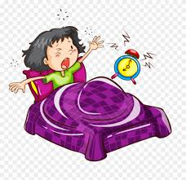 | - Get yourself breakfast  - Make your bed  - Get dressed
9:00 | PE with Joe Wicks | 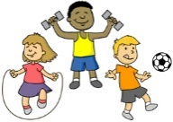 | https://www.thebodycoach.com/blog/pe-with-joe-1254.html  YouTube- Body Coach
9:15 | Reading Time  (30 mins)
9:45 | Academic Time-  - Set online studies  - Packs from school | 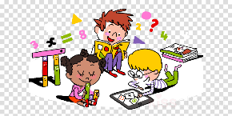 | No Electronics- except for online learning!
10:45 | Break- Fresh Air!  https://www.gonoodle.com/  https://www.heartfulness.uk/primaryschools/  https://www.cosmickids.com/ (Yoga)  Just Dance (You Tube) |  | - Walk  - Star Jumps  - Yoga  - Time in garden?
11:30 | Academic Time-  - Set online studies  - Packs from school |  | No Electronics- except for online learning!  Daily Times Tables?  Daily Spelling/Spag? (spelling and grammar)
12:30 | Lunch
1:30 | Project work?  Creative Writing? Writing task?
2:00- 3:00 | Creative Time- | 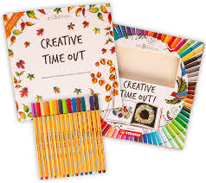 | Lego, drawing, painting, cooking, crafts, music  Board Games
3:00 | Chore Time | 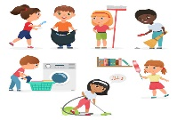 | Wipe door handles, light switches, Clean out car, do recycling etc …

