Home Learning for Year 2
Below is the expected home learning weekly timetable for your child. Please check the year group page for additional resources/website links. If you have any questions please contact the class teacher on ‘Class Dojo’.
Week commencing: Monday 15th June
St Ignatius Home Learning Weekly Timetable
Allocated time | Resource/Activity | Access
Daily Reading- 30 mins | Individual reading books  Read the eBook ‘Who’s at the zoo?’. | https://www.twinkl.co.uk/resource/roi-t-2546191-exploring-my-world-whos-at-the-zoo-ebook
Daily Spelling/Phonics | Practise spelling these 10 common exception words:  Early  Earth  Eight  Eighth  Enough  Exercise  Experience  Experiment  Extreme  Famous  You can revise these spelling words in the Sumdog challenge games. | Practise writing these words and then use the correct spelling of the word in a sentence. For example: The busy teacher rode a bicycle quickly to school.  Your login details are in your homework books. Please contact us on Dojo message if you are finding it difficult to log in.  https://www.sumdog.com/user/sign_in
Daily Times Tables | Continue to learn the 2, 5 and 10 multiplication tables. Write them down for example, 1 x 2 = 2. Then ask someone to test you on them out of order. | Try this topmarks games. Select multiplication then you can choose the times table you want to work on:  https://www.topmarks.co.uk/maths-games/mental-maths-train
Daily Sumdog- 30 mins | - 2D shape properties  - 3D shape properties  Challenges have been set up on Sumdog.  Maths – Problem of the Week | https://www.sumdog.com/user/sign_in  Username and password included in home learning pack  See Maths challenge on the year group page.
Twice Weekly Grammar | Let’s practice our homophones!! | https://www.bbc.co.uk/bitesize/articles/z7g8jhv  Watch the videos and complete the 3 different activities to practice. Can you think of other homophones?
Maths- Daily | White Rose- Maths  Test Base is a website with lots of games for children to try. The links opposite take you to questions about fractions, our focus this week. | https://whiterosemaths.com/homelearning/  See next page for more details!  https://uk.ixl.com/math/year-2/count-vertices-edges-and-faces  https://uk.ixl.com/math/year-2/compare-sides-and-vertices
English- Daily | We continue to learn about Beegu.  You will be able to access the story on a Powerpoint on our year 2 page under ‘week 9 – additional resources’ | See daily lesson below!  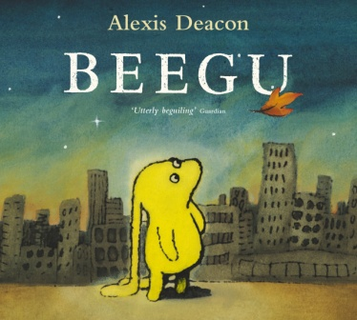
Topic | We are continuing out topic of the seaside.  This week we will be learning about what is human or physical. We have looked at this in class before.  Human is when things in our nature is made my people such as buildings, shops or traffic lights.  Physical is when things are naturally made, such as trees, clouds or soil.  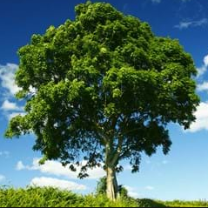  Go through the Powerpoint called ‘features of the seaside – human or physical’ to learn about different things we can find by the sea side and whether they were made by humans or was made naturally. | Watch this video:  https://www.bbc.co.uk/teach/class-clips-video/william-whiskerson-seaside-town/zd88qp3  Read the Powerpoint ‘features of the seaside – human or physical’ to learn and complete the activity.  Human Physical  shops cave  This will be under additional resources on our year 2 page.
Maths Lessons- Monday-Friday
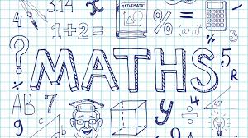
Please click on the links below that will take you straight to the activities on White Rose Home Learning. For each lesson there is a
- Video
- Activity
- Answer Sheet

HOW TO USE THE LESSONS

Just follow these four easy steps…
- Click on the set of lessons for your child’s year group.
- Watch the video (either on your own or with your child).
- Find a calm space where your child can work for about 20-30 minutes.
- Use the video guidance to support your child as they work through a lesson.

JOIN IN THE DAILY MATHS!
Lesson 1 (Monday) – 15.6.20  Count sides and vertices on 2D shapes.  Video  https://resources.whiterosemaths.com/resources/year-2/  Challenge- See Problem of the Week | Activity Link  See School website Year 2 Home Learning page Week 10.  https://stignatiuscatholicprimary.co.uk/key-information/online-learning/year-2-home-learning | Answers  See School website Year 2 Home Learning page Week 10.  https://stignatiuscatholicprimary.co.uk/key-information/online-learning/year-2-home-learning
Lesson 2 (Tuesday)- 16.6.20  Count faces, edges and vertices on 3D shapes.  Video  https://resources.whiterosemaths.com/resources/year-2/  Challenge- See Problem of the Week | Activity Link  See School website Year 2 Home Learning page Week 10.  https://stignatiuscatholicprimary.co.uk/key-information/online-learning/year-2-home-learning | Answers  See School website Year 2 Home Learning page Week 10.  https://stignatiuscatholicprimary.co.uk/key-information/online-learning/year-2-home-learning
Lesson 3 (Wednesday)- 17.6.20  Sort 2D and 3D shapes.  Video  https://resources.whiterosemaths.com/resources/year-2/  Challenge- See Problem of the Week | Activity Link  See School website Year 2 Home Learning page Week 10.  https://stignatiuscatholicprimary.co.uk/key-information/online-learning/year-2-home-learning | Answers  See School website Year 2 Home Learning page Week 10.  https://stignatiuscatholicprimary.co.uk/key-information/online-learning/year-2-home-learning
Lesson 4 (Thursday) – 18.6.20  Merge 2D and 3D shapes  Video  https://resources.whiterosemaths.com/resources/year-2/  Challenge- See Problem of the Week | Activity Link  See School website Year 2 Home Learning page Week 10.  https://stignatiuscatholicprimary.co.uk/key-information/online-learning/year-2-home-learning | Answers  See School website Year 2 Home Learning page Week 10.  https://stignatiuscatholicprimary.co.uk/key-information/online-learning/year-2-home-learning
Lesson 5 (Friday) – 19.6.20  Challenge  https://whiterosemaths.com/homelearning/year-2/  Challenge- See Problem of the Week | Activity Link | Answers

English Lessons- Monday- Friday
Monday | Beegu has been exploring Earth, but her mother parents have been very worried on their own planet. They don’t know where she has gone!  You might have seen missing posters when people’s pets have gone missing. They are used so that people can help find them.  Here is an example of a missing poster:  You can copy this on paper yourself. You do not need to print this.  In the description you need to include:  Colour, size, age. What does she enjoy doing? | Challenge:  Use adjectives to describe an accurate picture of what Beegu looks like.
Tuesday | Well done everyone!! Beegu has seen your missing poster that you created to find her. She is going to get in contact with her parents so that they do not worry anymore. She has decided to write a postcard. Can you help her write one?  You can copy this template on paper and complete it.  You need to include:  - A stamp  - Write in past tense  - Include his parent’s address (you can make it up, remember that they live on another planet)  - ‘Dear’ or ‘To’ and include your name at the end  - Explain where you have been and what you have been doing.  Remember that you are writing this postcard as Beegu so it has to be written in first person (I, me) | Challenge:  Add time conjunctions to explain what Beegu has been doing.
Wednesday | Beegu’s parents were very happy to receive Beegu’s postcard. Remember the scene of the story where Beegu is reunited with her parents?  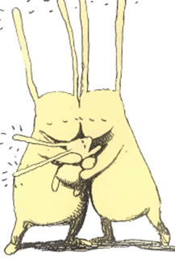  What conversation do you think Beegu and her parents had when they saw each other again? Have a think...  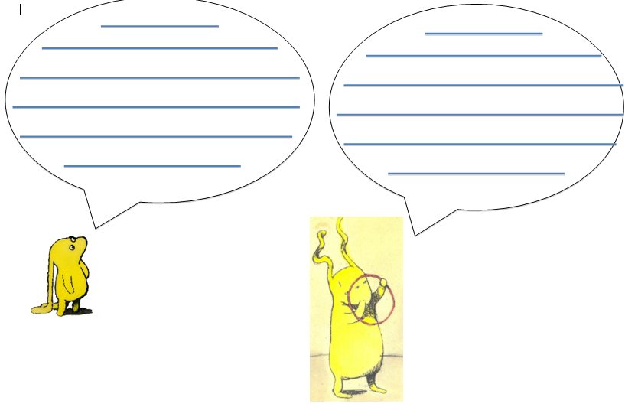  You can draw Beegu and her parents in your books and draw a speech bubble above their heads, just like this picture.  Remember to write in first person again and create a short conversation between Beegu and her parents. | Challenge:  Use quotation marks to show that it is a speech. For example:  ’I am so excited to see you’
Thursday | Footballer Jesse Lingard reads the book Attack of the Demon Dinner Ladies. Listen to the videos and complete the activities.  https://www.bbc.co.uk/bitesize/articles/zncc92p
Friday | Big write:  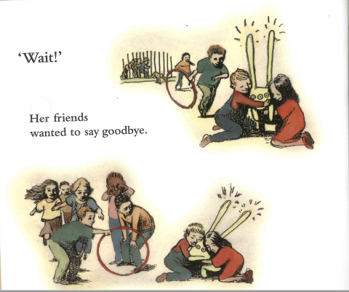  Beegu’s friends really liked playing with her and wanted to goodbye to her but didn’t get the chance to do it properly.  You will be the children in the book and you will write a goodbye letter from you to Beegu.  Include:  - ‘Dear Beegu’ at the beginning of your letter.  - Why you are writing this letter  - What you enjoyed about playing with Beegu. Maybe you can talk about your favourite game  - How you felt when your teacher told Beegu to leave.  - That you are excited to see Beegu again.  - Finish the letter by writing your name so Beegu knows who it is from. | Challenge:  Use 5 common exception words in your big write.

