Home Learning for Year 2
Below is the expected home learning weekly timetable for your child. Please check the year group page for additional resources/website links. If you have any questions please contact the class teacher on ‘Class Dojo’.
Week commencing: Monday 11th May
St Ignatius Home Learning Weekly Timetable
Allocated time | Resource/Activity | Access
Daily Reading- 30 mins | Individual reading books  Read the eBook ‘A Tale of Two Feathers’. | https://www.twinkl.co.uk/resource/a-tale-of-two-feathers-ebook-t-e-1000
Daily Spelling/Phonics | Practise spelling these 10 common exception words:  Pretty  Prove  Should  Steak  Sugar  Sure  Told  Water  Who  Whole  You can revise these spelling words in the Sumdog challenge games. | Practise writing these words and then use the correct spelling of the word in a sentence. For example: The kind child helped me to improve my work.  Your login details are in your homework books. Please contact us on Dojo message if you are finding it difficult to log in.  https://www.sumdog.com/user/sign_in
Daily Times Tables | Continue to learn the 2, 5 and 10 multiplication tables. Write them down for example, 1 x 2 = 2. Then ask someone to test you on them out of order. | Try this nrich problem using some of your learning:  https://nrich.maths.org/204
Daily Sumdog- 30 mins | - Addition to 100  - Subtract within 100  Challenges have been set up on Sumdog.  Maths - Problem of the Week | https://www.sumdog.com/user/sign_in  Username and password included in home learning pack  See Maths challenge on the year group page.
Twice Weekly Grammar | - Play Simon says with a family member. All the sentences you are saying in this game are commands. Simon is giving bossy instructions.  - Practicing capital letters on this game! Remember to skip the advert after 15 seconds | Watch the video and complete the activities:  https://www.bbc.co.uk/bitesize/topics/zrqqtfr/articles/z8strwx  https://www.roythezebra.com/reading-games/capital-letter-1.html
Maths- Daily | White Rose- Maths  Test Base is a website with lots of games for children to try. The links opposite takes you to questions about adding and subtracting within 100, our focus this week. | https://whiterosemaths.com/homelearning/  See next page for more details!  https://uk.ixl.com/math/year-2/write-addition-sentences-to-describe-pictures-sums-up-to-100  https://uk.ixl.com/math/year-2/write-subtraction-sentences-to-describe-pictures-numbers-up-to-100
English- Daily | We are looking at a new story called:  The whole truth  Please find the story on active learn my stuff wordsmith The whole truth | See daily lesson below!
Topic | We are learning about food chains this week!  Task:  Can you create a food chain?  For example:  The tree is eaten by the deer and the deer is eaten by the lion.  You could draw your own one. | Watch this video about food chains:  https://www.bbc.co.uk/bitesize/clips/z96r82p  There will be a powerpoint called ‘food chain’ and some pictures also attached to help you!

Maths Lessons- Moday-Friday
Please click on the links below that will take you straight to the activities on White Rose Home Learning. For each lesson there is a
- Video
- Activity
- Answer Sheet

HOW TO USE THE LESSONS

Just follow these four easy steps…
- Click on the set of lessons for your child’s year group.
- Watch the video (either on your own or with your child).
- Find a calm space where your child can work for about 20-30 minutes.
- Use the video guidance to support your child as they work through a lesson.

JOIN IN THE DAILY MATHS!
Lesson 1 (Monday) – 11.5.20  Adding and Subtracting Tens  Video  https://resources.whiterosemaths.com/resources/year-2/  Challenge- See Problem of the Week | Activity Link  See School website Year 2 Home Learning page Week 6.  https://stignatiuscatholicprimary.co.uk/key-information/online-learning/year-2-home-learning | Answers  See School website Year 2 Home Learning page Week 6.  https://stignatiuscatholicprimary.co.uk/key-information/online-learning/year-2-home-learning
Lesson 2 (Tuesday)- 12.5.20  Add 2-digit numbers  Video  https://resources.whiterosemaths.com/resources/year-2/  Challenge- See Problem of the Week | Activity Link  See School website Year 2 Home Learning page Week 6.  https://stignatiuscatholicprimary.co.uk/key-information/online-learning/year-2-home-learning | Answers  See School website Year 2 Home Learning page Week 6.  https://stignatiuscatholicprimary.co.uk/key-information/online-learning/year-2-home-learning
Lesson 3 (Wednesday)- 13.5.20  Subtract 2-digit numbers  Video  https://resources.whiterosemaths.com/resources/year-2/  Challenge- See Problem of the Week | Activity Link  See School website Year 2 Home Learning page Week 6.  https://stignatiuscatholicprimary.co.uk/key-information/online-learning/year-2-home-learning | Answers  See School website Year 2 Home Learning page Week 6.  https://stignatiuscatholicprimary.co.uk/key-information/online-learning/year-2-home-learning
Lesson 4 (Thursday) – 14.5.20  Bonds to 100 (tens and ones)  Video  https://resources.whiterosemaths.com/resources/year-2/  Challenge- See Problem of the Week | Activity Link  See School website Year 2 Home Learning page Week 6.  https://stignatiuscatholicprimary.co.uk/key-information/online-learning/year-2-home-learning | Answers  See School website Year 2 Home Learning page Week 6.  https://stignatiuscatholicprimary.co.uk/key-information/online-learning/year-2-home-learning
Lesson 5 (Friday) – 15.5.20  Challenge  https://whiterosemaths.com/homelearning/year-2/  Challenge- See Problem of the Week | Activity Link | Answers
English Lessons- Monday- Friday
Monday | Look at the cover of ‘the whole truth’ on active learn. Answer these questions:  - Who do you think these people are?  - What might the story be about?  - What does the picture tell you?  Now read chapter 1 and 2 only. Do you get on with your brothers and sisters?  Your task is to write what you think about Marcie and Armitage.  What is Marcie like?  What are her likes or dislikes?  What is Armitage like?  What does he like to do? | Challenge:  How many adjectives can you use to write about what you think of Marcie and Armitage?
Tuesday | Re-read chapter 2 of ‘the whole truth’.  Now read chapter 3 and talk about the situation with a family member.  Read chapter 4: were you surprised?  Your task is to predict what will happen next. Think about it first, maybe make some notes and then act it out to your family! | Challenge:  Write your prediction down and check if you were right tomorrow!
Wednesday | Read chapter 5 and 6:  Now go to page 16-17 of ‘The Whole Truth’. Have a look at the advertisements. Do these make you want the things they are advertising? What makes you want them?  Now re-read pages 40-43 and think about the details about the boots.  Your task is to create a poster to advertise the rocket boots! You can use ‘rocket boots advertisement’ on active learn to help you or you can draw them and use the words on your own poster. | Challenge:  Can you use alliteration in your advertisement?  For example:  Boisterous boots!  Use this website to help you:  https://adjectivesstarting.com/with-a/
Thursday | Re-read chapter 5, while reading think about how Marcie is feeling or is thinking.  Your task is to write down Marcie’s thoughts during each page.  For example, on page 30-31. Marcie tested the drops on her mum. Marcie is feeling very curious. She is wondering if the drops will actually work! | Challenge:  Can you use quotes of what Marcie is saying in her head while having that thought.  For example:  Marcie tested the drops on her mum. Marcie is feeling very curious. She is wondering if the drops will actually work! ‘If I put these drops quietly into my mum’s tea I can actually find out if they work!’
Friday | Big write:  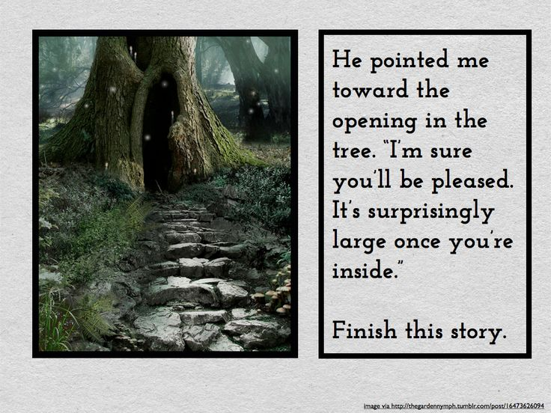  - Who is walking to this tree?  - Where is the tree?  - How did he find it?  - What does he find inside the tree?  - What problem does he face inside the tree?  - How does he solve it? | Challenge:  Use 5 common exception words in your big write.  Use quotes in your writing.

