Home Learning for Year 2
Below is the expected home learning weekly timetable for your child. Please check the year group page for additional resources/website links. If you have any questions please contact the class teacher on ‘Class Dojo’.
Week commencing: Monday 18th May
St Ignatius Home Learning Weekly Timetable
Allocated time | Resource/Activity | Access
Daily Reading- 30 mins | Individual reading books  Read the eBook ‘The Town Mouse and the Country Mouse’. | https://www.twinkl.co.uk/resource/t-t-12324-the-town-mouse-and-the-country-mouse-ebook
Daily Spelling/Phonics | Practise spelling these 10 common exception words:  Accident  Accidentally  Actual  Actually  Address  Although  Answer  Appear  Arrive  Believe  You can revise these spelling words in the Sumdog challenge games. | Practise writing these words and then use the correct spelling of the word in a sentence. For example: The kind child helped me to improve my work.  Your login details are in your homework books. Please contact us on Dojo message if you are finding it difficult to log in.  https://www.sumdog.com/user/sign_in
Daily Times Tables | Continue to learn the 2, 5 and 10 multiplication tables. Write them down for example, 1 x 2 = 2. Then ask someone to test you on them out of order. | Try these topmarks games. You can choose the times table you want to work on:  https://www.topmarks.co.uk/maths-games/hit-the-button
Daily Sumdog- 30 mins | - Skip Counting by 2s, 3s, 5s and 10s  - Fact Families for 2s, 5s and 10s  Challenges have been set up on Sumdog.  Maths - Problem of the Week | https://www.sumdog.com/user/sign_in  Username and password included in home learning pack  See Maths challenge on the year group page.
Twice Weekly Grammar | Apostrophes for possession. Go through the PowerPoint called ‘apostrophes for possession’  Read through the presentation and answer the questions.  Could you write your own sentences using apostrophes? | You can watch this video for more:  https://www.bbc.co.uk/bitesize/topics/zvwwxnb/articles/zx9ydxs
Maths- Daily | White Rose- Maths  Test Base is a website with lots of games for children to try. The links opposite takes you to questions about multiplication, our focus this week. | https://whiterosemaths.com/homelearning/  See next page for more details!  https://uk.ixl.com/math/year-2/count-equal-groups  https://uk.ixl.com/math/year-2/identify-multiplication-expressions-for-arrays
English- Daily | We are continuing looking at our story from last week:  The whole truth  Please find the story on active learn my stuff wordsmith The whole truth | See daily lesson below!
Topic | We are going to be looking at microhabitats. These are little habitats that live in our local habitat (which would be your area). These microhabitats could be:  - Under stones/rocks  - In grass  - Under leaves  Your task is to walk around your local area/park and see if you can find these microhabitats. What kind of insects or animals can you find living there? Take pictures and share them on class dojo! | There is a PowerPoint presentation called ‘microhabitats’ under additional resources. Have a read to learn all about microhabitats.  Watch this video to see how you can find them:  https://www.youtube.com/watch?v=5mXEsvrJUnU

Maths Lessons- Monday-Friday
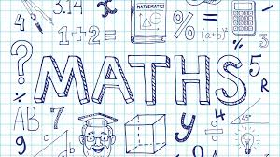
Please click on the links below that will take you straight to the activities on White Rose Home Learning. For each lesson there is a
- Video
- Activity
- Answer Sheet

HOW TO USE THE LESSONS

Just follow these four easy steps…
- Click on the set of lessons for your child’s year group.
- Watch the video (either on your own or with your child).
- Find a calm space where your child can work for about 20-30 minutes.
- Use the video guidance to support your child as they work through a lesson.

JOIN IN THE DAILY MATHS!
Lesson 1 (Monday) – 18.5.20  Multiplication sentences using the symbol  Video  https://resources.whiterosemaths.com/resources/year-2/  Challenge- See Problem of the Week | Activity Link  See School website Year 2 Home Learning page Week 7.  https://stignatiuscatholicprimary.co.uk/key-information/online-learning/year-2-home-learning | Answers  See School website Year 2 Home Learning page Week 7.  https://stignatiuscatholicprimary.co.uk/key-information/online-learning/year-2-home-learning
Lesson 2 (Tuesday)- 19.5.20  Use arrays  Video  https://resources.whiterosemaths.com/resources/year-2/  Challenge- See Problem of the Week | Activity Link  See School website Year 2 Home Learning page Week 7.  https://stignatiuscatholicprimary.co.uk/key-information/online-learning/year-2-home-learning | Answers  See School website Year 2 Home Learning page Week 7.  https://stignatiuscatholicprimary.co.uk/key-information/online-learning/year-2-home-learning
Lesson 3 (Wednesday)- 20.5.20  The 2 times-table  Video  https://resources.whiterosemaths.com/resources/year-2/  Challenge- See Problem of the Week | Activity Link  See School website Year 2 Home Learning page Week 7.  https://stignatiuscatholicprimary.co.uk/key-information/online-learning/year-2-home-learning | Answers  See School website Year 2 Home Learning page Week 7.  https://stignatiuscatholicprimary.co.uk/key-information/online-learning/year-2-home-learning
Lesson 4 (Thursday) – 21.5.20  The 5 times-table  Video  https://resources.whiterosemaths.com/resources/year-2/  Challenge- See Problem of the Week | Activity Link  See School website Year 2 Home Learning page Week 7.  https://stignatiuscatholicprimary.co.uk/key-information/online-learning/year-2-home-learning | Answers  See School website Year 2 Home Learning page Week 7.  https://stignatiuscatholicprimary.co.uk/key-information/online-learning/year-2-home-learning
Lesson 5 (Friday) – 22.5.20  Challenge  https://whiterosemaths.com/homelearning/year-2/  Challenge- See Problem of the Week | Activity Link | Answers

English Lessons- Monday- Friday
Monday | Read chapter 5 and 6. While you are reading, think about whether Armitage is telling the truth or not?  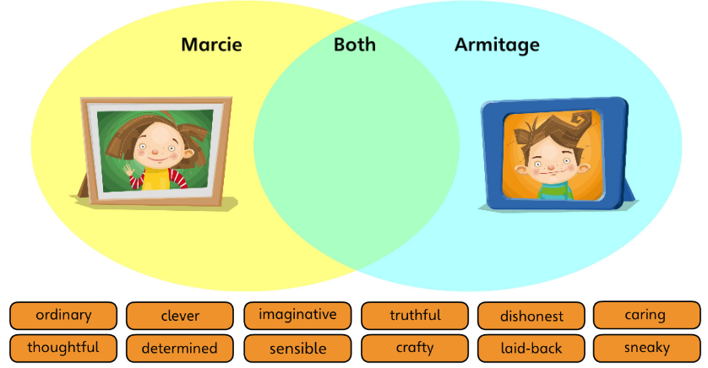  You could draw this Venn diagram in your books and think about which words go where. Or you could access this and do it on activelearn my stuff wordsmith Describe Marcie and Armitage.  You could role play the conversation between Marcie and Armitage in chapter 6. What would they say about each other at the end of the story? How have they changed? | Challenge:  Write about:  - What Marcie thought about Armitage at the beginning of the story and then at the end of the story.  - What Armitage thought about Marcie at the beginning of the story and then at the end of the story.
Tuesday | Choose your favourite chapter of the story.  Write a diary entry as Marcie. Remember these features you need to include when you are writing a dairy:  - Include a date  - Start your diary with ‘Dear diary’ or give your diary a name.  - Write in first person (I, my, me)  - Write in past tense (it has already happened)  - Write in chronological order (first, then, next…)  - Write about your feelings | Challenge:  Use quotes of other people in the story who might have spoken to Marcie.  For example:  I’m so confused why the anti-truth-drops-drops weren’t working on Armitage. I laid down on my bed asking Armitage and he said ‘it might have been because I was telling the truth the whole time!’. I was shocked, he might actually be right!
Wednesday | Let’s have a look at Armitage’s gadget:  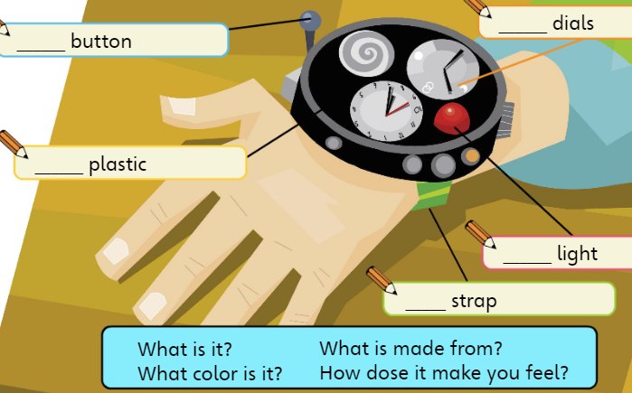  Have a think about how you can describe the gadget. For example:  Shiny light (describing what it looks like)  Green strap (describing the colour)  Clicky button(describing the sound it makes)  Your task now is to create your own gadget. Think about:  What is it called?  What does it do?  What colour is it?  What is it made from?  How does it make you feel?  It doesn’t need to be a watch; you could create anything you like! Draw your gadget and label it all the features! | Challenge:  Use alliteration to describe your gadget.  For example:  Silky white strap  Use this word bank to help you with your gadget:  Metal wood plastic glass button switch strap dial screen tool light wheel camera tube scissors hook grabber
Thursday | Comprehension lesson on BBC Bitesize! Read or listen to the story and complete the activities:  https://www.bbc.co.uk/bitesize/articles/zd63gwx
Friday | 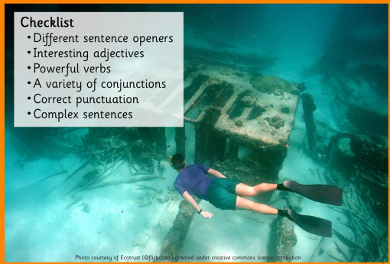  Big Write:  - Where is this?  - Who is the person swimming towards the object?  - Who is he? How did he find the object?  - What does he do with it?  Write your story as interesting as you can. Remember to build suspense and excitement! | Challenge:  Use 5 common exception words in your big write.  Use quotes in your writing.

