Home Learning for Year 2
Below is the expected home learning weekly timetable for your child. Please check the year group page for additional resources/website links. If you have any questions please contact the class teacher on ‘Class Dojo’.
Week commencing: Monday 1st June
St Ignatius Home Learning Weekly Timetable
Allocated time | Resource/Activity | Access
Daily Reading- 30 mins | Individual reading books  Read the eBook ‘Charlie the Firefighter’. | https://www.twinkl.co.uk/resource/t-or-271-charlie-the-firefighter-ebook
Daily Spelling/Phonics | Practise spelling these 10 common exception words:  Bicycle  Breath  Breathe  Build  Busy  Business  Calendar  Caught  Centre  Century  You can revise these spelling words in the Sumdog challenge games. | Practise writing these words and then use the correct spelling of the word in a sentence. For example: The busy teacher rode a bicycle quickly to school.  Your login details are in your homework books. Please contact us on Dojo message if you are finding it difficult to log in.  https://www.sumdog.com/user/sign_in
Daily Times Tables | Continue to learn the 2, 5 and 10 multiplication tables. Write them down for example, 1 x 2 = 2. Then ask someone to test you on them out of order. | Try these topmarks games. You can choose the times table you want to work on:  https://mathsframe.co.uk/en/resources/resource/306/Maths-Fishing-Multiplication
Daily Sumdog- 30 mins | - Identify even and odd numbers within 20  - Division facts for 2s, 5s and 10s  Challenges have been set up on Sumdog.  Maths - Problem of the Week | https://www.sumdog.com/user/sign_in  Username and password included in home learning pack  See Maths challenge on the year group page.
Twice Weekly Grammar | Homophones:  Practice recognising and using homophones. On the BBC Bitesize website  You can also practice homophones on Active Learn | https://www.bbc.co.uk/bitesize/articles/z7g8jhv  Active Learn my stuff Wordsmith homophones
Maths- Daily | White Rose- Maths  Test Base is a website with lots of games for children to try. The links opposite take you to questions about division, our focus this week. | https://whiterosemaths.com/homelearning/  See next page for more details!  https://www.ictgames.com/mobilePage/doggyDivision/index.html  https://www.arcademics.com/games/demolition
English- Daily | We are looking at a new story called ‘Penny Dreadful and the Rat’  Please find the story on active learn my stuff wordsmith Penny Dreadful and the rat | See daily lesson below!
Topic | We are going to look at the basic things animals and humans need to survive.  Have a think and write some ideas down about what you think is important for animals and humans need to stay alive.  Follow the PowerPoint presentation and complete the poster activity at the end. | Watch this video to help you:  https://www.bbc.co.uk/bitesize/topics/z6882hv/articles/zx38wmn  The PowerPoint is under additional resources on the Year 2 home learning page called: Animals and humans survival.

Maths Lessons- Moday-Friday
Please click on the links below that will take you straight to the activities on White Rose Home Learning. For each lesson there is a
- Video
- Activity
- Answer Sheet

HOW TO USE THE LESSONS

Just follow these four easy steps…
- Click on the set of lessons for your child’s year group.
- Watch the video (either on your own or with your child).
- Find a calm space where your child can work for about 20-30 minutes.
- Use the video guidance to support your child as they work through a lesson.

JOIN IN THE DAILY MATHS!
Lesson 1 (Monday) – 1.6.20  The 10 times table  Video  https://resources.whiterosemaths.com/resources/year-2/  Challenge- See Problem of the Week | Activity Link  See School website Year 2 Home Learning page Week 8.  https://stignatiuscatholicprimary.co.uk/key-information/online-learning/year-2-home-learning | Answers  See School website Year 2 Home Learning page Week 8.  https://stignatiuscatholicprimary.co.uk/key-information/online-learning/year-2-home-learning
Lesson 2 (Tuesday)- 2.6.20  Make equal groups  Video  https://resources.whiterosemaths.com/resources/year-2/  Challenge- See Problem of the Week | Activity Link  See School website Year 2 Home Learning page Week 8.  https://stignatiuscatholicprimary.co.uk/key-information/online-learning/year-2-home-learning | Answers  See School website Year 2 Home Learning page Week 8.  https://stignatiuscatholicprimary.co.uk/key-information/online-learning/year-2-home-learning
Lesson 3 (Wednesday)- 3.6.20  Make equal groups  Video  https://resources.whiterosemaths.com/resources/year-2/  Challenge- See Problem of the Week | Activity Link  See School website Year 2 Home Learning page Week 8.  https://stignatiuscatholicprimary.co.uk/key-information/online-learning/year-2-home-learning | Answers  See School website Year 2 Home Learning page Week 8.  https://stignatiuscatholicprimary.co.uk/key-information/online-learning/year-2-home-learning
Lesson 4 (Thursday) – 4.6.20  Odd and even numbers  Video  https://resources.whiterosemaths.com/resources/year-2/  Challenge- See Problem of the Week | Activity Link  See School website Year 2 Home Learning page Week 8.  https://stignatiuscatholicprimary.co.uk/key-information/online-learning/year-2-home-learning | Answers  See School website Year 2 Home Learning page Week 8.  https://stignatiuscatholicprimary.co.uk/key-information/online-learning/year-2-home-learning
Lesson 5 (Friday) – 5.6.20  Challenge  https://whiterosemaths.com/homelearning/year-2/  Challenge- See Problem of the Week | Activity Link | Answers

English Lessons- Monday- Friday
Monday | Open ‘Penny Dreadful and the Rat’ on Active Learn. It will be under Word Smith.  Look at the cover.  - What do you think the story will be about?  - Do you know any other stories by this author?  - What does that make you think about this story? (will it be a funny story? Or a sad story? Why?  Write down your predictions of the story  After your have written your predictions you can read pages 5-19 of the story. Have a chat about what you think about the story so far. | Challenge:  Can you summarize the story so far?  You can use the statements below to put them in order.  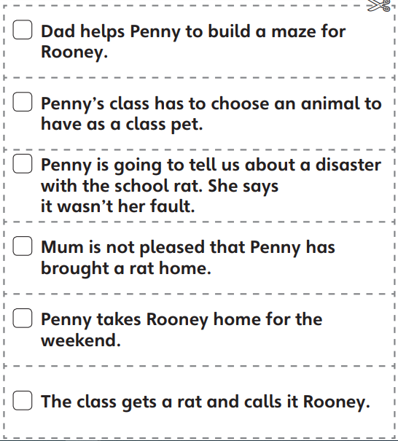
Tuesday | Now read pages 20 – 41.  What do you think Penny will do if she can’t find Rooney?  What do you think is the right thing to do?  Your task is to write a letter to penny explaining whether she should tell her teacher that she has lost Rooney or if you think she shouldn’t tell her class.  You have to explain why.  Remember:  - To start a letter with ‘Dear Penny’  - Include a date  - Include Penny’s address (you can make this up)  - Explain why you are writing this letter  - Give detail why she should or should not tell her teacher that she has lost Rooney  - Make sure you write who the letter is from. | Challenge:  Can you summarize the story so far?  You can use the statements below to put them in order.  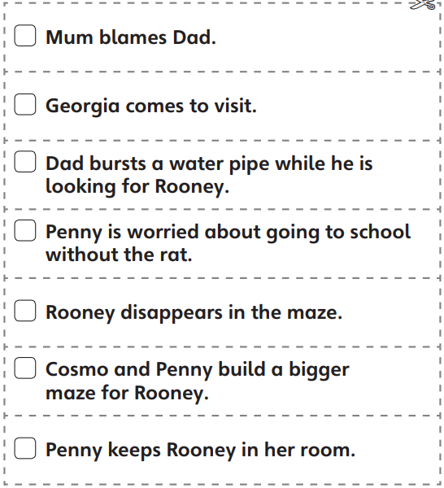
Wednesday | Have a think about what has happened in the story so far.  Read pages 42-50.  - What will she do now?  - Where could Rooney 1 be?  - Did Georgia’s violin teacher like finding a rat in her briefcase?  - How do you know?  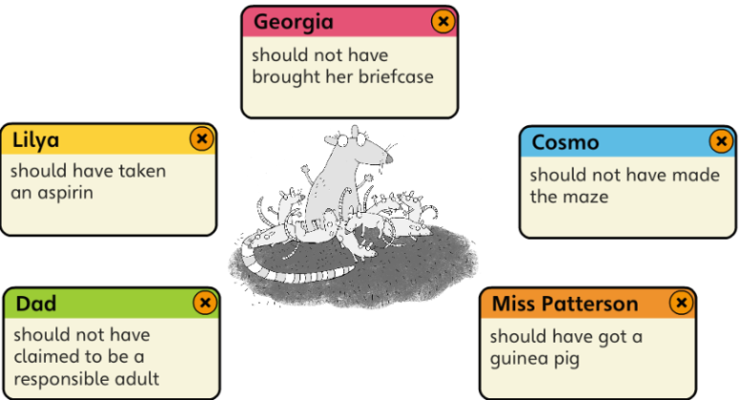  Look at the statements above, this is what Penny thinks of each person.  Whose fault do you think it is that Rooney was lost?  Have a think and maybe discuss it with someone in your house and explain why? | Challenge:  Can you summarize the story so far?  You can use the statements below to put them in order.  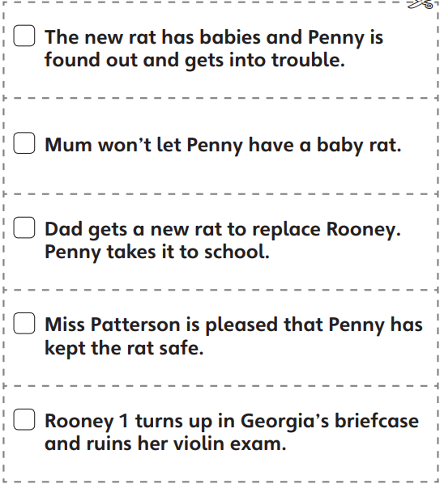
Thursday | Comprehension lesson on BBC Bitesize! Read or listen to the story and complete the activities:  https://www.bbc.co.uk/bitesize/articles/zfmtpg8
Friday | Big Write:  If you could choose where your class goes on a trip, where would you go and what would your class do there?  - Make sure you are writing in full sentences.  - Don’t forget your capital letters, finger spaces and full stops.  - Maybe you could do some research online of where you want our class to go and use that information in your writing. For example: if you wanted to go to the zoo, you could talk about wanting to feed the penguins and be a mini zoo-keeper for the day.  - Remember to talk about your feelings. | Challenge:  Use 5 common exception words in your big write.

