Home Learning for Year 2
Below is the expected home learning weekly timetable for your child. Please check the year group page for additional resources/website links. If you have any questions please contact the class teacher on ‘Class Dojo’.
Week commencing: Monday 8th June
St Ignatius Home Learning Weekly Timetable
Allocated time | Resource/Activity | Access
Daily Reading- 30 mins | Individual reading books  Read the eBook ‘Carrot Club’. | https://www.twinkl.co.uk/resource/t-or-150-carrot-club-ebook
Daily Spelling/Phonics | Practise spelling these 10 common exception words:  Certain  Circle  Complete  Consider  Continue  Decide  Describe  Different  Difficult  Disappear  You can revise these spelling words in the Sumdog challenge games. | Practise writing these words and then use the correct spelling of the word in a sentence. For example: The busy teacher rode a bicycle quickly to school.  Your login details are in your homework books. Please contact us on Dojo message if you are finding it difficult to log in.  https://www.sumdog.com/user/sign_in
Daily Times Tables | Continue to learn the 2, 5 and 10 multiplication tables. Write them down for example, 1 x 2 = 2. Then ask someone to test you on them out of order. | Try this topmarks games. Select Level 2 then you can choose the times table you want to work on:  https://www.topmarks.co.uk/maths-games/daily10
Daily Sumdog- 30 mins | - Third of a whole  - Fractions of a shape and fractions on a number line  Challenges have been set up on Sumdog.  Maths - Problem of the Week | https://www.sumdog.com/user/sign_in  Username and password included in home learning pack  See Maths challenge on the year group page.
Twice Weekly Grammar | Let’s practice our conjunctions again. This is very important to use well in our writing. | https://www.bbc.co.uk/bitesize/articles/z6rvbdm  Active Learn my stuff Wordsmith conjunctions
Maths- Daily | White Rose- Maths  Test Base is a website with lots of games for children to try. The links opposite take you to questions about fractions, our focus this week. | https://whiterosemaths.com/homelearning/  See next page for more details!  https://uk.ixl.com/math/year-2/halves-thirds-and-quarters  https://uk.ixl.com/math/year-2/simple-fractions-what-fraction-does-the-shape-show
English- Daily | We are looking at a new story called Beegu. You might already have heard of it.  You will be able to access the story on a Powerpoint on our year 2 page under ‘week 9 – additional resources’ | See daily lesson below!  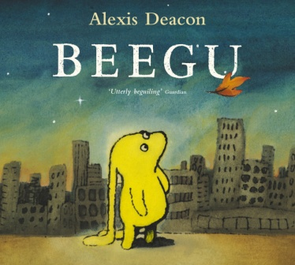
Topic | We are starting a new topic for this summer half term. It is called ‘At the seaside’ that’s right, we are going to learn all about our seaside and the beach!  For this week let’s have a look at what we could find at our sea side  Have you been to the seaside before?  What did you see?  What did you play with?  What did you eat?  What did you wear?  Task:  Draw a picture of a seaside and label the different things you could find at the sea side. | Watch this video of Brighton sea side in England.  https://www.youtube.com/watch?v=0KVqu-rUTyI  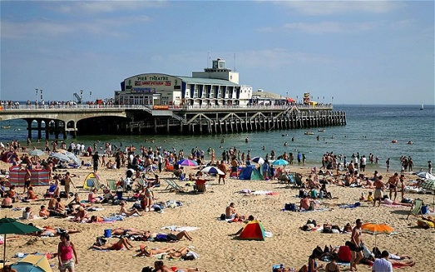  Read the Powerpoint ‘at the seaside’ for more information on what you could find at the seaside.  This will be under additional resources on our year 2 page.

Maths Lessons- Monday-Friday
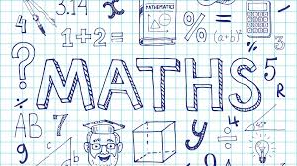
Please click on the links below that will take you straight to the activities on White Rose Home Learning. For each lesson there is a
- Video
- Activity
- Answer Sheet

HOW TO USE THE LESSONS

Just follow these four easy steps…
- Click on the set of lessons for your child’s year group.
- Watch the video (either on your own or with your child).
- Find a calm space where your child can work for about 20-30 minutes.
- Use the video guidance to support your child as they work through a lesson.

JOIN IN THE DAILY MATHS!
Lesson 1 (Monday) – 8.6.20  Unit fractions  Video  https://resources.whiterosemaths.com/resources/year-2/  Challenge- See Problem of the Week | Activity Link  See School website Year 2 Home Learning page Week 9.  https://stignatiuscatholicprimary.co.uk/key-information/online-learning/year-2-home-learning | Answers  See School website Year 2 Home Learning page Week 9.  https://stignatiuscatholicprimary.co.uk/key-information/online-learning/year-2-home-learning
Lesson 2 (Tuesday)- 9.6.20  Non-unit fractions  Video  https://resources.whiterosemaths.com/resources/year-2/  Challenge- See Problem of the Week | Activity Link  See School website Year 2 Home Learning page Week 9.  https://stignatiuscatholicprimary.co.uk/key-information/online-learning/year-2-home-learning | Answers  See School website Year 2 Home Learning page Week 9.  https://stignatiuscatholicprimary.co.uk/key-information/online-learning/year-2-home-learning
Lesson 3 (Wednesday)- 10.6.20  Finding a half  Video  https://resources.whiterosemaths.com/resources/year-2/  Challenge- See Problem of the Week | Activity Link  See School website Year 2 Home Learning page Week 9.  https://stignatiuscatholicprimary.co.uk/key-information/online-learning/year-2-home-learning | Answers  See School website Year 2 Home Learning page Week 9.  https://stignatiuscatholicprimary.co.uk/key-information/online-learning/year-2-home-learning
Lesson 4 (Thursday) – 11.6.20  Finding a quarter  Video  https://resources.whiterosemaths.com/resources/year-2/  Challenge- See Problem of the Week | Activity Link  See School website Year 2 Home Learning page Week 9.  https://stignatiuscatholicprimary.co.uk/key-information/online-learning/year-2-home-learning | Answers  See School website Year 2 Home Learning page Week 9.  https://stignatiuscatholicprimary.co.uk/key-information/online-learning/year-2-home-learning
Lesson 5 (Friday) – 12.6.20  Challenge  https://whiterosemaths.com/homelearning/year-2/  Challenge- See Problem of the Week | Activity Link | Answers

English Lessons- Monday- Friday
Monday | We are starting the story Beegu!  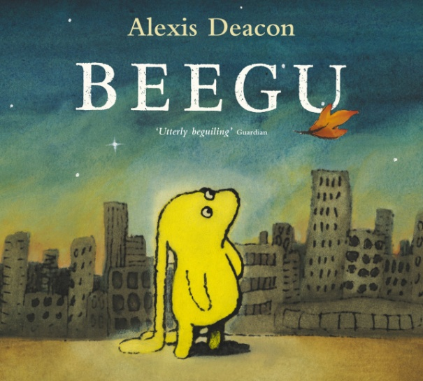  Let’s make some predictions:  - What kind of character do you think Beegu will be?  - What do you like about the picture?  - What kind of creature is she?  - Is there something you find confusing about this cover?  - What kind of story do you think this will be? | Challenge:  Have a think about the picture of Beegu:  Why has the writer chosen a picture of Beegu looking lonely and sad?
Tuesday | Read the story Beegu – find this under ‘week 9 - additional resources’  https://stignatiuscatholicprimary.co.uk/key-information/online-learning/year-2-home-learning  Were your predictions correct?  Let’s do some hot seating:  First write some questions you would like to ask Beegu (remember to ask open-ended questions) then you can pretend to be Beegu – use your alien voice.  Ask an adult or sibling in your house to ask you the questions you have written down and you can answer them as Beegu! | Challenge:  Write some questions you think Beegu might ask you about our planet. For example:  How do you get your food?
Wednesday | Let’s have a look at different scenes from the story and write about how you think Beegu is feeling and thinking. Write in full sentences.  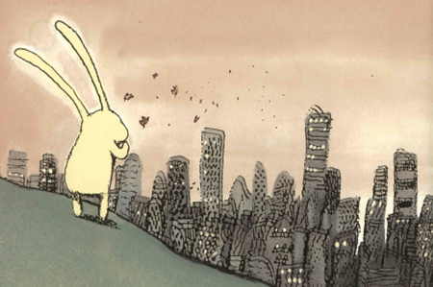  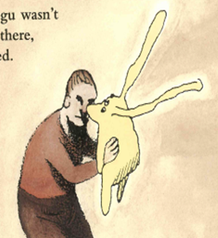  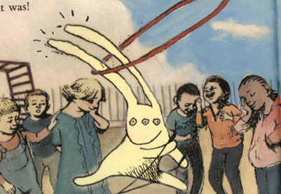  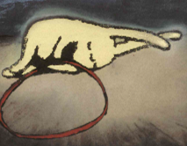  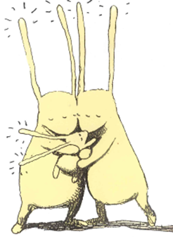 | Challenge:  Try and use wow words to describe how Beegu might be feeling such as disappointed, excited, lonely etc.
Thursday | You will be looking at a short story called Cake and there are some short activities for you. Follow the link for the story and the activities:  https://www.bbc.co.uk/bitesize/articles/zhqr47h
Friday | Big Write:  Last week we saw SpaceX launch to the International Space Station. Imagine you are one of the astronauts. Write the story from his view.  - How are you feeling?  - What would you see?  - What does space look like? (describe it using adjectives and extended noun phrases)  - Who are you with?  Write it as a story...start with the beginning, middle and end. | Challenge:  Use 5 common exception words in your big write.

