Home Learning for Year 2
Below is the expected home learning weekly timetable for your child. Please check the year group page for additional resources/website links. If you have any questions please contact the class teacher on ‘Class Dojo’.
Week commencing: Monday 22nd June
St Ignatius Home Learning Weekly Timetable
Allocated time | Resource/Activity |  | Access
Daily Reading- 30 mins | Individual reading books  Read ‘Pete’s Peculiar Pet shop: I want a Unicorn’ story |  | Access the story on active learn.  ActiveLearn my stuff wordsmith Pete’s Peculiar Pet Shop: I want a Unicorn
Daily Spelling/Phonics | Practice these common exception words. If you feel like you can spell and use the year 2 words then you can move on to year 3 words. |  | Practise writing these words and then use the correct spelling of the word in a sentence. For example: The busy teacher rode a bicycle quickly to school.  You can revise these spelling words in the Sumdog spelling challenge games.  Your login details are in your homework books. Please contact us on Dojo message if you are finding it difficult to log in.  https://www.sumdog.com/user/sign_in
 | Year 2 common exception words:  Door  Floor  Poor  Because  Find  Kind  Mind  Behind  Child  children | Year 3/4 common exception words:  Favourite  February  Forward  Fruit  Grammar  Group  Guard  Guide  Heard  heart
Daily Times Tables | Continue to learn the 2, 5 and 10 multiplication tables. Write them down for example, 1 x 2 = 2. Then ask someone to test you on them out of order. |  | Try this topmarks games. Select multiplication then you can choose the times table you want to work on:  https://www.topmarks.co.uk/maths-games/mental-maths-train
Daily Sumdog- 30 mins | - Analysing graphs to 10  - Interpret and compare charts and tables  Challenges have been set up on Sumdog.  Maths – Problem of the Week |  | https://www.sumdog.com/user/sign_in  Username and password included in home learning pack  See Maths challenge on the year group page.
Twice Weekly Grammar | Let’s practice our conjunctions!! |  | https://www.bbc.co.uk/bitesize/articles/zjdxhbk  Watch the videos and complete the 3 different activities to practice. Can you use these conjunctions in your writing during this week?
Maths- Daily | White Rose- Maths  - Length (cm)  - Compare mass |  | See next page on daily maths lessons on White Rose page:  https://whiterosemaths.com/homelearning/year-2/
English- Daily | We are starting a new story called ‘The Panda Problem’.  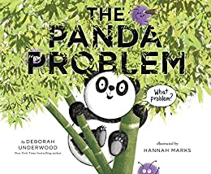 |  | See daily lesson below!
Topic | We are going to look at rubbish on our British beaches. Lots of people visit our beaches during a hot day and have picnics to eat and drink all day. Sometimes, people leave their rubbish on the beach without throwing it all in the bin. That rubbish is then blown into the water by the wind and our oceans end up with lots of rubbish. This is very dangerous for the animals that live in that water.  Click on the link to read about the issues and watch the videos:  https://www.bbc.co.uk/newsround/47979998 |  | Watch this video to understand how it could affect animals:  https://www.youtube.com/watch?v=xFPoIU5iiYQ  Task:  Create a poster to show the importance of cleaning our beaches so that our rubbish is not harmful for the animals.  Here is an example:  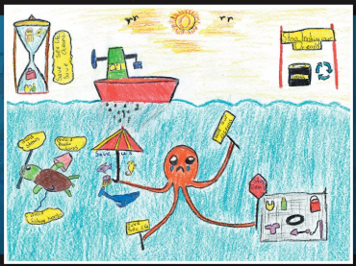  You need to add more facts and what people can do to keep beaches clean.
Maths Lessons- Monday-Friday
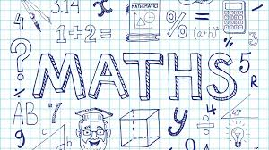
Please click on the links below that will take you straight to the activities on White Rose Home Learning. For each lesson there is a
- Video
- Activity
- Answer Sheet

HOW TO USE THE LESSONS

Just follow these four easy steps…
- Click on the set of lessons for your child’s year group.
- Watch the video (either on your own or with your child).
- Find a calm space where your child can work for about 20-30 minutes.
- Use the video guidance to support your child as they work through a lesson.

JOIN IN THE DAILY MATHS!
Monday – 22.6.20  Lesson1 – measure length (cm)  Challenge- See Problem of the Week | Find Monday’s activity sheets and answers on the school website:  https://stignatiuscatholicprimary.co.uk/key-information/online-learning/year-2-home-learning
Tuesday - 23.6.20  Lesson2 – Compare length  Challenge- See Problem of the Week | Find Tuesday’s activity sheets and answers on the school website:  https://stignatiuscatholicprimary.co.uk/key-information/online-learning/year-2-home-learning
Wednesday - 24.6.20  Lesson3 – Four operations with lengths  Challenge- See Problem of the Week | Find Wednesday’s activity sheets and answers on the school website:  https://stignatiuscatholicprimary.co.uk/key-information/online-learning/year-2-home-learning
Thursday – 25.6.20  Lesson4 – Compare mass  Challenge- See Problem of the Week | Find Thursday’s activity sheets and answers on the school website:  https://stignatiuscatholicprimary.co.uk/key-information/online-learning/year-2-home-learning
Friday – 26.6.20  BBC Bitesize challenges | Follow the link for Friday challenges:  https://www.bbc.co.uk/bitesize/articles/z8ppqfr

English Lessons- Monday- Friday
Monday | We are reading a new story called ‘The Panda Problem’.  Let’s have a look at the cover and think about these questions:  - Who do you think is the main character?  - What do you think the problem will be?  - What do you like about the picture?  - What kind of story do you think this will be?  You task:  Do some research online to find facts about Panda’s and create a fact file which can include a picture of a panda and some facts about them.  Here is a good website:  https://www.natgeokids.com/uk/discover/animals/general-animals/ten-panda-facts/  A video about pandas:  https://www.youtube.com/watch?v=d6YeB3mRFyk | Challenge:  Can you think of why the habitats that the pandas live in suits them. Write down some ideas.
Tuesday | ‘The Panda Problem’ will be posted on our class story for you to listen to and enjoy! Were your predictions correct?  Think about the story and the facts you found about pandas yesterday. What in the story is based on facts (real) and what is not real and made up. You can create a table:  Real Not real  - Pandas live on trees - Pandas can’t talk | Challenge:  Use your facts to explain why the made-up bits in the story are not real.  For example:  Animals don’t talk – that’s a fact.
Wednesday | The problems that the panda presented to the narrator were ridiculous problems such as:  - Burping panda  - Jelly bean rain  - Aliens  - Pandas in Antarctica  Your task is to introduce your own ridiculous problems that the panda could say.  For example: ‘I have a problem! What if I was eating bamboo and then suddenly, a massive group of pink flies came and started eating my bamboo food’  Think of a few! | Challenge:  Write your quote (what the panda says) in a speech bubble and include extended noun phrases to describe.
Thursday | Practice verbs and use those in your diary writing:  https://www.bbc.co.uk/bitesize/articles/zvr6pg8
Friday | Big write:  Last week 2A adopted a giant panda and 2W has already adopted an orangutan.  Create a poster to explain and persuade why people should adopt the animal your class has adopted.  You need to:  - Explain why pandas or orangutans are going extinct and need to be saved (you could do some online research)  - Make your poster very colourful and catchy  - Draw pictures of your animal  - Write some facts about them  Here are some things that you could use:  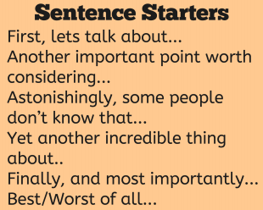 | Challenge:  Use 5 common exception words in your big write.

