Home Learning for Year 2
Below is the expected home learning weekly timetable for your child. Please check the year group page for additional resources/website links. If you have any questions please contact the class teacher on ‘Class Dojo’.
Week commencing: Monday 29th June
St Ignatius Home Learning Weekly Timetable
Allocated time | Resource/Activity |  | Access
Daily Reading- 30 mins | Individual reading books  Read ‘City Kids Detective Agency’ story |  | Access the story on Activelearn.  Activelearn my stuff wordsmith City Kids Detective Agency
Daily Spelling/Phonics | Practice these common exception words. If you feel like you can spell and use the year 2 words in your writing then you can move on to year 3 words. |  | Practise writing these words and then use the correct spelling of the word in a sentence. For example: The busy teacher rode a bicycle quickly to school.  You can revise these spelling words in the Sumdog spelling challenge games.  Your login details are in your homework books. Please contact us on Dojo message if you are finding it difficult to log in.  https://www.sumdog.com/user/sign_in
 | Year 2 common exception words:  Wild  Climb  Most  Only  Both  Old  Cold  Gold  Hold  Told | Year 3/4 common exception words:  Height  History  Imagine  Increase  Important  Interest  Island  Knowledge  Learn  length
Daily Times Tables | Continue to learn the 2, 5 and 10 multiplication tables. Write them down for example, 1 x 2 = 2. Then ask someone to test you on them out of order. |  | Try this topmarks games. Select multiplication then you can choose the times table you want to work on:  https://www.topmarks.co.uk/maths-games/mental-maths-train
Daily Sumdog- 30 mins | - Counting coins (10s and 1s)  - Add 3 numbers within 20  Challenges have been set up on Sumdog.  Maths – Problem of the Week |  | https://www.sumdog.com/user/sign_in  Username and password included in home learning pack  See Maths challenge on the year group page.
Twice Weekly Grammar | Let’s practice our contractions!! |  | https://www.bbc.co.uk/bitesize/articles/zjwcsk7  Watch the videos and complete the 3 different activities to practice. Can you use contractions in your writing during this week?
Maths- Daily | White Rose- Maths  - Measure mass in grams and kilogram  - Compare volume  - milliliters |  | See next page on daily maths lessons on White Rose page:  https://whiterosemaths.com/homelearning/year-2/
English- Daily | We are starting a non-fiction e-book on Active Learn called:  ‘There’s No Place Like Home’ |  | See daily lesson below!  Access the e-book on Activelearn  Activelearn my stuff Wordsmith There’s no place like home  Remember the e-book is interactive so make sure you click on all the paws and videos for more information.
Topic | We are learning about how seaside holidays were different a very long time ago compared to how they are now.  Have a think about what you think was different a long time ago?  Watch the youtube video on how the seaside holidays have changed.  Read the Powerpoint presentation to learn more.  Task - You could either:  Write about the differences and similarities of what seaside holidays are like now and then.  Or  Draw a picture of what seaside holidays are now and then. |  | Watch this video to learn more about the difference:  https://www.youtube.com/watch?v=1N6peInd_pI  Access the Presentation on our website under ‘Week 11 additional resources Seaside holidays now and then’:  https://stignatiuscatholicprimary.co.uk/key-information/online-learning/year-2-home-learning
Maths Lessons- Monday-Friday
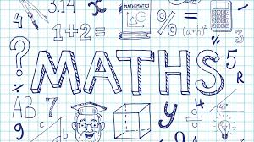
Please click on the links below that will take you straight to the activities on White Rose Home Learning. For each lesson there is a
- Video
- Activity
- Answer Sheet

HOW TO USE THE LESSONS

Just follow these four easy steps…
- Click on the set of lessons for your child’s year group.
- Watch the video (either on your own or with your child).
- Find a calm space where your child can work for about 20-30 minutes.
- Use the video guidance to support your child as they work through a lesson.

JOIN IN THE DAILY MATHS!
Monday – 29.6.20  Lesson1 – Measure mass in grams  Challenge- See Problem of the Week | Find Monday’s activity sheets and answers on the school website:  https://stignatiuscatholicprimary.co.uk/key-information/online-learning/year-2-home-learning
Tuesday - 30.6.20  Lesson2 – Measure mass in kilogram  Challenge- See Problem of the Week | Find Tuesday’s activity sheets and answers on the school website:  https://stignatiuscatholicprimary.co.uk/key-information/online-learning/year-2-home-learning
Wednesday – 1.7.20  Lesson3 – Compare volume  Challenge- See Problem of the Week | Find Wednesday’s activity sheets and answers on the school website:  https://stignatiuscatholicprimary.co.uk/key-information/online-learning/year-2-home-learning
Thursday – 2.7.20  Lesson4 – Millilitres  Challenge- See Problem of the Week | Find Thursday’s activity sheets and answers on the school website:  https://stignatiuscatholicprimary.co.uk/key-information/online-learning/year-2-home-learning
Friday – 3.7.20  BBC Bitesize challenges | Follow the link for Friday challenges:  https://www.bbc.co.uk/bitesize/articles/z8ppqfr

English Lessons- Monday- Friday
Monday | We are looking at a new non-fiction e-book called ‘There’s No Place Like Home’.  Find the e-book on Activelearn (don’t read it yet)  Have a look at screen 1 and 2.  What kind of places do you think we might be finding out about?  Look for clues in the contents page list.  These places are unusual, which means that you don’t see this a lot.  Task:  Write about what might be different about living in a cold place, space, an island or at the sea.  Then read the e-book when you have finished to see if you were right! | Challenge:  Think about some of the difficulties of living in some of those places. How would you describe the experience?
Tuesday | Re-read the e-book and write down words you are not sure about.  For example:  Scientists – people who study and learn about nature  engineer  machinery  vehicles  gravity  Have a look for more. Go to screen 9 to find the glossary. The glossary is where you find the definition of some of the words. Write the definition of each word next to your words. If you can’t find your word there, have a look at a dictionary. You can access dictionaries online, ask an adult to help you. | Challenge:  Choose a few of these words and create your own sentences.  For example:  Scientists are working hard to find a vaccine for Covid-19.
Wednesday | Go to screen 4 and re-read ‘All at sea’  We are going to be asking Robert some questions about his job. Remember the 5 W’s:  Who? What? Where? When? Why?  Practice asking a family member who works some questions about their job. For example: When did you start your job?  Task:  Have a look at some of the daily activities that Robert does (below). Think about an open question that you could ask about each daily activity.  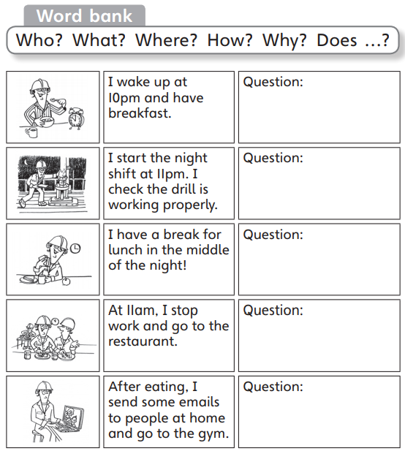 | Challenge:  Try and answer the questions you have asked as Robert. What do you think he would answer to your questions?
Thursday | We are going to practice how to correct errors. This is an important skill to have for when we are checking our work. It is important to recognise any spelling mistakes or incorrect sentence structure. This will improve our writing greatly.  Follow the link to learn and complete the activities:  https://www.bbc.co.uk/bitesize/articles/z799ydm | Challenge:  Can you have a look at previous writing tasks you have done and look for errors in your writing? You can improve it using a coloured pencil/pen.
Friday | Bitesize Daily Book Club:  Enjoy some reading and some fun activities for a Friday  https://www.bbc.co.uk/bitesize/articles/z8q83j6

