Home Learning for Year 2
Below is the expected home learning weekly timetable for your child. Please check the year group page for additional resources/website links. If you have any questions please contact the class teacher on ‘Class Dojo’.
Week commencing: Monday 6th July
St Ignatius Home Learning Weekly Timetable
Allocated time | Resource/Activity |  | Access
Daily Reading- 30 mins | Individual reading books  Read ‘Here is a water drop’ story  Can you spot the rhyming words? |  | Access the story on Activelearn.  Activelearn my stuff wordsmith Here is a water drop
Daily Spelling/Phonics | Practice these common exception words. If you feel like you can spell and use the year 2 words in your writing then you can move on to year 3 words. |  | Practise writing these words and then use the correct spelling of the word in a sentence. For example: The busy teacher rode a bicycle quickly to school.  You can revise these spelling words in the Sumdog spelling challenge games.  Your login details are in your homework books. Please contact us on Dojo message if you are finding it difficult to log in.  https://www.sumdog.com/user/sign_in
 | Year 2 common exception words:  Every  Great  Break  Steak  Pretty  Beautiful  After  Fast  Last  past | Year 3/4 common exception words:  Library  Material  Medicine  Mention  Minute  Natural  Naughty  Notice  Occasion  often
Daily Times Tables | Continue to learn the 2, 5 and 10 multiplication tables. Write them down for example, 1 x 2 = 2. Then ask someone to test you on them out of order. |  | Try this topmarks games. Select multiplication then you can choose the times table you want to work on:  https://www.topmarks.co.uk/maths-games/mental-maths-train
Daily Sumdog- 30 mins | - Add three numbers within 20 – word problems  - Identify even and off numbers within 20  Challenges have been set up on Sumdog.  Maths – Problem of the Week |  | https://www.sumdog.com/user/sign_in  Username and password included in home learning pack  See Maths challenge on the year group page.
Twice Weekly Grammar | Let’s practice our suffixes! |  | https://www.bbc.co.uk/bitesize/articles/z6vc86f  Watch the videos and complete the different activities to practice. Can you use suffixes in your writing during this week?
Maths- Daily | White Rose- Maths  - Litres  - Temperature  - O’clock and half past  - Quarter past and quarter to |  | See next page on daily maths lessons on White Rose page:  https://whiterosemaths.com/homelearning/year-2/
English- Daily | We are continuing the non-fiction e-book on Active Learn called:  ‘There’s No Place Like Home’ |  | See daily lesson below!  Access the e-book on Activelearn  Activelearn my stuff Wordsmith There’s no place like home  Remember the e-book is interactive so make sure you click on all the paws and videos for more information.
Topic | Imagine you are going to the sea side!!  What would you pack to the beach?  Make a list using bullet points of things you need to take with you to the beach:  - Sunglasses  - Sandals  - …  - …  Add as many things as you can think of.  When you have finished making your list, pack a bag and take a picture of all the things you would take with you to the sea side. We can share these with the class.

Maths Lessons- Monday-Friday
Please click on the links below that will take you straight to the activities on White Rose Home Learning. For each lesson there is a
- Video
- Activity
- Answer Sheet

HOW TO USE THE LESSONS

Just follow these four easy steps…
- Click on the set of lessons for your child’s year group.
- Watch the video (either on your own or with your child).
- Find a calm space where your child can work for about 20-30 minutes.
- Use the video guidance to support your child as they work through a lesson.

JOIN IN THE DAILY MATHS!
Monday – 29.6.20  Lesson1 – Litres  Challenge- See Problem of the Week | Find Monday’s activity sheets and answers on the school website:  https://stignatiuscatholicprimary.co.uk/key-information/online-learning/year-2-home-learning
Tuesday - 30.6.20  Lesson2 – Temperature  Challenge- See Problem of the Week | Find Tuesday’s activity sheets and answers on the school website:  https://stignatiuscatholicprimary.co.uk/key-information/online-learning/year-2-home-learning
Wednesday – 1.7.20  Lesson3 – O’clock and half past  Challenge- See Problem of the Week | Find Wednesday’s activity sheets and answers on the school website:  https://stignatiuscatholicprimary.co.uk/key-information/online-learning/year-2-home-learning
Thursday – 2.7.20  Lesson4 – Quarter past and quarter to  Challenge- See Problem of the Week | Find Thursday’s activity sheets and answers on the school website:  https://stignatiuscatholicprimary.co.uk/key-information/online-learning/year-2-home-learning
Friday – 3.7.20  BBC Bitesize challenges | Follow the link for Friday challenges:  https://www.bbc.co.uk/bitesize/articles/z8ppqfr

English Lessons- Monday- Friday
Monday | Go to screen 5 of the e-book ‘There’s no place like home’ remember to press on the paws to read all the information .  Use the glossary to help you understand what gravity means.  What do you think about living on the International Space Station?  Task:  Write some questions you would like to ask Fern.  For example:  How long do you stay at the International Space Station? | Challenge:  Read the statements. Highlight the part that gives the reason to the statement:  We have to keep the computers clean, as things like crumbs and hair can float into the buttons.  We have to exercise on special equipment for two hours a day to keep our bones and muscles strong.  We attach ourselves to the wall to sleep so we don’t float around and get hurt.
Tuesday | Read screen 7 of the e-book.  Think about how Heather’s life is compared to yours. What is different?  Can you imagine living on Fair Isle?  Task:  Complete the worksheet below in your books. Read the statements about Fair Isle and write about how different it is where you live. For example:  In Fair Isle, there aren’t very many people but in London there are thousands of different people.  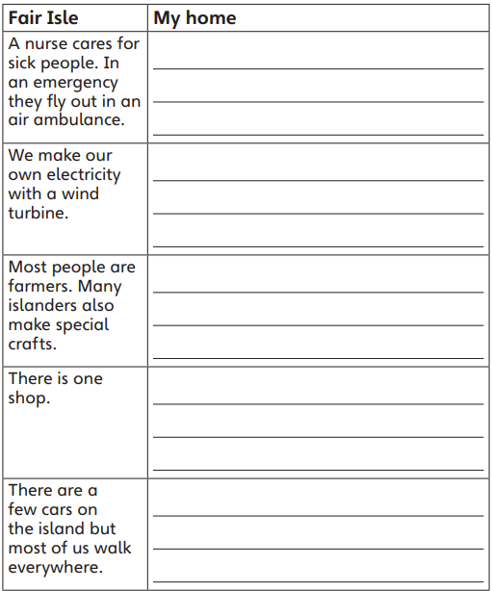 | Challenge:  Can you think of the reasons why it might be so different where we live compared to Fair Isle. Write those reasons down.
Wednesday | Choose one of the living places from ‘There’s no place like home’ and write about how different your life is compared to theirs. Think about a few different things you were able to spot.  Think about your chosen place from the e-book and write about what your favourite parts would be.  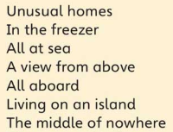 | Challenge:  Use these conjunctions in your writing:  And  But  Or
Thursday | BBC Bitesize daily book club: Cake  https://www.bbc.co.uk/bitesize/articles/zhqr47h
Friday | Watch the video of ‘A day in the life of Okello’. Okello is a young girl living in Uganda. Her life is very different to ours and she works much harder than a child would in London. We should recognise that we are very lucky.  Your task is to write a diary entry as Okello. In the diary write about what Okello did in her day shown in the video. You need to:  - Write in first person (I, my, me)  - Start with ‘Dear diary’  - Write in past tense  - Write in chronological order (first, then, next)  - Include personal emotions and feelings  https://www.youtube.com/watch?v=AqpQYeYo0zM | Challenge:  Use 5 year 2 common exception words and try to include 2 year 3/4 common exception words.  You can find the common exception words on google.

