Home Learning for Year 2
Below is the expected home learning weekly timetable for your child. Please check the year group page for additional resources/website links. If you have any questions please contact the class teacher on ‘Class Dojo’.
Week commencing: Monday 13th July
St Ignatius Home Learning Weekly Timetable
Allocated time | Resource/Activity |  | Access
Daily Reading- 30 mins | Individual reading books  Read ‘The runaway iceberg’ story |  | Access the story under ‘additional resources week 14’ on our year 2 page:  https://stignatiuscatholicprimary.co.uk/key-information/online-learning/year-2-home-learning
Daily Spelling/Phonics | Practice these common exception words. If you feel like you can spell and use the year 2 words in your writing then you can move on to year 3 words. |  | Practise writing these words and then use the correct spelling of the word in a sentence. For example: The busy teacher rode a bicycle quickly to school.
 | Year 2 common exception words:  Father  Class  Grass  Pass  Plant  Path  Bath  Hour  Move  prove | Year 3/4 common exception words:  Opposite  Ordinary  Particular  Peculiar  Perhaps  Popular  Position  Possess  Possible  Potatoes
Daily Times Tables | Continue to learn the 2, 5 and 10 multiplication tables. Write them down for example, 1 x 2 = 2. Then ask someone to test you on them out of order. |  | Try this topmarks games. Select multiplication then you can choose the times table you want to work on:  https://www.topmarks.co.uk/maths-games/mental-maths-train
Daily Sumdog- 30 mins | - Count within 100  - Compare and order numbers within 100  - Place value within 100  Challenges have been set up on Sumdog.  Maths – Problem of the Week |  | https://www.sumdog.com/user/sign_in  Username and password included in home learning pack  See Maths challenge on the year group page.
Twice Weekly Grammar | Putting words in the correct alphabetical order:  Practising spelling and writing questions: |  | https://www.bbc.co.uk/bitesize/articles/zsv6wnb  https://www.bbc.co.uk/bitesize/articles/zg2cf82
Maths- Daily | White Rose- Maths  - Telling time to 5 minutes  - Hours and days  - Find durations of time  - Compare durations of time |  | See next page on daily maths lessons on White Rose page:  https://whiterosemaths.com/homelearning/year-2/
English- Daily | This is our last week of school! I know you aren’t in school but our summer holidays are starting from next week.  I am truly upset that we cannot enjoy our last week together but we can share our memories through Dojo! |  | See daily lesson below!
Topic | Have a look at the images below:  Write about the differences and similarities of both pictures. Think about your 5 senses:  - What can you see?  - What can you hear?  - What can you smell?  - What can you taste? Think about the foods you would be eating  - What would you feel? |  | 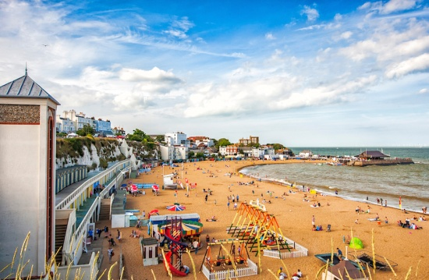

Maths Lessons- Monday-Friday
Please click on the links below that will take you straight to the activities on White Rose Home Learning. For each lesson there is a
- Video
- Activity
- Answer Sheet

HOW TO USE THE LESSONS

Just follow these four easy steps…
- Click on the set of lessons for your child’s year group.
- Watch the video (either on your own or with your child).
- Find a calm space where your child can work for about 20-30 minutes.
- Use the video guidance to support your child as they work through a lesson.

JOIN IN THE DAILY MATHS!
Monday – 13.7.20  Lesson1 – Telling time to 5 minutes  Challenge- See Problem of the Week | Find Monday’s activity sheets and answers on the school website:  https://stignatiuscatholicprimary.co.uk/key-information/online-learning/year-2-home-learning
Tuesday – 14.7.20  Lesson2 – Hours and days  Challenge- See Problem of the Week | Find Tuesday’s activity sheets and answers on the school website:  https://stignatiuscatholicprimary.co.uk/key-information/online-learning/year-2-home-learning
Wednesday – 15.7.20  Lesson3 – Find durations of time  Challenge- See Problem of the Week | Find Wednesday’s activity sheets and answers on the school website:  https://stignatiuscatholicprimary.co.uk/key-information/online-learning/year-2-home-learning
Thursday – 16.7.20  Lesson4 – Compare durations of time  Challenge- See Problem of the Week | Find Thursday’s activity sheets and answers on the school website:  https://stignatiuscatholicprimary.co.uk/key-information/online-learning/year-2-home-learning
Friday – 17.7.20  BBC Bitesize challenges | Follow the link for Friday challenges:  https://www.bbc.co.uk/bitesize/articles/z8ppqfr
English Lessons- Monday- Friday
Monday | Think about your favourite part of your classroom. Draw it and write about why it is your favourite.  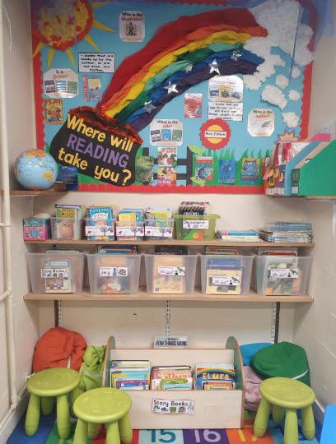
Tuesday | Write about your favourite memory of this year in year 2. It could be an activity we did altogether, a trip, a favourite lesson, a favourite experiment. You can also draw a lovely picture.  Write about:  - Who you were with  - Where you were  - What was the activity  - Why did we do the activity  - Why did you enjoy it so much
Wednesday | Complete your A to Z of the year! Write something you have learnt for each letter of the alphabet. Think about all our topics that we learnt about throughout the year. For example:  A – adverbs  See picture below:  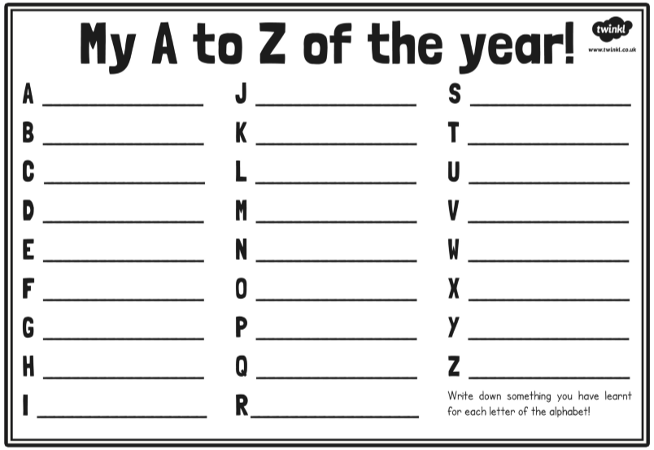
Thursday | What are you looking forward to in September when you come back? Make a list about what you are excited about. You can use bullet points. For example:  - I am very excited to go to Anne Line building.  - I can’t wait to meet my new teacher.  When you finish, write an ‘about me’ for your new teacher. You could use this format:  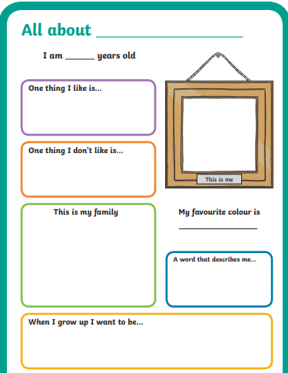
Friday | We haven’t been able to say goodbye in our class. So I will be writing a letter to you all to say thank you and wishing you all the best in year 3!  Your task is to write a thank you letter to your teacher. You can choose to write anything you like. You can use the template:  