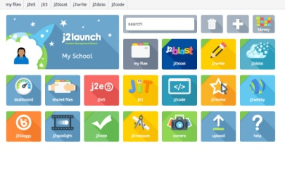

Friday 16th October 2020
Dear Parents and Carers,

Your child now has access to J2E, a whole world of fun and exciting opportunities in one safe place.

What is J2E?
J2E is a comprehensive suite of online learning tools and content, designed to be used by Primary aged children in the classroom and at home. It is an online digital platform created by LGFL (London Grid for Learning).

Why are we using it?
The expectation now is that schools provide remote learning for children in the event of further lockdowns or in situations where children/bubbles are self isolating.
All schools are moving to ensure that children have access to remote learning websites and digital platforms; it seems to be the way forward in this current climate.
At St Ignatius we are looking at a blended learning approach and J2E provides us with a great deal more functions and online tools for the children to use to continue their learning at home if needed.
We would still like to continue with some hard copy, paper homework being sent home if possible, but we need to ensure we have the ability to provide online support at well.

J2E also has great additional functions for uploading work and feeding back to the children, which is key for them to make progress.
Teachers can send audio and written feedback directly on the work so the children can see exactly what they need to do to improve. Teachers will trial this next week.
This week the teachers have posted one piece of homework so that the children can have a go at accessing it through J2E. The children have been shown how to find the work in their shared files in class. The children can then complete and edit their work and the teacher will then be able to see what each child has done. They will feedback next week on J2E.

Please familiarise yourself with J2E and have a go at accessing the homework this week. Details on how to log in are on the next page. Please let teachers know through Class Dojo if you are experiencing any problems. The children should come home with their log in details.

Thank you for your continued support,

Step 1) Log into www.J2E.com

Step 2) Click on LGFL

Step 3) Click on Normal USO Login

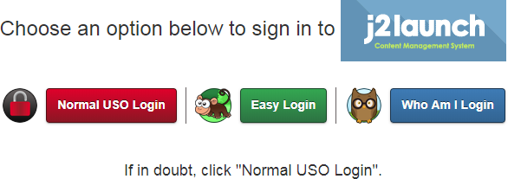

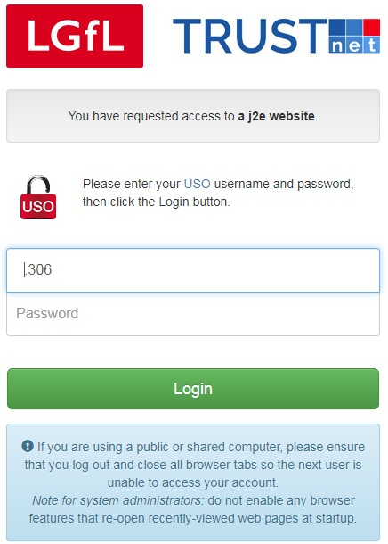Step 4:
Type your LGFL USO with .309 and your
password. These were given to children. Any questions, Please contact the class teacher on Class Dojo

Step 5:
You will now be on the ‘Launch Pad’. You will also see all of the tiles that the children will learn to access in time.
- Go to the tile which says ‘shared files’ or ‘Homework feature’
- Click on your class file- e.g 6D Rhinos
- Look at the work set in the folder- complete the work by Tuesday 20th Oct
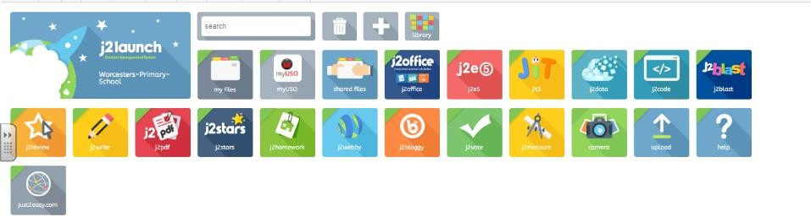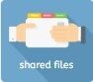Well done!

Clix

