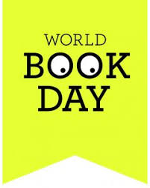
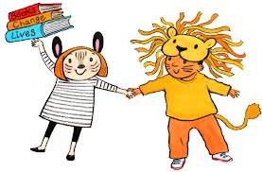

St Ignatius Catholic Primary School
Tuesday 21st February 2023
Dear Parents/Carers,
This year World Book Day is being celebrated on Tuesday 7th March 2023.
Reading is something we really value at St Ignatius and we understand the importance of children getting enjoyment from their reading.
This year World Book Day’s theme is ‘Making it your World Book Day’
We are giving our children the choice this year as to whether they want to either:
- dress up as their favourite well known book character or
- dress in their favourite pyjamas, dressing gowns/ slippers and pretend it is night-time!
Whatever they choose, as the weather is cold still, they may want to come to school in their own clothes and change when they get here. If they choose pyjamas, they can also wear legging/ tights / tops under their pyjamas or even just jogging bottoms / sweatshirt, if they do not have or want to wear their pyjamas.
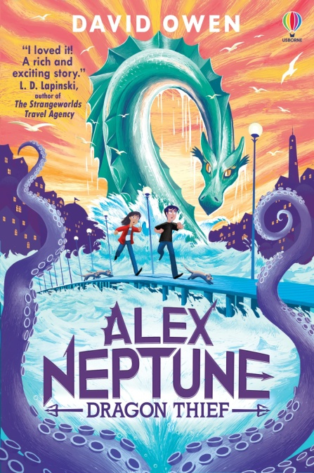
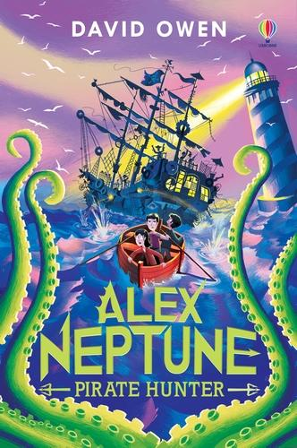
Years 3 to 6 Author Visit on Thursday 9th March: David Owen
Local children’s author, David Owen, will be visiting the school and running workshops with years 3-6. As a small token to the author for his visit, we would like to encourage you to buy his books by following the link below. These are lovely stories that your child will enjoy reading at home should you choose to purchase them. The money will go towards the author’s visit. Pupils will also be able to get their books signed by the author if they purchase one. We will also be accepting the exact amount of £8.00 in cash should you prefer to pay this way on the day: https://www.pickledpepperbooks.co.uk/collections/st-ignatius-author-events

The Children will receive their £1 book tokens on World Book Day that they can spend in local book stores. At home you can encourage your child further by visiting the website www.worldbookday.com and getting involved with the many activities online.

You can join us in building your child’s enthusiasm for books well beyond World Book Day by reading together regularly and joining your local library. Remember – you can read to your child in your home language as well as English – Reading is reading in every language!

The expectation at St Ignatius is that children read at least 5 times per week at home and this should be evidenced in their reading record. A great reader then becomes a great writer! Sharing stories together for just ten minutes a day will encourage a love of reading and it’s fun for everyone. We would also like to encourage parent to come along to the Parent Reading Morning, which is on Wednesday 8th March this half term. Thank you for your support!
Ms Demetriou

