 | Autumn 1 |  | Autumn 2 | Spring 1 | Spring 2 | Summer 1 | 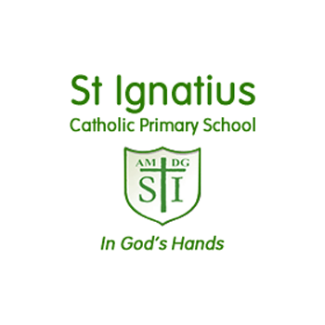  Summer 2
EYFS/  Rec | 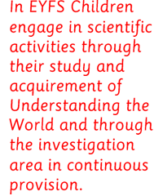 | Food Glorious Food  Healthy food – sorting and classifying.  Oral health (related Vocabulary  Milk teeth, cavities) | Brilliant Bodies /  Autumn / Christmas  Seasons – discussions and observations.  Life cycles – Human  Human Body – body parts/skeleton Healthy habits (teeth) | The World and Beyond /  Winter  Seasons – discussions and observations.  Space – Name planets in the solar system  Planet Earth | Heroes and Villains / Spring  Seasons - changes from Autumn to Spring.  Growing Plants/Investigation – what happens with no light/water  Parts of a plant | On the Move  Shadows  Materials – properties of different materials.  Materials – best materials to make a pirate ship,  Investigating floating and sinking – sorting items that sink or float. | Minibeasts /  Summer  Animals – making a bug hotel.  Classifying/researching minibeasts.  Seasons – changes from Spring to Summer.  Habitats – Minibeasts  Life cycles – butterflies caterpillars.
 | Continuous  provision | Recycling  Changing states of matter (water to ice)  Floating and sinking  Living things and animals – ocean animals. Observations of animals under the sea and shells  Materials – uses and discussion about their properties Wool, cotton, plastic, wood.  Spiders  Planting/observation/growth  Animals – herbivores, carnivores, omnivores  Plants – soil and compost  Planting bulbs
Yr 1 | Seasonal Changes |  | Animals including Humans - About Me | Exploring everyday Materials 1 | Exploring everyday Materials 2 | Plants | Animals including Humans – All about animals
Yr 2 | Animals including Humans – Life cycles |  | Everyday Materials | Animals including Humans - Growth | Living Things and their Habitats | Living Things and their Habitats-Habitats around the world | Plants – Growth and Care
Yr 3 | Animals including Humans |  | Forces and Magnets | Rocks | Light | Plants | Scientific enquiry
Yr 4 | Animals including Humans |  | Living Things and their Habitats | States of matter | Sound | Electricity | Explore life cycles
Yr 5 | Properties of Materials |  | Changes of Materials | Animals including humans | Earth and Space | Living things and their habitats | Forces
Yr 6 | Animals including Humans – Blood and Transportation |  | Electricity | Animals including Humans – The Heart and Health | Evolution and  Inheritance | Living Things and their Habitats | Looking after our environment
Long Term Science Plan

