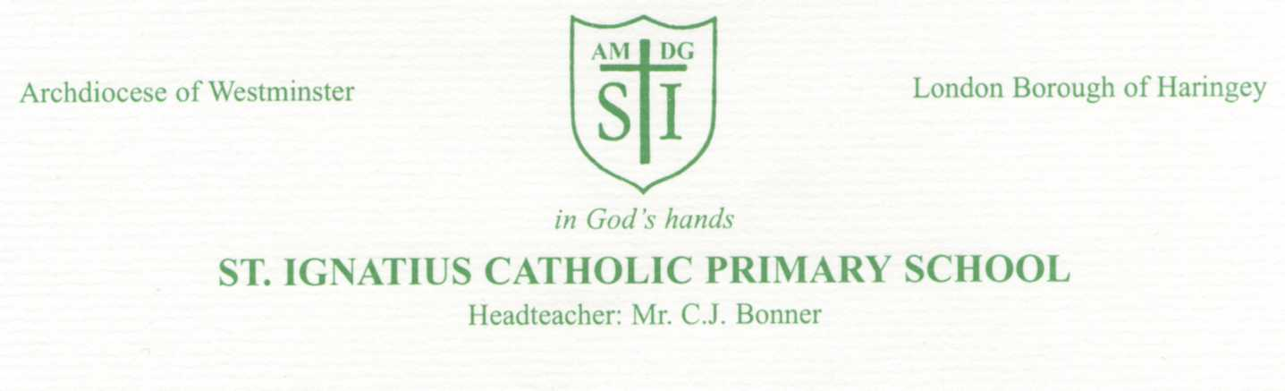Monday 13th December 2021
Dear Parents / Carers of Y5/Y6 pupils
Re : Concern with regards to pupil use of WhatsApp
It has been brought to our attention that some of our pupils have been using social media in an inappropriate and concerning way. Please note: These activities have taken place outside of school and school hours. Many of our older pupils use WhatsApp to chat outside of school and are part of a WhatsApp group or groups. I would like to remind you that WhatsApp has a minimum age policy of 13. If your child is using WhatsApp please do remind them of the importance of conducting themselves appropriately and not using bad language on the app.
Some of the messages that have been written have been upsetting for pupils receiving them and have consequently, impacted on relationships within the classroom and playground.
As SATs are approaching for Year 6 we feel it very important and serious enough to bring to your attention so that the main focus is on preparing for these tests at the end of the year.
Most social networks have a minimum age policy of 13. This age has been set for good reasons. We understand your desire, as is ours, for your children to be independent as they get older. However, you do not need to be reminded that your children are only 10 or 11 years old and, as their parent / carer, it is your responsibility and obligation to safeguard them against accessing any material, outside of school, that is considered to be potentially harmful to their development.
It is also your responsibility to ensure that what they write and say on social media is appropriate and does not offend anyone else in any way. We ask that you monitor your child’s activity on their phones/ devices very closely.
We have spoken with all of the children today and have emphasised the serious nature of this issue. They need to be aware that anything they write or say can become permanent evidence that can affect their reputation well in to their future lives. They also need to be aware that the age of criminal responsibility in England is 10 years old.
As part of our Internet Safety Policy, as a school, we strive to ensure our pupils’ internet access is monitored and safe. We ask that you have a conversation with your child about their internet use. Find out how they use it and if they are worried about anything that they are sent, or that they have sent to another person. We are aware that many of you will be safeguarding your child’s access to the internet through applying parental controls to their devices, etc. However, if this is not the case, please ensure you attend to this issue, as a matter of great importance. We appreciate your support in this matter.
Yours sincerely,
Miss Taylor

