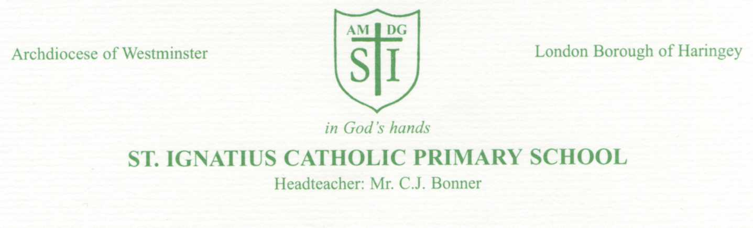

15th May 2020

Dear Parents and Carers,

Re: Possible re-opening of school to more pupils in June 2020.

We know you will have seen in the news that schools may reopen on 1 June, subject to government feeling it is safe to do so, for Nursery, Reception, Year 1 and Year 6 pupils.
We would like to reassure you that we will be doing everything in our power to protect your child’s health and wellbeing when we are asked to re-open our school, in whatever form that may be. Our first priority is the safety of the children.
As there is no vaccine or medicine that is effective against COVID-19, we have all spent the last few weeks following ‘social distancing’advice, as a way of protecting our families from this life-threatening virus.
In reality, it will not be possible to maintain social distancing in our school environment.

Whilst we do not yet have the government’s detailed plans on school re-openings, we completely appreciate that many of us will be feeling anxious about our children returning to school during this period.
It is not compulsory that your children return and, as a school, we will completely respect your decision if you decide that your child will be safer at home. There will be no fines or penalties for any absences your child may have during this time. Our staff will do everything they can to make sure that all the children get the help they need to fill in any gaps when we eventually all return.
In the meantime, our children at home have the support they need from their teachers, primarily through our Online Home Learning page on the school website and our Class Dojo system.

If we do open our school, it will be organised in a very different way than the children are used to and familiar with.
Some of the differences include the following:

- Children may not be taught by their class teacher
- Children will be in groups or “social bubbles” and will not meet or interact with other groups
- Children will not access the same range of resources to prevent cross contamination
- Children will need to sit in the same desk and use the same equipment through the day
- Staff may have to wear PPE
- Playtimes will be in small groups with limited interaction
- Movement around the school site will be severely limited
- Siblings in other year groups will not be attending school

Today, we will send you a link to a short parent survey: we ask that you return this to us as soon as possible; the latest Monday 18th May 2020.
We would like as great a response as possible so that we may gain a greater understanding of your views in these difficult times and also, this will help us to plan and guide our subsequent decisions.
A survey for children in other year groups will be sent out at a later date.

I want to reassure you that we are not going to be putting any pressure on anyone to send their children to school. We will keep you updated with all our preparations for making sure the school is as safe as possible, so you can make an informed decision.
If your child remains at home beyond 1 June, because this is the best decision for your family, or because your child does not fall into one of these year groups, we will continue to support you and them with home learning, and meal support for those eligible to Free School Meals.

We would like to take this opportunity to thank all our parents and carers for everything you are doing to support your child’s education during this time. We feel our partnership with you has never been more important and we know that the more we can work together, the better it is for our children.

We will keep you updated once we know more about how and when schools will be able to re-open for other year groups. As always, if you have any questions or concerns, please contact via phone or email.

Please continue to stay safe.
We ask the Holy Spirit to guide us all in these troubled times,
God Bless,

C.J. Bonner

Headteacher

Further Information for Parents/ Carers

Some of the precautions and risks that we are currently considering are as follows:
- Considering how to effectively provide education opportunities to children with limited resources and materials to prevent cross contamination (especially for younger children who rely heavily on resources and materials for their play and learning)
- Limiting class sizes- children will be in groups not their usual class, and not necessarily with their class teacher
- Limiting playtime activities.
- Whether there is a way that children returning to school can do so part-time on a rota basis, e.g. mornings/afternoons or some days each week or one week in school/one week at home
- How we can safely stagger break times, lunch times and pick-up and drop-off times
- Not allowing visitors on to the school site, which would include parents and families.
- How we ensure sufficiently regular hand washing throughout the day
- Ensuring we have the materials and staff to provide Increased cleaning and sanitising throughout the school sites
- How we identify and safely keep pupils and staff with coronavirus symptoms at home
- The fact that there will not be an opportunity to provide before or after school club provision during this time

What if my child is vulnerable?
If your child is clinically extremely vulnerable, or living with someone who is in this group, they should not come back to school, if and when we re-open to more pupils, and should continue home learning. Ifyour child is clinically vulnerable, but not clinically extremely vulnerable, you should follow medical advice to decide if they should come back to school.
Please refer to government guidance for further details of these groups.

What will school be like when it re-opens?
Our priority, as always, is the health and safety of both the children and the staff. That includes their mental well-being. With that in mind, we wanted to ask families to please begin to consider that if and when more children return to school, they will not necessarily be experiencing “normal” school life and things may be quite different and unusual for them. Obviously we will do our utmost to help make life as normal as possible, but we want parents to understand that things will have changed within school for children and this may be something that you may want to begin to prepare them for now.

