Reflection and Prayer Opportunities
Listening
An important skill we learn at school and at home is the skill of listening. We know it is important to listen to our parents, carers and teachers, and it is equally important that they listen to us to. By listening to each other we can show love and respect, and we can share in each other’s joys and sorrows. Listening also helps us to learn about life. Jesus taught us many things through his thoughts and his stories and invited us to listen so that we might learn from him.

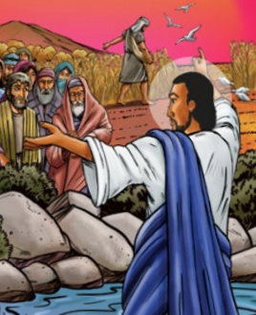
Adapted from Matthew 13: 1-9
Jesus was teaching the people by the lakeside and he told them a story. He said, “A farmer went out to sow seeds. As he sowed the seeds, some fell on the path, some among weeds and some upon rock where they could not grow properly. But some seeds fell on good soil and they produced a great crop. This is like those people who hear my words and understand them; those people grow strong and produce a great harvest. Now, anyone who has ears – listen to what I am really saying!”

Activity:
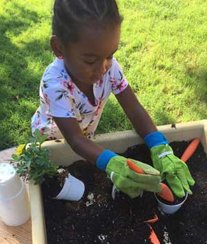
Sow some seeds with your family. Get two plant pots and put soil in one and stones in another. Plant your seeds (broad beans work well) into both pots and discuss with your family which ones you think will grow best and why. Give them some water. Watch and keep watering over the next few weeks and see what happens. Just like the seeds, we will grow healthily and happily if we are well cared for.

Prayer:
Challenge
Next time you pray, read one of Jesus’ parables and then have some quiet time. Close your eyes and stay silent. What is it that Jesus was saying? What was his message? Listen carefully to the message and see what you can learn from it.

Dear Lord Jesus,
Thank you for listening to us. Please help us to listen and understand your words and to be good listeners to each other too.
Amen.

Ask a grown up to help you stick a pin through the centre and attach to a straw or stick. Then blow and watch your windmill spin!

