St Ignatius- History Long Term Plan
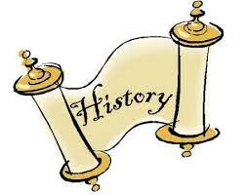
 | Autumn 1 | Autumn 2 | Spring 1 | Spring 2 |  | Summer 1 | Summer 2
Year 1 | Who am I? |  | Mighty Monarchs |  |  | Wheels and Wings
Year 2 | Home Grown Hero |  | Time to Explore |  |  | Panic on Pudding Lane
Year 3 | Prehistoric Britain |  | Ancient Egypt |  | Cradles of Civilisation | Ancient Greece
Year 4 | The Roman Republic |  | Roman Empire |  |  | Ancient Arabia/Early Islam
Year 5 | Anglo- Saxons |  | Vikings |  |  | Early Civilisation in the Americas
Year 6 | London Migration |  | London through Time |  |  | Travel on the River Lea/Thames

