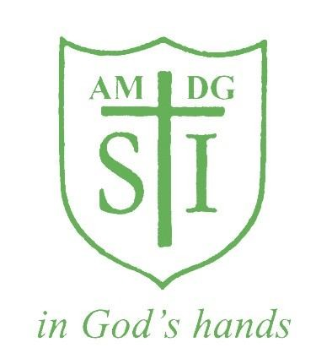

St Ignatius Primary School

Marking and Feedback Policy

Status | Non Statutory
Date of policy adoption | December 2023
Date of policy review | December 2024

Effective Feedback and Marking Policy

At St Ignatius Catholic Primary School, we believe that marking and feedback is an essential part of planning, assessment, teaching and learning. It is the mechanism by which we are able to:
• assess children on a day-to-day basis;
• check that the children have understood what we have taught;
• show children that their work is valued;
• show children how to improve and help them to understand the next steps in their learning;
• engage children in the learning process;
• create a personal dialogue about learning between the teacher and the child;
• raise standards.

We believe that effective marking and direct feedback should:
• be positive, motivating and constructive, at the child’s level of comprehension;
• relate to the learning objective which has been shared with the children;
• involve all the adults working with children in the classroom;
• inform future planning and individual target setting;
• be accessible and inclusive;
• give concise strategies and next steps for improvement;
• involve children in the marking process;
• be written in the whole-school agreed cursive handwriting style, be legible and provide a good model for children with correct spelling, grammar and accurate use of Standard English.

Non-Negotiable Written Feedback

We expect all work in pupils’ books to be marked daily in green pen. To help us to be consistent in our practice we ask everyone to follow these guidelines.

There are two kinds of marking:
1. Acknowledgement Marking
2. Deep Marking

English Writing
Every pupil will receive at least one piece of Deep Marking per week in English Writing with the rest Acknowledgement Marked. Self/peer assessment can take place for one of the other 4 pieces.

English Reading
Every pupil should receive at least one piece of Deep Marking per week in Reading with the rest Acknowledgement Marked. Self/peer assessment can take place for one of the other 4 pieces.

Religious Education
As we are a Catholic school and this is a core subject, every RE piece is Deep Marked.

Maths
Because Maths work is made up of closed questions with only one correct answer, all pieces should be Deep Marked, which can include additional peer/self-marking to assist teachers’ formative assessment.

Science
Because this is a core subject, pupils will receive a Deep Mark every other week, with the rest to be Acknowledgement Marked.

Humanities, RHE and PSHE
Every pupil should receive a Deep Mark every other week, with rest to be Acknowledgement Marked.

Summative Assessment
Summative assessment, such as End of term test, Past SATs papers and Hot Tasks should be marked before the next tests. Hot Tasks should be Acknowledge Marked and a Skill that has not been included in the work by the pupil should be written at the bottom of the work as a target for the next Hot Task in green pen. Achieved skills should be ticked on the Hot Task Skills Checker. Pupils are to self-assess or peer-assess their Hot Tasks (See Self and Peer Assessment paragraph). In Year 2 and Year 6, a checklist of writing standards is printed and placed at the front of each student’s Hot Task Folder, that should be checked off with dates for the standards that are completed by students in their Hot Tasks.

1. Acknowledgement Marking

- Acknowledgment marking shows a pupil that a teacher has looked at their work and gives the teacher the opportunity to pick up any misconceptions involving tier 2 vocabulary or the learning objective.

- Acknowledgement marking is most effective if used on closed tasks or exercises, where the answers are either right or wrong.

- It consists of using green pen and marking codes (see appendix) which acknowledges work and may indicate to the pupil that they need to adjust tier 2 spelling errors or a sentence.

- Marking stickers or stamps can be used (if the teacher chooses) to encourage pupils to reflect on their learning.

2. Deep Marking

Deep Marking should:

- Be linked to the learning objective;
- Provide guidance on the next steps for improvement;
- Prompt the child to make an improvement to their work;
- Engage the teacher and child in dialogue about learning.

When Deep Marking, teachers should provide legible and carefully worded comments and include:

- Example/s of where the child has met the learning objective - in green highlighter.

- A focused, concise and instructional comment/next step, which will help the child to ‘close the gap’ between what they have achieved and what they could have achieved – using pink highlighter and pink highlighter dashes as well as green pen. The Challenge on the LO Stickers/Sentence Checkers/Selfies should be used as a next step, if the pupil has achieved the learning objective, however has not attempted the challenge during learning.

Examples of quality Deep Marking (including Challenges on stickers) must be instructional and concise and include:

- Bloom’s Taxonomy questioning- What else could you say here? Can you rewrite using…? Can you write this better to include…? Can you explain…? Can you explain why you think…? What do you think would happen if…?

- Scaffolded prompts- (e.g. What was the dog’s tail doing? Describe the expression of the dog’s face; Circle the adverb that could go here and rewrite the adverbial; Circle the term used for the breaking down of food; Complete the sentence frame I have made for you.)

- Example prompts- provide WAGOLLs. This type of prompt will often give the child a choice (eg. Use one of these words instead of bad – ferocious, terrifying, evil. Or a WAGOLL sentence to assist the pupil in then making their own. In Maths, it could be a calculation or number sentence in green pen to show method and then to ask the pupil to use this method for an incorrect answer from the main task.)

Self and Peer Assessment
LO Sticker/Sentence Checker Self-Assessment: All work should be self-assessed by pupils before the end of the lesson for lessons that have the St Ignatius LO sticker or Sentence Checker. This should be apparent on the Learning Objective sticker or Sentence Checker. KS1 – smiley faces, KS2- ticks and dots. This is done with pencil/blue pen as it is not considered a fit time activity.

Other self and peer assessment can take place once per week for English Writing and English Reading. For Maths, self and peer assessment can take place more regularly. Self and Peer marking can have a key role to play in effective marking and feedback- it empowers pupils to take ownership of their learning. Pupils can use purple pen to underline work that shows that they have achieved the learning objective. Pupils can circle in purple pen where they have used their sentence checkers in Writing. Pupils can use purple pen to tick and dot their answers for closed questions, where there can only be one correct answer.

FIT Time (Focus Improvement Time)
In order for marking to be formative, the information must be used and acted on by the pupils as soon as possible. Therefore, when work has been Deep Marked, time is allocated for pupils to read and make their improvement based on the suggestion using purple pen. Time is allocated on timetables for Years 1-5 for this to happen at the beginning of each lesson or during Registration time. It may also be necessary to find other times in the day. Teachers model this process to the children regularly so that they are clear what the different coloured markings and codes in their books mean and what is expected of them when they respond. This time must be valued as an important step in the learning process and needs to be built into teachers’ planning, and where necessary, timetables. Teachers will need to make sure pupils can read and understand the comments and pupils are encouraged to remember green is great and pink to think.

Green is for great! | Pink to think!

Some pupils might need help from an adult or another child to help them do this. To indicate a response is required, teachers draw a dash using a pink highlighter in the margins of pupils’ work. They may also draw an arrow from a section of work to be improved to the pink dash to indicate that the child is expected to make an improvement to that particular aspect.

Teaching Assistants

TAs should only mark work produced by the group of pupils they are working with during the session to give immediate feedback in Maths and in English using green pen. They should then inform the teacher of the progress and any difficulties arising from that piece of work. It is not the role of the TA to complete any other marking for the teacher. TAs provide direct feedback during lessons to children, when necessary, in order to correct, improve and build on their knowledge and skills in the lesson, also using green pen. Where pupils have responded to direct feedback during learning using pencil or blue pen, TAs can write their initials in the pupils’ books to acknowledge the responses.

Supply Teachers

When covering a lesson, a supply teacher is expected to Acknowledge Mark the work undertaken in books.

Responsibilities
- It is the responsibility of the class teachers to ensure that this policy is consistently carried out, including enabling pupils to respond to feedback tasks.
- It is the responsibility of all staff working with pupils to ensure the marking code is consistently adhered to across the school.
- Each subject leader has the responsibility for monitoring that the policy is being consistently carried out in their particular subject area. Likewise the SENCO has responsibility to ensure the policy is appropriately adapted and implemented for SEN pupils.

SEN and Inclusion
Effective feedback and marking must be accessible to all pupils and will reflect their individual needs and abilities. This may mean writing comments for specific pupils in an accessible colour, it may mean support pupils to read comments, it may mean recording verbal feedback and response. Such requirements should be identified in a pupil’s EHCP plan.

Monitoring and Evaluation
Monitoring of the policy will be done through work scrutiny led by the Head Teacher and SLT leads as appropriate. It will be monitored for whole school consistency and evaluated for impact on pupils’ outcomes.

The SLT team will also monitor the impact of developmental marking through work scrutiny in both Maths and English as part of lesson observations to monitor the quality of teaching and learning in the school, in Foundation Stage this will also include scrutiny of observational assessment. This will be triangulated with pupil interviews to ascertain how developmental marking supports them in understanding what they need to do to improve their learning and to make progress.

Work scrutiny will be used to monitor consistency across the school and impact of the policy on pupil outcomes. PPR meetings will be to discuss specific progress of individual pupils/groups of pupils in relation to their work/progress with a focus on the quality of marking. Evaluation of Feedback and response will be done through the impact on pupil progress, including progress data but also pupil progress meetings and review of SEN provision and impact of the PPG Grant.
A work scrutiny schedule will be used to monitor and feedback will be given to individual teachers.

Policy Review
Summer 1 2023
Appendix
Marking Codes, which can be used by teachers to assist Acknowledgement Marking. To be written in the margin or where the error has occurred.
G | Check your grammar. Does your sentence make sense?
T | You have used the wrong tense.
^ | Insert a word you missed out.
// | You need to start a new paragraph here.
O | Write in the missing punctuation.
C | Write in the missing capital letter.
Cc | This should be lower case.
sp and wiggly line underneath | You have made a spelling error. Teacher models correct spelling and pupil writes x3 at the bottom of the work.
AA | You needed adult assistance to complete this work.
pr | You need to improve your presentation/handwriting.
VF | Verbal Feedback given with green pen
OA, OPA, ONA | Objective Achieved/Partly Achieved/Not Achieved
fs | Finger Spaces- You have forgotten finger spaces.
TM | Time Management- You need to manage time better in order to complete the task at hand.

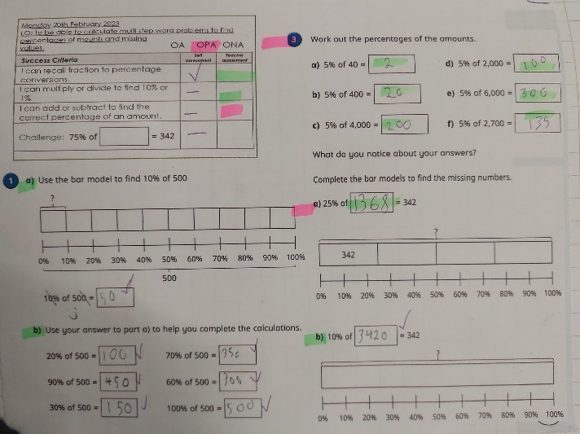
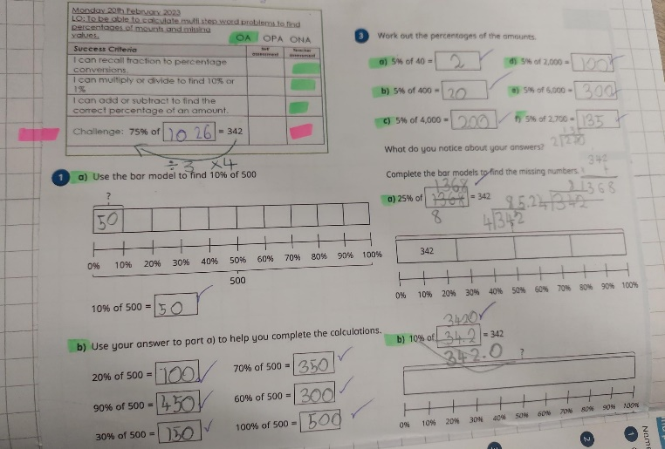
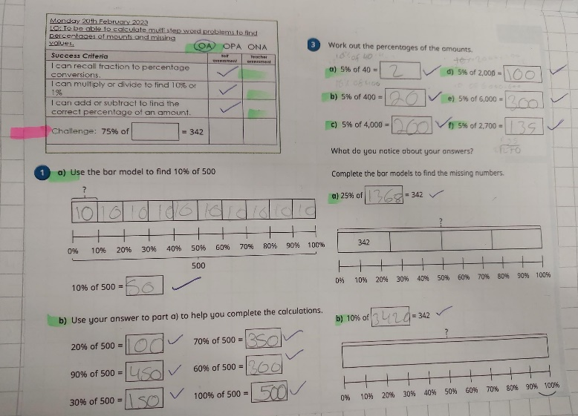
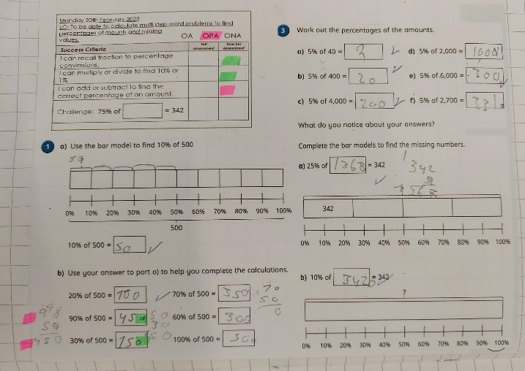
Examples of the Marking Policy in Books:

