St Ignatius Primary School Multiplication Tables Policy

Status | Non Statutory
Date of policy adoption | JUNE 2023
Date of policy review | JUNE 2025

Times Tables are at the heart of mental and written arithmetic. Once the children have learnt the times tables and related divisions by heart, they are able to work far more confidently – and efficiently – through a wide range of more advanced calculation that they would approach in the rest of their compulsory education in England.

The National Curriculum requires that all children should achieve their full times tables knowledge by t he end of Year 4 up to 12x12. At St Ignatius Catholic Primary School, we believe that through a variety of interactive, visual, engaging and rote learning techniques, most children can achieve the full times tables knowledge required by 9 years old.

Aims
1. To raise the profile of the teaching of times tables and to raise overall
knowledge of the times tables and related division facts across the school.
2. To explain the expected practices, to ensure children learn their times
tables.
3. To ensure continuity in practices and progression in times tables.

- To ensure there is successful teaching and learning of times tables and related divisions within our school.

- To develop our knowledge of language associated with times tables:
‘times’, ‘lots of’, ‘multiplied by’, and ‘group of’, ‘multiplier’, ‘multiplicand’, ‘product’.

Step 4 Introduce new times table by building it around facts already
known
Step 5 Explore patterns in times tables. Reasoning. Investigation.
Deeper learning. Making links
Step 6 Consistency of language
Step 7 Time-tabled opportunities to practise times tables facts
Steps to ensure consistency across the school and complete the
school Aims.
Step 1 Order of introduction
Step 2 Making conceptual links to the real world - display
Step 3 Use of the concrete, pictorial, abstract approach – use of
arrays to model

Step 1 explained: Order of Introduction

Year Group | What Should be Taught | Additional Comments
Reception | -Introduce concept of X1 (one group of 5 etc)  -Solve problems with doubling and halving
Year 1 | -Counting in multiples of 2, 5 and 10  -X1 table (one group of…)
Year 2 | -Count in steps of 2,3 and 5 from 0 and in 10s from any number forwards or backwards.  -Recall and use multiplication and division facts for the 2, 5 and 10 multiplication tables, including recognising odd and even numbers.  -Begin to introduce concept of square numbers through arrays  -X1 table  -Begin to introduce X0 table
Year 3 | -Count from 0 in multiples of 4, 8, 50 and 100  -Recall and use multiplication and division facts for the 3, 4 and 8 multiplication tables  -Revise X2, X5, X10 multiplication tables  - X1 and X0 tables  - Square number times tables | Link x4 to x2. Link x8 to x4.
Year 4 | Count in multiples of 6, 7, 9, 25 and 100  -Recall multiplication and division facts for multiplication tables up to 12 x 12 (x6, x7, x9, x11 and x12 are new tables for this year group)  -Revise X0, X 1, X 2, X 3, X4, X 5, X 8, X10  -Continue with square number times tables | Link x6 to x3. Link x12 to x6
Year 5 | Revise all times tables (including x0 and x1) to 12x12  -Revise square number times tables  -Establish whether a number to 100 is prime. Recall prime numbers to 19
Year 6 | -Revise all times tables (including x0 and x1) to 12 x12  -Revise square numbers times table  -Revise prime numbers

 | EYFS | Year 1 | Year 2 | Year 3 | Year 4 | Year 5 | Year 6
Au 1 | -Counting in 1s considering the Counting Principles.  -Matching pairs. Finding groups or sets of an object. | -Doubling and halving. | -X1, X2, X5, X10 | -Revise X0,X2,X5X 10 | -Revise X0, X 1, X 2,  X 3, X4, X 5, X 8, X10 | -X10, X100, X1,000  --Revise square numbers times table  -Revise prime numbers | --Revise square numbers times table  -Revise prime numbers  -Factors  -Multiples
Au 2 | -Counting in 1s up to 4. | -Counting to 10. | -Introduce concept of square numbers through arrays .  -X1 table | -X3, X4, X8 | -X10, X100  -X1,X0,X3,X6,X9,X7 | - Revise X6, X7, X9, X25, X100 | -Revise X10, X100, X1,000  -Doubling and halving.
Sp 1 | -Counting in 1s up to 8. | -Counting to 20. | -X2, X5, X10  -Recognising odd and even | -X2, X4, X8 | -Introduce X11, X12 | -Revise X8, X3, X4, X11, | -Revise X11, X12, X6, X7, X9,
 |  |  | numbers. |  |  | X12 | X25, X100
Sp 2 | -Counting in 1s up to 10.  -Consolidation up to 10. | -X1 table (one group of…) | -Introduce X0  -X2, X5 | - X2,X3,X4, X50, X100. | -Revise X9,X7,X11, X12 | -Revise X9, X8, X12  -Doubling and halving. | -Recall up to 12 x 12
Su 1 | -Counting to 20 and beyond. | -X2, X5, X10 | -X2, X5, X10  -Recognising odd and even numbers. | -X3, X4, X8.  -Square numbers | -Recall up to 12 x 12 | -Recall up to 12 x 12 | -Recall up to 12 x 12
Su 2 | -Doubling and halving. | -X2, X5, X10  -Doubling and halving. | -X2, X5, X10  -Recognising odd and even numbers. | -X3, X4, X8.  -Square numbers | -Recall up to 12 x 12  -Square Numbers | -Recall up to 12 x 12 | -Recall up to 12 x 12

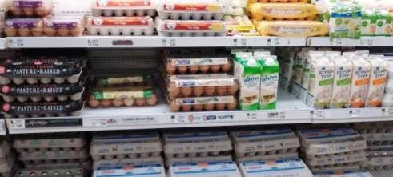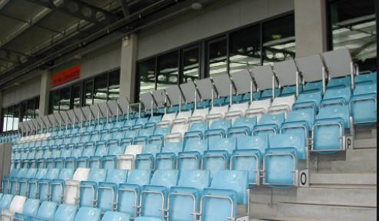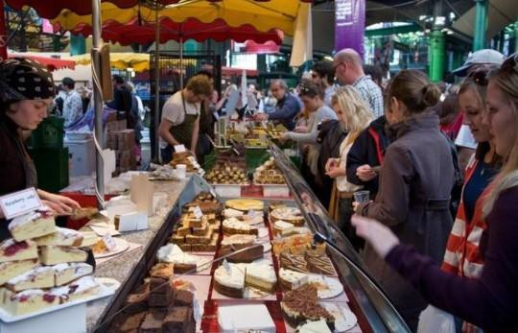
Step 2 explained: Making Conceptual Links to the Real World

Each classroom should have their year groups allocated time tables on display and a display linking times tables to the real world. Use images below and White Rose Maths questions that link to the real world as inspiration.

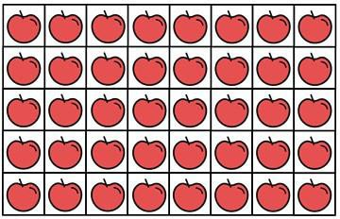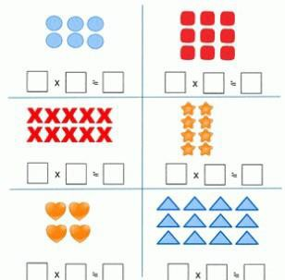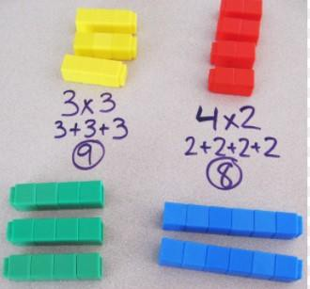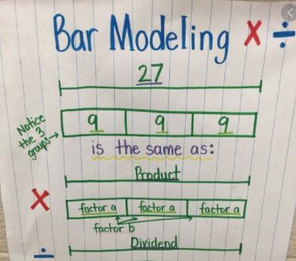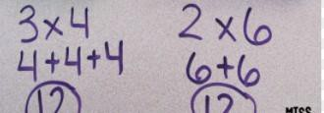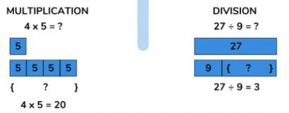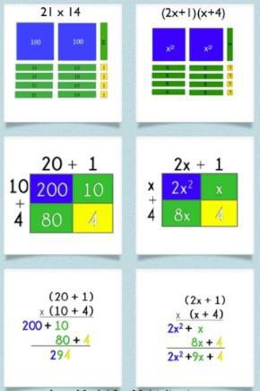
Step 3 explained: Use of the concrete, pictorial, abstract approach – use of arrays to model

When introducing a new times table, use White Rose Maths lessons from yours and (if necessary) other year groups and adapt to suit
your children’s needs. It should include the Mastery Approach of concrete-pictorial-abstract such as the below.

Concrete- cube links Pictorial- arrays Pictorial- Bar Model Pictorial- arrays

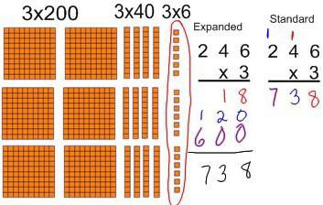8x5=40
Pictorial- Area Model
Concrete OR Pictorial- Base 10 Blocks
Pictorial- Bar Model

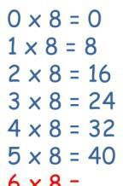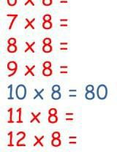Step 4 explained: Introduce new times tables around facts already known.

e.g. We have learned the 2,3,4,5 and 10 times tables. We have already met some of the facts from the 8 times table. What are they?

Which facts are left to learn?

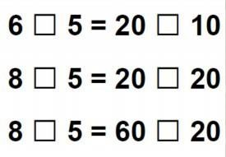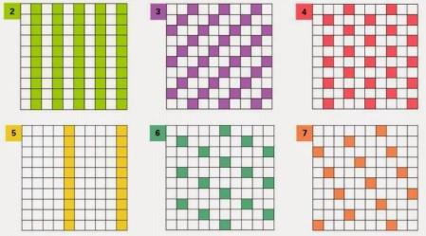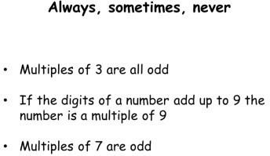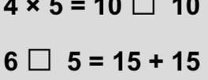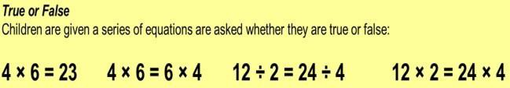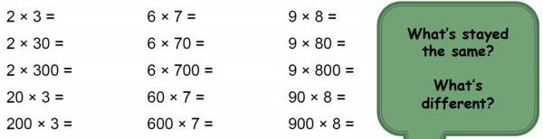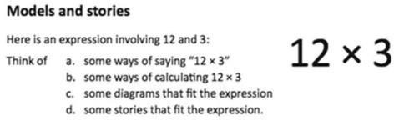
Step 5 explained: Explore patterns in times tables. Reasoning. Investigation. Deeper learning. Making links.

Take time to explore the patterns of each times table as you introduce it to the class. Provide opportunities which deepen knowledge and understanding and require children to reason, conjecture, predict and explain. Ensure children engage with engaging activities and games linked to times tables, which encourage deeper learning, greater levels of reasoning, links to be made and patterns to be discovered such as the below. See White Rose Maths Multiplication and Division Units for effective lessons and the below.
Procedural Variation- Explore different ways to complete multiplication and division sentences.

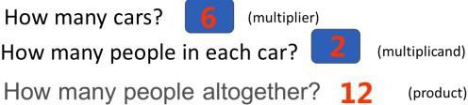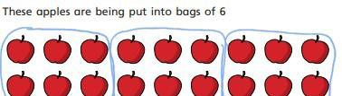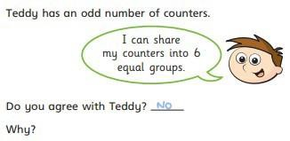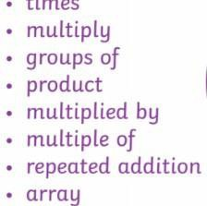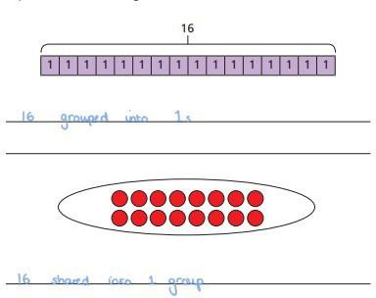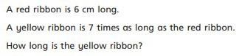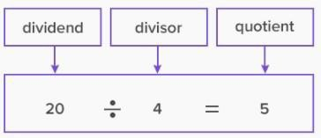
Step 6 explained: Consistency in Language
Teachers should ensure they are clear about use of language: ‘multiplier’, ‘multiplicand’ and ‘product’ AND ‘divisor,’ ‘dividend.’ and ‘quotient.’ In older year groups: ‘factor’ and ‘multiple.’ They should be confident to identify each within a multiplication problem and should encourage children to be able to identify each one within problems too. See more examples of language below. (some taken from White Rose Maths).

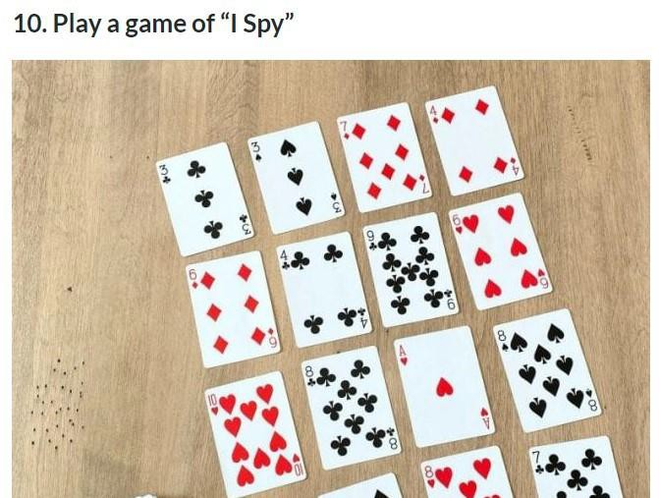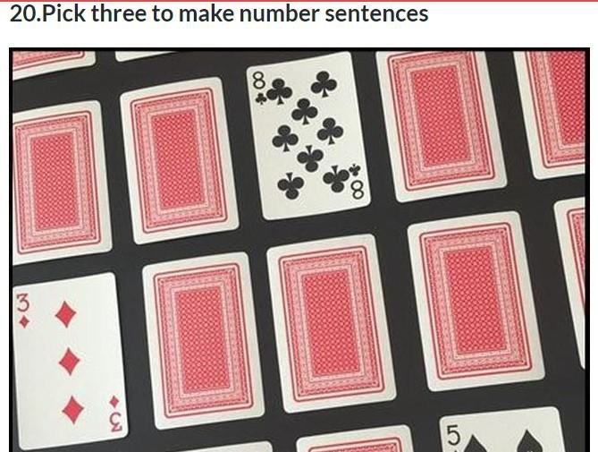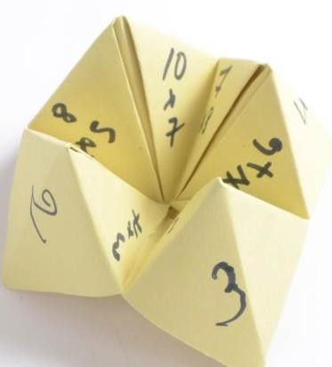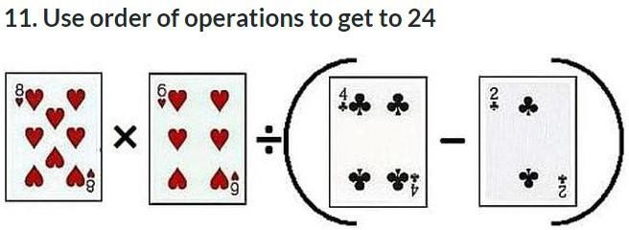
Step 7 explained: Time-tabled opportunities to practise times tables facts
Teachers should adjust their timetable to include 2x 20 minute sessions that are dedicated to practising times tables. Here are some ideas and White Rose Maths Flashback 4, Sumdog, Times Table Rock Stars or Manipulatives to be used also.

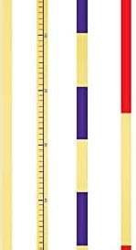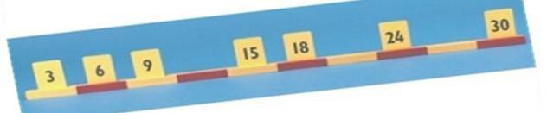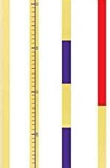Continued
Step 7 explained: Time-tabled opportunities to practise times tables facts

Suggested Scripture for Using a Counting Stick
Learning the 7 times table (adapt for times table being learnt). Step 1: What number do we always start with?
Step 2: What times table are we learning? (repeat steps 1&2) Step 3: Can you multiply it by 10? (repeat steps 1&2)
Step 4: Can you double it?
Step 5: Can you double that? (repeat steps 1-5 in order)
Step 6: I have a very special number to tell you and it is called the key. Our key in this times table is 21. What is our key?
Step 7: Can you double the key?
Step 8: This is really hard now, can you triple the key? (Repeat steps 1-8 in order) Step 9: Who remembers our key? (children answer) Double it. Now add seven (repeat steps 1-9)
Step 10: Everybody touch your nose. That’s 35. Touch your nose.
Step 11: Now everybody needs to help me. There is one number I always forget. It’s
56. What number do I always forget? (Repeat steps 1-11)
Begin to remove the sticky notes as children become more confident with remembering .

