Music Challenge – Singing.
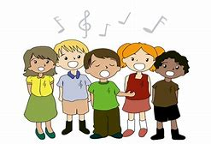

Singing is really important for your wellbeing.

Try singing some of the songs the BBC have made available for primary children.

https://www.bbc.co.uk/teach/school-radio/music-songs-ks1--ks2-page/znrj8xs

See if you can find a song that matches up to a topic you have been learning about in your home learning. Send a video of you singing it to your class teacher using the portfolio section of Class Dojo.

