Music Challenge – Making a wind instrument.

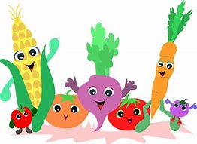

This week, I am challenging you to make your own musical instrument out of vegetables!

Please watch the video for instructions on how to make your instrument.

https://youtu.be/nrDY1rsWFsM

