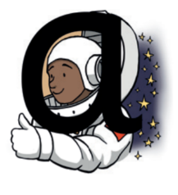 | 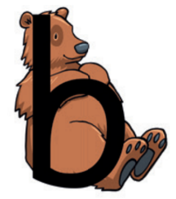 | 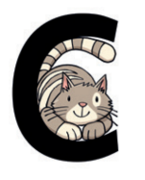 | 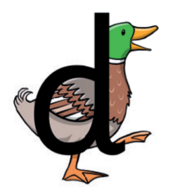 | 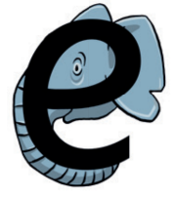 | 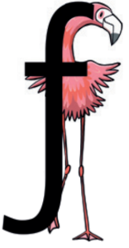 | 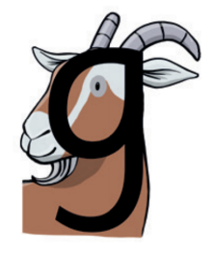 | 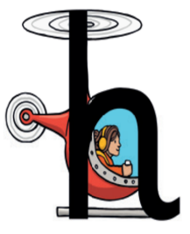 | 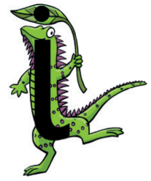
Around the astronaut’s helmet and down into space. | Down the bear’s back, up and round its tummy. | Curl around the cat. | Round the duck’s body, up to its head and down to its feet. | Around the elephant’s eye and curl down its trunk. | Down the flamingo to its foot and across its wings. | Round the goat’s face and curl under its chin. | Down, up and over the helicopter. | Down the iguana and dot the leaf.
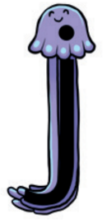 | 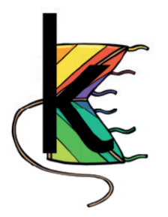 | 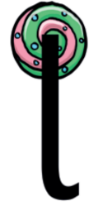 | 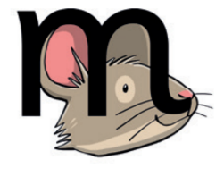 | 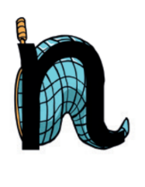 | 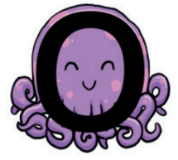 | 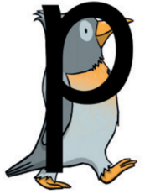 | 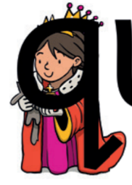 | 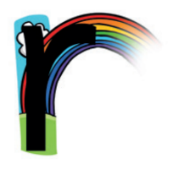
Down the jellyfish and dot its head. | Down the kite, up to the top corner and down to the bottom corner. | Down the lollipop stick | Down, up and over the mouse’s ears | Down, up and over the net. | All around the octopus. | Down the penguin’s back, up and around its head. | Round the queen’s face, up to her crown, down her robe with a flick at the end. | From the cloud to the ground and over the rainbow.
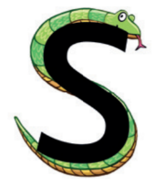 | 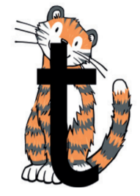 | 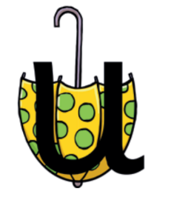 | 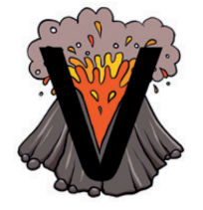 | 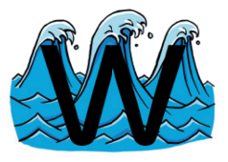 | 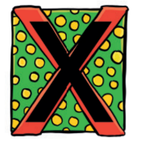 | 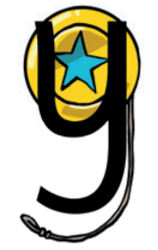 | 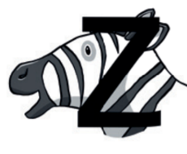
Down the snake from head to tail. | Down the tiger and across its neck. | Down and around the umbrella, and back to the ground. | Down to the bottom of the volcano and back up to the top. | Down and up and down and up the waves. | From the top, across the box to the bottom. From the top again across the box to the bottom. | Down, around the yo-yo and curl round the string. | Across the top of the zebra’s head, zig-zag down its neck and along.

