Nursery Home Learning Timetable

Below is the suggested home learning weekly timetable for your child. Please look on Tapestry for other practical ideas and examples and don’t forget to upload your pictures and videos. The timetable will be updated weekly.

Week commencing: 8th June 2020

Daily Reading | 15 mins | ‘ | Enjoy a story as a family. Cuddle up with a family member, relax, and listen to a story. Listen to Ms Donna’s story of the week on Tapestry.
Daily Phonics | 10 mins | 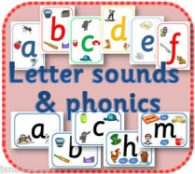 | Sound of the Week  g  Name some things that begin with g. Watch the “g” lesson on Tapestry.  Have a look at the Ruth Miskin Speed Sounds Set 1 lesson on Youtube.  https://www.youtube.com/channel/UCo7fbLgY2oA_cFCIg9GdxtQ/featured
Daily Mark Making | 10 mins |  | Practise naming and writing sounds in your name. Can you write the sound “g” in the air? Can you write the sound “g” using chalk on the floor outside? “Round her face, down her hair and give her a curl”.
Daily Nursery Rhyme | 5 mins | 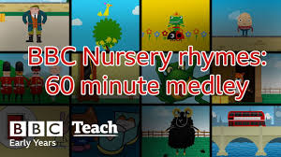 | The Goats Came Marching  https://www.bbc.co.uk/teach/school-radio/nursery-rhymes-the-goats-come-marching/zjqgscw  Practise every day until you can sing it by yourself.
Daily Maths | 10 mins | 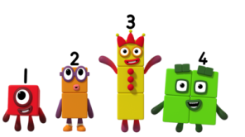 | Look out for the Three Billy Goats Gruff maths activity on Tapestry.  Watch an episode of Number Blocks on BBC I Player or You Tube. Practise counting and recognising numbers to 10 or 20.
Daily Physical Activity | At least 3 hours a day | 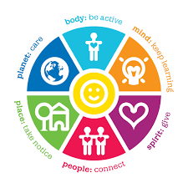 | Go for a walk in a park or open space (following government social distancing guidelines). Dance around to your favourite music. Try out some of our Wellbeing Wednesday ideas (Updated on Tapestry every Wednesday)

