Nursery Home Learning Timetable

Below is the suggested home learning weekly timetable for your child. Please look on Tapestry for other practical ideas and examples and don’t forget to upload your pictures and videos. The timetable will be updated weekly.

Week commencing:11th May 2020

Daily Reading | 15 mins | ‘ | Enjoy a story as a family. Cuddle up with a family member, relax, and listen to a story. Listen to Ms Donna’s story of the week on Tapestry.
Daily Phonics | 10 mins | 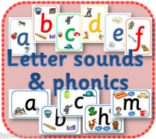 | Watch the Jolly Phonics songs on YouTube.  Sound of the Week  i  Name some things that begin with i. Watch the “i” lesson on Tapestry.
Daily Mark Making | 10 mins |  | Practise naming and writing sounds in your name. Can you write the sound “i” in the air?  Can you find any i-i,nsects around your garden or outside?
Daily Nursery Rhyme | 5 mins | 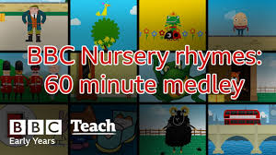 | It’s Raining, it’s Pouring  https://www.bbc.co.uk/teach/school-radio/nursery-rhymes-its-raining-its-pouring/z6hq92p  Sing daily until you can sing it by yourself.
Daily Maths | 10 mins | 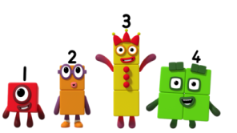 | This week we are thinking about properties of shapes and objects. Can you find something that is smooth, something that is rough, and something that can roll? Post your pictures and videos on Tapestry!  Watch an episode of Number Blocks on BBC I Player or You Tube.
Daily Physical Activity | At least 3 hours a day |  | Go for a walk in a park or open space (following government social distancing guidelines). Play in your garden if you are lucky enough to have one. Try out some of our Wellbeing Wednesday ideas (Updated on Tapestry) inside your house.

