Nursery Home Learning Timetable

Below is the suggested home learning weekly timetable for your child. Please look on Tapestry for other practical ideas and examples and don’t forget to upload your pictures and videos. The timetable will be updated weekly.

Week commencing: 22nd June 2020

Daily Reading | 15 mins | ‘ | Enjoy a story as a family. Cuddle up with a family member, relax, and listen to a story. Listen to Ms Donna’s story of the week on Tapestry.
Daily Phonics | 10 mins | 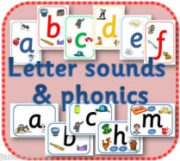 | Sound of the Week  k  Name some things that begin with k. Watch the “k” lesson on Tapestry.  Have a look at the Ruth Miskin Speed Sounds Set 1 lesson on Youtube.  https://www.youtube.com/channel/UCo7fbLgY2oA_cFCIg9GdxtQ/featured
Daily Mark Making | 10 mins |  | Practise naming and writing sounds in your name. Can you write the sound “k” in the air? Can you write the sound “k” in shaving foam, paint or flour in a tray?
Daily Nursery Rhyme | 5 mins |  | 3 Blind Mice  https://www.bbc.co.uk/teach/school-radio/nursery-rhymes-three-blind-mice/zmnxwty  Practise every day until you can sing it by yourself.
Daily Maths | 10 mins | 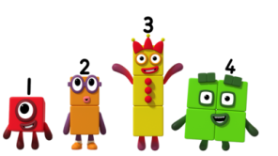 | Check Tapestry for this week’s activities. Watch Numberblocks episode 1,2,3.  https://www.bbc.co.uk/iplayer/episode/b08bzh11/numberblocks-series-1-one-two-three  Practise counting and recognising numbers to 10 or 20. Can you put the numbers in order?
Daily Physical Activity | At least 3 hours a day |  | Go for a walk in a park or open space (following government social distancing guidelines). Try out some of our Wellbeing Wednesday ideas (Updated on Tapestry every Wednesday) Dance with Oti on Boogie beebies.  https://www.bbc.co.uk/iplayer/episode/m000jzkk/otis-boogie-beebies-series-1-10-jungle

