REMOTE LEARNING GUIDANCE

Remote learning provision: guidance for parents / carers

This document is intended to provide parents / carers at St Ignatius Catholic Primary School with clarity and detail on what to expect from remote learning if local restrictions require entire cohorts or bubbles to remain at home.

The remote curriculum: what is taught to pupils at home

Pupils and families are prepared for remote learning through the use of some digital homework on J2E each week and this will provide a seamless transition to remote learning. The first day may be a slightly reduced provision but by day two pupils will receive full daily learning timetables. Teachers will communicate with parents via the Class Dojo app daily when the pupils are not in school.

Will my child be taught broadly the same curriculum through remote learning as they would if they were in school?

Your child will be taught the same curriculum remotely as they would in school with certain adaptations where necessary to ensure full coverage of the core subjects. For example, early years will focus on the prime areas and key stage two may have less time on foundation subjects to allow for rigorous teaching in English and maths. We may make some adaptations in some subjects to make them work more effectively online.

Remote teaching and study time each day

How long can I expect work set by the school to take my child each day?

The suggested time frame for each subject area is included in the daily timetable to provide pupils and parents with a guideline for their learning day. This increases the time expectations as your child moves further up the school. Early years pupils are expected to spend approximately 1-2 hours whereas year 6 should expect to spend 3-4 hours per day. It is important that children take regular breaks throughout the day and these can be built into the timetable.

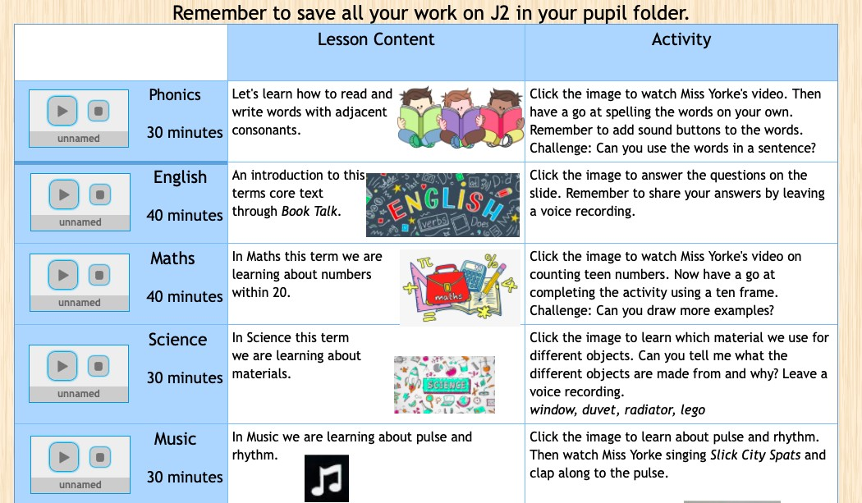
Here is an example of the daily timetable with suggested time allocations:

Accessing remote learning

How will my child access any online remote learning you are providing?

If your child is in the early years of school, nursery and reception, they will access remote learning through our digital journal Tapestry. If your child is in key stage 1 or 2 they will be using J2E, the digital platform we also use for weekly homework. We will also use Class Dojo to regularly post links and messages related to remote learning and to support families at home (staying connected). These platforms can be accessed on a PC, laptop, tablet or mobile phone but we recommend laptop or PC as the most efficient for completing work.
In addition, there will be a combination of:
- recorded video and a live Zoom for start of day registration
- instructional videos and morning messages
- other digital content including; BBC Bitesize, Oak Academy, White Rose
- Sumdog, Reading Eggs, TTRS

Where appropriate, some children may receive physical materials such as numicon, writing tools and story books.

If my child does not have digital or online access at home, how will you support them to access remote education?

We recognise that some pupils may not have suitable online access at home. We will support pupils to access remote learning by:
- Loaning devices to families on a temporary basis
- Providing data sim cards and Wi-Fi dongles where needed
- Supplying exercise books and pencils to record written activities

How will my child be taught remotely?

We use a combination of the following approaches to teach pupils remotely:

- Pre-recorded lessons led by the class teacher and/or teaching assistants
- Audio recorded teaching slides with directed learning points
- Directed tasks on educational subscription sites such as Sumdog, TTRS, Reading Eggs
- Digital worksheets created on J2 tools

Engagement and feedback

What are your expectations for my child’s engagement and the support that we as parents and carers should provide at home?

We expect our parents and carers to take an active interest in all areas of their child’s remote learning by supporting where they can. Our remote lessons are provided by teachers to guide your child through the learning without needing an adult to support however we know that pupils achieve more with additional guidance at home.

We expect parents and carers to treat a remote learning day as they would a school day by encouraging your child to get up at a sensible time, get dressed and have breakfast and find a quiet, calm place to begin their learning. Use the daily timetable to create structure for the day and take regular breaks and outdoor exercise to maintain concentration.

Parents should contact the school if the child is ill or otherwise can’t complete work. Please keep in contact with the class teacher via Class Dojo.

We hope the lessons provided both for our weekly digital homework and the remote learning will be informative and helpful for parents and carers as well as the pupils.

How will you check whether my child is engaging with their work and how will I be informed if there are concerns?

Teachers will check daily that pupils have logged in to their remote learning and that they have attended their ‘live registration’ on Zoom and will send messages through Class Dojo that day. If there is persistent absence from the remote learning platform or Zoom sessions, the school will phone families to see what support they can offer to the pupil. Teachers will provide daily contact with pupils between the hours of 9:00 am and 3:30pm. If a parent messages a teacher after these hours the teacher will respond the next day or within 24 hours.

How will you assess my child’s work and progress?

Feedback can take many forms and may not always mean extensive written comments for individual children. For example, whole-class feedback or quizzes marked automatically via digital platforms may be used to check for understanding. Our approach to feeding back on pupil work is as follows:
- Providing one live meeting to be delivered each day.
- Every pupil will receive at least one piece of personalised feedback from their class teacher each day – either in written or audio format
- Moving on comments and challenge questions will be given by the teacher and pupils are expected to respond
- Pupils will have their work marked across all subjects throughout the week
- Regular quizzes and progress checks will be included in the daily timetable to check pupil understanding and produce whole class feedback
- Teachers will provide end of week feedback to the class
- Points will be issued through Class Dojo to keep parents and carers informed of their child’s progress

Additional support for pupils with particular needs

How will you work with me to help my child who needs additional support from adults at home to access remote learning?

We recognise that some pupils, for example some pupils with special educational needs and disabilities (SEND), may not be able to access mainstream remote learning without support from adults at home. We have additional groups/folders setup on J2 to provide work for pupils who need tailored support and the work provided on these groups is pitched at their level and specific needs.
Where pupils needs prevent them from accessing digital learning paper packs are produced by the inclusion team and distributed to families.

