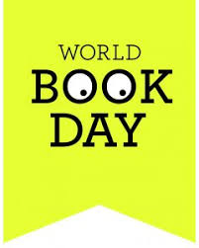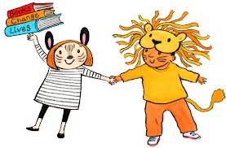
St Ignatius Catholic Primary School
Tuesday 22nd February 2022
Dear Parents/Carers,
This year World Book Day is being celebrated on Thursday 3rd March 2022.
Reading is something we really value at St Ignatius and we understand the importance of children getting enjoyment from their reading. This year World Book Day’s theme is ‘You Are A Reader.’
We are giving our children the choice this year as to whether they want to either:
- dress up as their favourite well known book character or
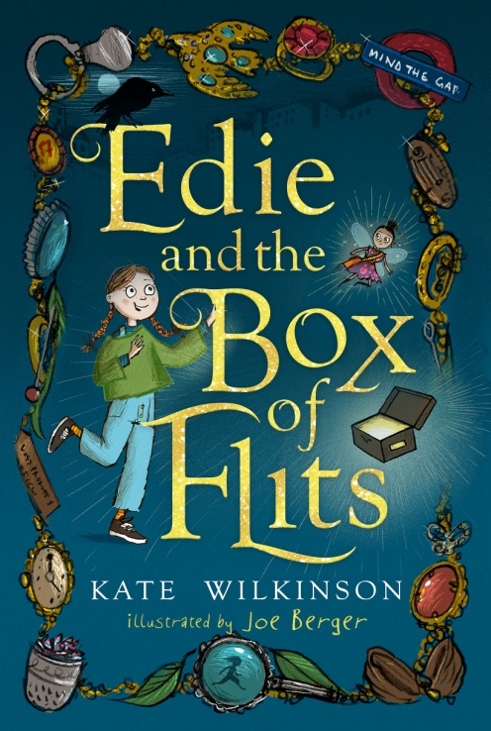
- dress in their favourite pyjamas, dressing gowns/ slippers and pretend it is night-time!
Whatever they choose, as the weather is cold still, they may want to come to school in their own clothes and change when they get here. If they choose pyjamas, they can also wear legging/ tights / tops under their pyjamas or even just jogging bottoms / sweatshirt, if they do not have or want to wear their pyjamas.
Author Visit: Kate Wilkinson
A local children’s author ‘Kate Wilkinson’ will be visiting the school and running workshops with years 3-6. As a small token to the author for her visit, we would like to encourage you to buy her book by following the link below. This is a lovely story that your child will enjoy reading at home should you choose to purchase it: https://www.pickledpepperbooks.co.uk/collections/st-ignatius-catholic-primary-school-author-event
The Children will also be participating in reading activities based on the book Journey by Aaron Beck throughout the day. You can watch an audio version of this story by clicking on this YouTube link: https://www.youtube.com/watch?v=AoIA9DebV70
The Children will receive their £1 book tokens on World Book Day that they can spend in local book stores. At home you can encourage your child further by visiting the website www.worldbookday.com and getting involved with the many activities online. You can join us in building your child’s enthusiasm for books well beyond World Book Day by reading together regularly and joining your local library. Remember – you can read to your child in your home language as well as English – Reading is reading in every language! The expectation at St Ignatius is that children read at least 5 times per week at home and this should be evidenced in their reading record. A great reader then becomes a great writer! Sharing stories together for just ten minutes a day will encourage a love of reading and it’s fun for everyone. Thank you for your support!
Ms Demetriou

