Pentecost
During the half term holiday we celebrated the Feast of the Ascension, when Jesus went up to Heaven to be with his Father. His disciples loved him and listened to his guidance, so when he left they felt sad and lonely. Have you ever had to say goodbye to someone you love? Soon the disciples knew exactly what to do next, as the Holy Spirit came to show them the way. This is what we celebrate on the Feast of Pentecost.

The Coming of the Holy Spirit (based on Acts 2: 1-47)
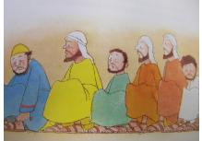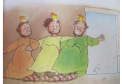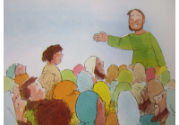
After Jesus had gone back to Heaven to be with his father, his twelve friends sat together and talked about all the things they remembered. They spoke of the way Jesus helped people, the wise things he had told them and the way he made people feel close to God. They felt very sad because they missed him. Suddenly there was a huge gust of wind in the room and flames appeared above the disciples' heads. They felt full of energy and excitement. The Holy Spirit had come! The disciples knew what they had to do. The Holy Spirit guided them. They ran into the street and started to tell people that Jesus was alive in Heaven. That day 3000 people said, "We want to follow Jesus".
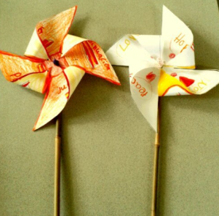

Activity:
Make a paper windmill to represent the coming of the Holy Spirit as a gust of wind. On each paddle you can write a word tells others what the Holy Spirit helps you with, fore example, honesty, peace, forgiveness, love. Can you think of any others? (See next page for windmill instructions.)

Prayer:
Challenge
Think about a time when you wanted to do something but you knew it was wrong. Did the Holy Spirit’s guidance keep you from making a bad choice? Next time you are faced with a challenge, listen carefully – the Holy Spirit will help.
Holy Spirit,
Your light helps to guide us along our path in life. But when our way is covered by difficulties, your light can be harder to see. During these times, please shine your light with even more strength, so that the right path will, once again become clear.
Amen

How to make a paper windmill:
Cut out or copy and cut this square. Then cut along the 4 diagonal lines and fold each corner with a dot into the centre.
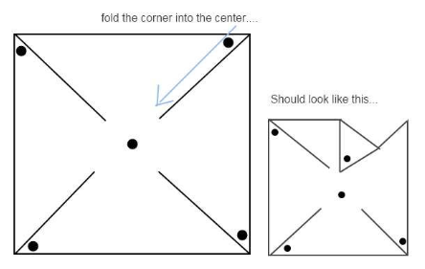
Ask a grown up to help you stick a pin through the centre and attach to a straw or stick. Then blow and watch your windmill spin!
Fold like this, making sure the dots line up in the centre. Stick each corner with glue.

