Reflection and Prayer Opportunities
Perseverance
Throughout our lives there will be things that we want. It might be a toy or book, or it might be to learn something in particular. It might be a place we want to visit or an experience we might want to have. Not everything is easy for us to achieve, but we must try not to give up. If we keep trying we can achieve our goals, it just takes perseverance. This is a story about a little girl who shows great perseverance, made stronger by her faith.
The Marie Jones Story
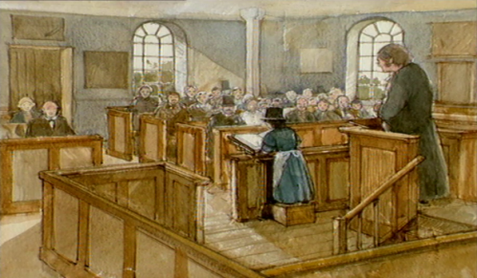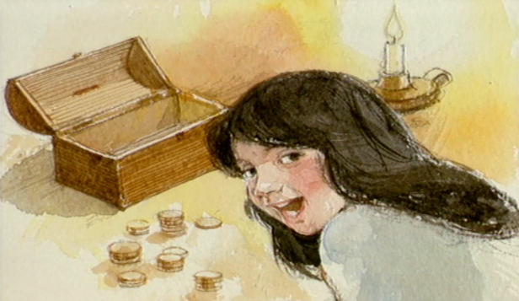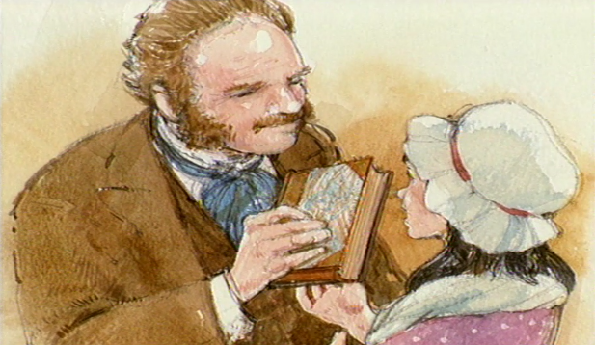
Many years ago a girl called Marie Jones lived with her parents in the Welsh countryside. Every Sunday they went to Mass at the village church and, one Sunday, Marie was asked to read from the Bible. She loved hearing the stories about Jesus and she longed for a copy of her own. As she was going to bed, she said to her parents, “I’ve decided to save up to buy my own Bible.” Her mother said, in a worried tone, “But Marie, they are expensive and we don’t have much money.” “That’s why I’m going to save up,” said Marie, “and I don’t care how long it takes. I’ll do anything to have my own Bible.” For six long years Marie saved all she could until she had enough money. Nothing was going to stop her now. The journey to the town was long and hard. Marie walked for 25 miles, across valleys and streams and over hills. Her feet were aching but she kept going. Finally she arrived in the town and found the home of Mr Charles, who sold Bibles. “Hello Mr Charles,” she said, “My name is Marie Jones and I would like to buy a Bible.” Marie couldn’t believe it when Mr Charles handed her a brand new Bible. “Oh, thank you Mr Charles!” she exclaimed. At long last Marie had the book she had always wanted.
Watch the video here: https://www.bbc.co.uk/bitesize/clips/z9cd2hv

Activity:
Pick something that you find difficult. It might be a puzzle, or learning to spell a tricky word, or bouncing and catching a ball, or hula hooping, or knowing our 10times tables. Set aside some time each day to practise and persevere – keep on trying. You can do it!

Prayer:
Everlasting God,
Your love and guidance never end. You do not grow tired and weary. When I am exhausted, you keep me safe and you breathe new life into me.
Please help me to learn from your perseverance so that I might not give up, but keep trying, whatever I want to achieve.
Amen

Challenge
Think about something you have achieved. Did you find it easy or difficult to achieve this? Was there anything you had to give up in order to achieve it?
Think about what Jesus gave up to achieve his goal of teaching us about Heaven.

