Physical Challenge- Yoga
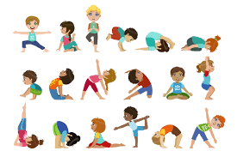
Wellbeing exercises are great for you and the whole family. Get on board and get in the habit!
The workout chosen for this week is based on Minecraft. Build your way to better wellbeing and fitness. Enjoy!

Minecraft Yoga:

https://www.youtube.com/watch?v=02E1468SdHg

