How to Draw Word Bubbles

Your challenge this week is to draw word bubbles in Pop Art comic style. All you need is a piece of paper, some felt pens and some time. Click on the link below and see how it is done.

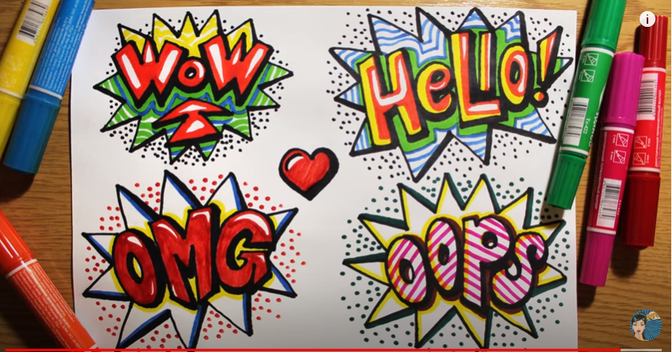

https://www.youtube.com/watch?v=jS-OTAwPRDY

