Praying to St Anthony
We say prayers for lots of different reasons; when we want to say sorry, or thank you, or to ask for something. Many people pray to St Anthony if they have lost something and want to find it again.

The story of St Anthony of Padua
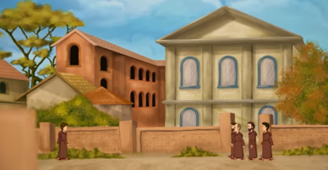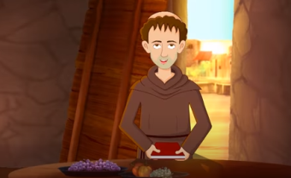
St Anthony is one of the saints that people pray to most often. He grew up in Portugal, and read and followed the Bible so closely that he decided to become a monk. After hearing about some monks being killed in Morocco for their beliefs, Anthony wanted to go there to try to teach the people about the love of Jesus. But as he sailed towards Morocco there was a huge storm and Anthony’s ship had to stop in Sicily. Here he spoke at a meeting with lots of other monks and everyone was amazed by the clear way he spoke about God. Anthony devoted his life to prayer and copied out some psalms into a special book, which he used during prayer times. One day his book was stolen and so Anthony prayed for the man who stole it, that he would realise he had done something wrong. God listened to Anthony and, sure enough, the man brought back Anthony’s book of psalms.

Watch the story here: https://www.youtube.com/watch?v=ITw42f17CPU

Activity:
Find a blank notebook, or make your own by folding and few pieces of paper in half and asking a grown up to staple along the fold for you. In your book, begin to write short prayers or copy psalms from a childrens bible, just like St Anthony did. Keep it somewhere safe and then you can use it at prayer times. Maybe your faith in God he mean he will answer some of your prayers.

Prayer:

Saint Anthony,
You lived your life with love and kindness, and you always listened to God. When you asked him for help, he listened to you. Please guide us towards a life full of goodness, in the hope that we will find many things in the future to make us happy.
Amen

Challenge
Next time someone in your family loses something, say a little prayer to St Anthony, and then help them look for the lost item. Can you find it together? Even if you can’t find it, they will be grateful that you tried, and you never know – St Anthony might help you find it another day.

Ask a grown up to help you stick a pin through the centre and attach to a straw or stick. Then blow and watch your windmill spin!

