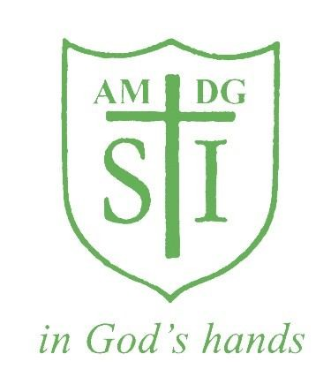

St Ignatius Primary School

Presentation Policy

Status | Non Statutory
Date Created | February 2023
Date to be reviewed | February 2025

Aims

To establish high expectations and pride in everything we do- both of ourselves and of the children.

To create a clear and consistent set of guidelines for the presentation of children’s learning.

Objectives

To motivate each individual to present their work in the best possible way.

To enable children to recognise work that is presented to a high standard.

To ensure each child knows the standard of presentation that is expected of them.

For Teachers

To create consistency in standards of presentation across the school.

To provide a baseline for judging acceptable standards of presentation.

Expectations for Teaching Staff

Remember- you are the most important role model for presentation and high expectations. Use the resources available to you e.g rulers, lines and grids on the IWB to model good practice.

All handwriting which is on display for the children- on the IWB, books, flipcharts, display- should be legible, consistently formed and neat. Cursive script should be used in KS2.

All children’s work must be marked using the agreed marking policy.

When sticking work/labels/headings in books ensure they are straight and cut to size.

Rulers should be used at all times.

Children’s work is to be marked in GREEN pen.

Teachers should ensure that pupils do not draw on or deface the covers of exercise books or folders.

Teachers should speak to the children about taking care of their exercise books. Books should not be dog eared and tatty. Children should not fold back the pages of their exercise books when writing.

Children are not to scribble on their books/labels.

If a child is away please ensure that their book is marked with ‘absent’ and write the date and learning objective.

Expectations for Children

Use of pencils and pens

Pencils should be used in all Maths books and in draft work if appropriate.

Purple pens are to be used so that the children can respond to the feedback marking. This work is part of the FIT process. The children should be encouraged to use these pens neatly, especially when redrafting.

Margins in books and on paper should be drawn in pencil if required.

Children can aquire a ‘pen licence’ – a handwriting pen, if their handwriting is neat and they are joining their letters. This can happen from as early as Year 3 if the teachers judges the work to be sufficiently neat and fluent.

Handwriting pens must be fibre tip. No ballpoint, biros or felt pens should be used.

The use of Erasers is not part of the Presentation Policy. A teacher can use one if they wish to make minor adjustments to a finished piece of work.

When work is used for display it should be the child’s best attempt at the piece of work. Handwriting pen should be used by those in KS2 with a pen licence.

Children’s names should be written on pieces of work on the top left hand side of the page or if on a display names should be presented underneath the work on the bottom right hand corner. These name labels will be backed neatly on card or laminated (first names only).

If children are writing a title it should be underlined neatly. If children are asked to draw on a blank page a label/heading/title should be given and underlined.

Expectations for Handwriting

The Nelson scheme is the agreed scheme for teaching handwriting.

Century Gothic is the preferred style for all worksheets and handouts.

Use the right size letters when you need to- capital letters at the start of the sentences and for proper nouns.

Expectations for Layout

When a sticker is not being used for the LO then the children will write the date in full on the top line on the right hand side of the page.

They will then leave a line before writing the LO on the left hand side of the page.

They will then leave another line before beginning the piece of work.

In Maths the short date (12.4.18) can be written in the case when there is not a sticker.

At the start of a new piece of work, miss a line under the last piece of work, rule off and start on a new line. Do not leave a blank page. A new page can also be begun, this is left to the discretion of the teacher.

To indicate new paragraphs the children should move onto a new line.

If a mistake is made, one neat line is to be drawn through the mistake- do not over-write.

In Maths figures should be written neatly and clearly with one figure to each square.

Each calculation must be clearly numbered with the number in the margin to distinguish it from working figures. There should be at least one clear square between each calculation, both horizontally and vertically.

When using the vertical/column layout, the answer should have ruler lines above and below an answer with the operation sign to the left or right in a separate column.

Calculations involving decimals should see the point written in the centre of the square used for the ones and tenths digits.

Classroom Organisation and Resources

All tables should have containers with the appropriate equipment: rulers, pens, pencils, colouring pencils etc.

Each room should have mini whiteboards available for the children.

Children and staff should check the floor and other surfaces before leaving the room e.g. at break time for spare equipment.

Outcomes of Presentation Policy

Children of all abilities are able to present their work to the highest possible standard increasing their confidence and self-esteem.

There is consistency across the school in terms of the standard of presentation expected.

Progression in presenting work between each class is evident and understood by all children and adults.

Monitoring of Presentation Policy

The Senior Leadership Team will look at examples of children’s work alongside work sampling to ensure that the policy is being implemented consistently. This ensures that the policy leads to good practice in facilitating effective feedback, learning and teaching.

