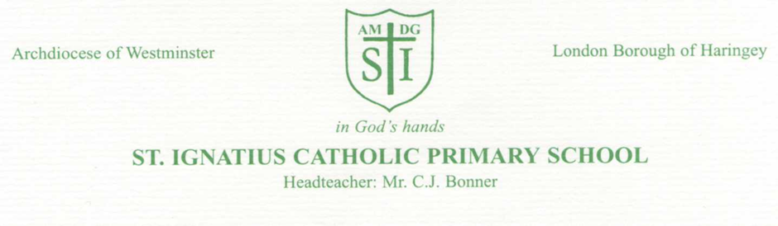

Updates to the RHE Curriculum- September 2026

Tuesday 23rd June 2026

Dear Parents/Carers,

In 2020, Relationships Education and Health Education became statutory for all primary schools in England. Then in July 2025 the Department for Education published new Guidance for teaching RSHE, implemented from September 2026.

As a Catholic school, our mission is to support the spiritual, moral, social and cultural development of all of our pupils, rooted in the wisdom and teaching of the Church. The education of children in human sexuality is an important, precious and privileged responsibility. The Church teaches us that this is very much a partnership with parents, in which parents are the ‘first educators’ of their children on these matters; ultimately, you confer on us the right to co-educate your children with you.

We have followed Life to the Full since 2020 and we feel it is an excellent programme, which sensitively teaches all of the elements of the RHE curriculum. Ten Ten are an award-winning Catholic educational organisation that is well-respected and very experienced in this field of work.

Life to the Full is also approved by our diocese. Furthermore, Ten Ten Resources have entered into a partnership with the Catholic Education Service and the Department for Education to provide training for teachers in Catholic schools on the subject of the RHE statutory curriculum. Therefore, we are confident that this programme continues to be a very good fit for our school.

Through their programme, Ten Ten Resources understand the foundational role that parents have in educating and nurturing their children on these matters. Within the programme, they have built in resources which will not only keep you informed about what is being taught in school, but will also give you the opportunity to engage your children in discussion, activity and prayer.

We would like to have your feedback on the changes that are due to take place in September, and particularly on the key decisions that we need to take regarding the teaching of certain topics. To this end, we have opened a consultation period during which we welcome your feedback.

Ten Ten Resources have provided an online Parent Consultation Course. This is a simple-to-follow, short online course which:

- Outlines the statutory changes that will come into place in England in September
- Articulates a vision for Catholic Relationships and Health Education.
- Explains how Life to the Full aims to help us fulfil the statutory curriculum with a Catholic ethos.
- Provides some information about key decisions we need to make, in consultation with parents.
- Answers some Frequently Asked Questions.

Ten Ten Resources have also provided an Online Parent Portal which will be a tool we can use throughout the year to keep you informed and updated about the work we are doing in school.

To take part in the consultation, please do the following:

- Access the Parent Consultation Course here:
www.tentenresources.co.uk/parent-consultation-primary

- You will need the following login credentials for our school:
Username: st-ignatius-n15
Password: 7-sisters

- Undertake the Parent Consultation course provided.

- Send us your feedback by 8th July 2026

We will also organise a coffee morning in the Autumn term where you will be able to give us any feedback and so we can answer any questions.

We hope that our approach not only assures you about the new programme of resources we are going to use, but will be an important and exciting opportunity for our entire school community.
We have also attached a booklet which outlines the updates should you prefer to this to looking at the online portal.

Thank you for your continued support

Miss Taylor
Assistant Head

