RHE Intention at St Ignatius  ‘I HAVE COME THAT YOU MIGHT HAVE LIFE AND HAVE IT TO THE FULL’ (John.10.10) | 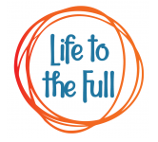
“Aim to build an educational relationship with each student, who must feel accepted and loved for who he or she is, with all of his or her limitations and potential.”
Pope Francis, 2015
Intent

At St Ignatius Catholic Primary School, we deliver a fully-integrated and holistic programme in RHE that truly enables children to ‘live life to the full’. We live, teach and learn through our PEARL values which ensure we are all Safe in God's hands. We want every child to learn to respect, believe and achieve. We will strive for excellence in all we do. We will respect and support one another, embrace diversity and celebrate each other's talents and successes through an RHE curriculum which underpins and develops these core values. We have adopted Life to the Full by Ten Ten Resources. Ten Ten is an award-winning Catholic educational organisation that is well-respected and very experienced in this field of work.

Life to the Full has been approved by our diocese. Furthermore, Ten Ten have entered into a partnership with the Catholic Education Service and the Department for Education to provide training for teachers in Catholic schools on the subject of the new statutory curriculum making this programme is a very good fit for our school.
Following the guidance of the Bishops of England and Wales and as advocated by the DFE (and the Welsh Assembly Government) RHE will be firmly embedded in the PSHE framework as it is concerned with nurturing human wholeness and integral to the physical, spiritual, emotional, moral, social and intellectual development of pupils. It is centred on Christ’s vision of being human as good news and will be positive and prudent, showing the potential for development, while enabling the dangers and risks involved to be understood and appreciated. All RHE will be in accordance with the Church’s moral teaching. It will emphasise the central importance of marriage and the family whilst acknowledging that all pupils have a fundamental right to have their life respected whatever household they come from. It will also prepare pupils for life in modern Britain.

Our Programme Pathway delivers the full programme over 3 terms every year through a spiral curriculum. This means that the full learning stages are run twice (e.g. the full KS1 programme is run with Year 1 and then repeated with Year 2). Children change and grow; their level of engagement will increase as they develop their social, moral, cultural and spiritual awareness and understanding. Through differentiated repetition the learning will be embedded as children build upon what they have previously learned. Some sessions can be omitted one year if the we feel that children are not quite ready, or they have surpassed that stage of learning; similarly, particular focus can be given to certain topics if we feel that is needed.

We aim for children to:

- know how to be healthy both emotionally and physically
- how to manage their academic, personal and social lives in a positive way
- what it means to be fully human living in right relationships with self and others
- be enabled to make moral decisions in conscience.
- understand the fundamental building blocks and characteristics of positive friendships, family relationships, and relationships with other children
- understand families and the people of who care for them
- have caring friendships,
- have respectful relationships,
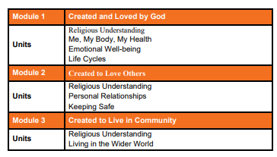
- have the skills, knowledge and understanding to be safe members of their communities and society (including online)

Implementation

Within each learning stage, there are three Modules which are based on the Model Catholic RSE Curriculum:

MODULE 1: Created and Loved by God
MODULE 2 :Created to Love Others
MODULE 3: Created to Live in Community

Each Module is then broken down into Units of Work which teachers teach in one stand-alone lesson every week. We follow a prescribed pathway with programme overviews which link directly to the session pages on the website.

Module 1: Created and Loved by God

Thus unit explores the individual. Rooted in the teaching that we are made in the image and likeness of God. It helps children to develop an understanding of the importance of valuing themselves as the basis for personal relationships.

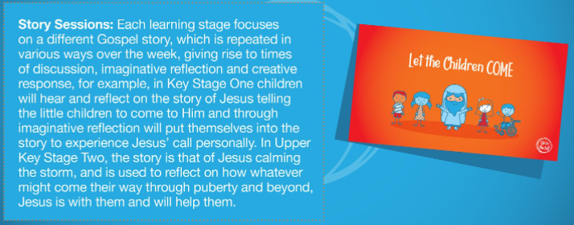
EYFS
Unit 1 – Religious Understanding introduces children to the story of creation, where God created the earth, sea, stars, plants, animals and humans. The five-story sessions encourage children to creatively explore this topic and help them to deeply know that they are created by God out of love and for love.
In Unit 2 – Me, My Body, My Health, children meet the story book characters of Freddy Teddy, Mollie the Cat and Billy Bird who will reappear throughout this scheme of work. Children will learn about their uniqueness in real terms, including celebrating differences and individual gifts, talents and abilities. They will learn about looking after and using their God-given bodies and develop their vocabulary around this topic.
Over the three sessions of Unit 3 – Emotional Well-Being, children will learn about likes, dislikes and self-acceptance. They will learn from Freddy Teddy and his friends how to describe different feelings, both good and bad. Finally through a real world example, children will learn that actions have consequences; that when we make mistakes we should say sorry and ask for forgiveness.
Through Mollie the Cat and Billy Bird talking about their respective journeys from kitten/egg to adult animals, in Unit 4 – Life Cycles children will explore the natural human cycle of life, focusing on what children can remember about their development so far and what they know will happen as they get older. This is underpinned by the religious understanding that growing up is part of God’s plan for our lives and that we are loved by Him at every life stage.

KS1
Unit 1 – Religious Understanding introduces children to the story from the Gospel of Matthew, when Jesus welcomed all of the little children to come to Him. The five-story sessions encourage children to understand that they are created by God out of love and for love. Children will revisit this Gospel story at the end of this Module.
Building on this knowledge, Unit 2 – Me, My Body, My Health encourages children to celebrate similarities and differences between people, including our God-given bodies and the things they enable us to do! Teaching also includes maintaining personal hygiene and the physical differences between boys and girls.
Over the three sessions of Unit 3 – Emotional Well-Being, children will meet presenters Jayden and Josie and fictional character Super Susie. They will help children to understand and articulate their own changing feelings and how other people’s feelings might differ from theirs. Children will learn how they can manage their feelings and about the consequences of their actions.
Unit 4 – Life Cycles returns to the Gospel story from Unit 1, to show that God created us to follow the cycle of life and He loves us at every stage. Children will learn about the specifics of the human life cycle and celebrate how they have already changed and grown.

LOWER KS2

Unit 1 – Religious Understanding explores the Gospel story Jairus’ daughter in various creative and reflective ways. Through story and discussion, children will learn that they are designed for a purpose and how they should live in light of this. A second session unpacks the Sacraments of Baptism and Reconciliation as a foretaste of heaven and a wonderful part of our relationship with God.
In Unit 2 – Me, My Body, My Health, children meet animated character, AJ, who will reappear throughout this scheme of work. In this Unit, children will learn to celebrate similarities and differences, and to appreciate and look after their bodies as gifts from God. Teaching also covers specific physical and emotional changes during puberty, and that growing from boys and girls to men and women is part of God’s loving plan for creation.
Unit 3 – Emotional Well-Being helps children to understand the difference between feelings and actions, how to manage them and what they can do to help themselves stay emotionally healthy. In this Unit, media is discussed as a ‘fake reality’ and God’s love for us is presented as a better basis for our self-confidence. Finally, children will identify unacceptable behaviours and learn to build resilience against negative feelings by practising thankfulness.
Returning to the story of Jairus’ daughter from Unit 1, Unit 4 – Life Cycles explores the miraculous nature of human conception and birth and offers an opportunity for thanksgiving.
UPPER KS2

Unit 1 – Religious Understanding explores the Gospel story of the ‘Calming of the Storm’ (from Matthew, Mark and Luke). Over five story sessions, children will consider experiences of change, growth and development, and the trust that they can have in the person of Jesus through times of trial and tribulation. This is the religious and spiritual foundation for the exploration throughout the rest of the work covered in Module 1: Created and Loved By God. Teaching across the rest of the Units in this Module is based on the Ten Ten TV drama series, Paradise Street.
In Unit 2 – Me, My Body, My Health, children will learn that celebrating differences between people is enriching to a community and know that their self-confidence should arise from being loved by God. They will learn about the physical changes that boys and girls go through during puberty and how they should respect and take care of their bodies as gifts from God.
Continuing through the Paradise Street series, Unit 3 – Emotional Well-Being helps children learn about pressures that they may experience from themselves, others and the media. Children will develop ideas on how to build resilience through thankfulness, use simplified CBT techniques to manage their thoughts, feelings and actions and cope with new or difficult feelings such as romance and rage. The final session in this Unit covers how children may be affected by what they see online, including pornography.
In Unit 4 – Life Cycles, children will learn about God’s design for creating new life through a more nuanced understanding of menstruation, fertility, conception, fetal development in the womb and childbirth. An optional session talks about sexual intercourse within the context of marriage being God’s plan for the place of sex within a relationship.
Module 2: Created to Love Others
Created to Love Others explores the individual’s relationship with others. Building on the understanding that we have been created out of love and for love, this module explores how we take this calling into our family, friendships and relationships, and teaches strategies for developing healthy relationships and keeping safe.

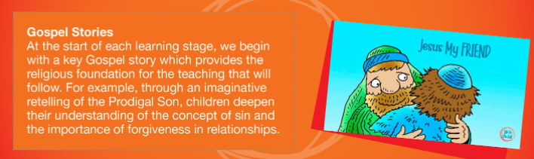

EYFS
The two part session in Unit 1 – Religious Understanding firstly helps children to understand why the Bible is so special to Christians, and secondly helps children to act out the Gospel account of Jesus washing His disciples’ feet, showing that He loves us and is a role model for us to copy in loving one another.
In Unit 2 – Personal Relationships children will expand their vocabulary by applying names to different family/friend relationships, consider positive/negative behaviour in relationships and learn to look to Jesus as their role model for a good friend. Children will learn to resolve conflict and the importance of asking for forgiveness: that when we hurt others, we also hurt Jesus – but that Jesus teaches us how to forgive ourselves and others.
In Unit 3 – Keeping Safe, children learn practical ways to stay safe inside and out, about bodily privacy (including the NSPCC PANTS message that ‘privates are private’) and the importance of talking to their ‘special people’ if anything troubles them. Children will meet animated expert Dr Datfa, who advises on medicine safety and the people who help us in emergencies (a session that can be linked to the ‘People Who Help Us’ topic in EYFS). All these topics are underpinned by the religious teaching that we are created and loved by God, with bodies and minds that He wants us to keep safe.

KS1

Unit 1 – Religious Understanding begins with an adapted version of the Prodigal Son story to show children that God loves us, and nothing we can do will stop Him from loving us.
In Unit 2 – Personal Relationships children once again meet Super Susie, who helps them to identify the ‘special people’ in their lives who they love and can trust. In further sessions, children will learn how to cope with various social situations and dilemmas, and the importance of saying sorry and forgiveness within relationships.
In Unit 3 – Keeping Safe, Super Susie helps children to tell the difference between good and bad secrets. This unit also explores the risks of being online by incorporating the ‘Smartie the Penguin’ resources from Childnet, and teaching on physical boundaries, incorporating the PANTS resource by the NSPCC. Through the animated expert Dr Datfa, children will also learn about the effects of harmful substances (including alcohol and tobacco), some basic First Aid, what makes a 999 emergency and what they should do if in an emergency situation.

LOWER KS2

Unit 1 – Religious Understanding tells the parable of The Prodigal Son, showing that God loves us, and nothing we can do will stop Him from loving us. Children will also learn about different types of sin, and the importance of forgiveness in relationships.
The sessions in Unit 2 – Personal Relationships help children to develop a more complex appreciation of different family structures, develop healthy relationships with family and friends and learn some strategies to use when relationships become difficult. Teaching also covers how to recognise discrimination and bullying, both physical and emotional. Children will learn strategies to develop resilience and resist pressure.
Unit 3 – Keeping Safe incorporates some of the excellent NSPCC Share Aware resources, as well as teaching on bullying and physical, emotional and sexual abuse through a series of animated stories. Through the animated expert Dr Datfa, children will also learn in greater depth about the effects of drugs, alcohol and tobacco and how to make good choices concerning these as they get older. The final session of the Module explores in more detail what to do in emergency situations.

UPPER KS2

Unit 1 – Religious Understanding explores the nature of God’s call to love others. Children will study and reflect imaginatively on the story of Zacchaeus’ conversion and explore ways in which they can hear God’s call in their lives.
Through a series of short sketches from presenters Zoe and Joey, Unit 2 – Personal Relationships aims to equip children with strategies for more complex experiences of relationships and conflict. This includes sessions that help children to identify and understand how to respond to spoken and unspoken pressure, the concept of consent and some practical demonstrations of this and further teaching on how our thoughts and feelings have an impact on how we act.
Unit 3 – Keeping Safe builds on the NSPCC Share Aware resources used in Lower Key Stage Two, equipping children to make safe and sensible decisions about what online content they should/shouldn’t share, cyberbullying and how to report and get help if they encounter inappropriate messages or material. The third session in the Unit moves into the real world and considers the four types of abuse: sexual, physical, emotional and neglect. Children will know how to spot each type of abuse and who they can go to for help.
The final three sessions in this Module explore how drugs, alcohol and tobacco can negatively affect people’s lifestyles and the body’s natural functioning, discuss how to make good choices even in pressured situations, and teach essential First Aid such as DR ABC and the recovery position.

Module 3: Created to Live in Community
Created to Live in the Community explores the individual’s relationship with the wider world. Here we explore how human beings are relational by nature and are called to love others in the wider community through service, through dialogue and through working for the Common Good. In the first unit, Religious Understanding, the sessions help children to develop a concept of the Trinity at a level appropriate for their learning stage.

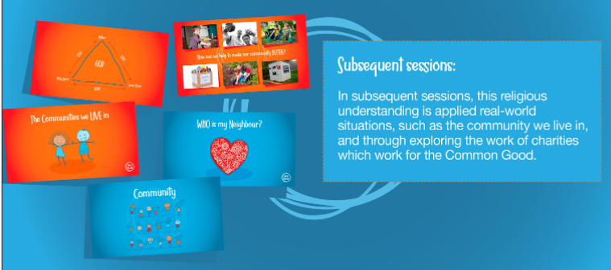

EYFS
Unit 1 – Religious Understanding introduces in a very simple way the concept of the Trinity, where God is three-in-one and each part loves the others and loves us. Children will come to understand that as we are made in the image of God, we are designed to love God and love one another in our wider communities too. Through the story of Jesus feeding the 5000 with just the humble offering of a small boy, children will learn that our loving actions can be used by God to do incredible things.
Unit 2 – Living in the Wider World helps children to extend their understanding of communities from Unit 1, as they learn about the responsibilities they have to people, places and the planet now and increasingly as they get older.

KS1

In Unit 1 – Religious Understanding children will hear the story of The Good Samaritan and will be introduced to the concept of the Trinity – God as a three in one community of love – and think about what the Trinity means for them. This is a simple teaching that we will return to in more complexity in later years. These stories show children that God made us to be in loving relationships with one another.
Unit 2 – Living in the Wider World helps children to learn about the different local and global communities that they are part of, and what rights and responsibilities come with belonging to these communities.
LOWER KS2
Unit 1 – Religious Understanding explores in greater detail the community aspect of the Trinity and encourages children to think about what the Trinity means to them and how as they were made in God’s image, they too are created to live in community.
In Unit 2 – Living in the Wider World, children will learn some of the principles of Catholic Social Teaching from Together For The Common Good, which will help them to live in communities in the way God intends. Teaching includes the common good, the human person, social relationships and stewardship.

UPPER KS2
Unit 1 – Religious Understanding deepens pupils understanding and appreciation of the three-part community of love, the Trinity, with the endpoint of discussing the Trinity as it might be communicated in a church setting. Children will learn that the Trinity demonstrates the perfect loving community, and we are called to emulate this self-giving and self-sacrificing love in our communities.
Building on learning from Lower Key Stage Two, Unit 2 – Living in the Wider World teaches children some of the principles of Catholic Social Teaching from Together For The Common Good, which will help them to fulfil their purpose of making a difference in the world around them. Teaching includes the common good, the human person, social relationships and stewardship.

Impact

The impact of RHE teaching at St Ignatius will ensure our children will…

- embrace the challenges of creating a happy and successful adult life
- have the knowledge that will enable them to make informed decisions about their wellbeing, health and relationships
- build their self-efficacy
- be able to put their knowledge into practice as they develop the capacity to make sound decisions when facing risks, challenges and complex contexts
- develop resilience, to know how and when to ask for help, and to know where to access support
- have a deep understanding and uphold the Christian beliefs in the unique dignity of the human person made in the image and likeness of God
- will reflect Gods beauty and understand they share in God’s divine creativity

Class Big books

Each class has a Big Book where they keep a ‘scrapbook’ of practical lessons and awareness weeks and days which both support and cross over with RHE and the non-statutory PSHE objectives. These are built upon throughout the year and are a running record for both children and staff serving as reminders/consolidation and evidence of the learning throughout the year.

Exercise books

Each child has a RHE/PSHE exercise book where worksheets and tasks are recorded throughout the year. Each module has a cover sheet. There is an expectation that the learning objective for the session is either on the worksheet or stuck into the books. The children record both their RHE and PSHE lessons in these books. They are expected to present their work (at least) within year group expectations for writing, spelling etc as well as opportunities to extend greater depth pupils.

Glossary of terms document

The terminology as set out in Ten Ten resources should be adhered to by all staff throughout the school. Children and staff must all be aware of key words in each lesson and definitions adhered to. This gives both children and staff the knowledge, skills and confidence to talk openly as well as support them in being able to disclose for safeguarding reasons as well as ensure consistency and progression of skills. Words often have shades of meaning depending on their context and this document serves to share with you the meanings that are intended. As such, the definitions are written as if for children, with the meanings that should be evident to them through the sessions. The same word may be explained to children slightly differently depending on their age, so the document is split into Key Stages to show age-appropriate definitions.

RHE folder

Every class has a green RHE ring binder folder which contain the same documents (relevant to the key stage/cyear group) such as the programme pathway, progression of skills and the glossary etc. Any other evidence such as wellbeing surveys, audits and PSHE tasks should be kept in this file also.

Teaching

One stand-alone lesson is taught once a week. Our chosen Programme Pathway requires class teachers to plan lessons a little more carefully by ensuring that the content is age appropriate. It is differentiated from previous learning the year before within key stages as set out in the programme pathway and curriculum map for each module. Teachers plan well in advance to allow for consultation with the co-ordinator and the senior leadership team around key decisions within the curriculum as well as parent consultation/communication as directed by the needs of each cohort.

Assessment

There is one Assessment Activity for each Unit of sessions within each module. The activities take into account the Learning Objectives of the sessions within the unit and provide before and after evidence that learning has taken place. The activity is completed before the first lesson of each unit of lessons, and then it is revisited the again after the series of lessons to assess whether learning has taken place.

Formative:
All children are actively involved in AFL through prescribed and planned assessment tasks completed at the beginning and end of each unit of work for each module throughout the year within the Ten Ten curriculum.
Aims, objectives and learning outcomes are discussed with the children in each lesson as well as at the beginning and end of each unit. The children get a combination of verbal and written feedback (marking) on their performance enabling them to self-assess their performance, knowledge and understanding in relation to agreed criteria.

Summative:
All children are assessed using the Ten Ten assessment activities worksheets. This allows teachers to keep track of children’s learning as well as differentiate and build upon prior learning/fill gaps. Teachers use the progression of skills map for their year group to map and collate assessment data in relation to each learning objective throughout the year.

