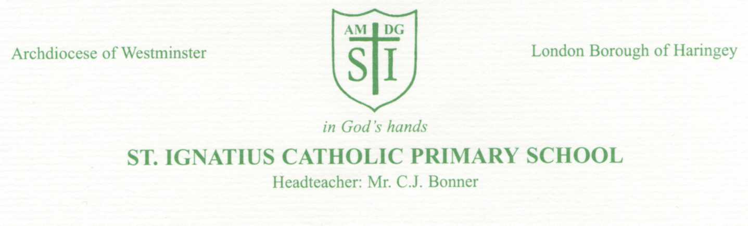

Friday 11th February 2022

Dear Parents/Guardians,

Changes to How we Teach Reading at St Ignatius in Reception and Year 1.
We have recently purchased a new reading scheme called Little Wandle Letters and Sounds to bring our reading approaches/schemes in line with the new guidance about how to teach children to read. Little Wandle Letters and Sounds is a systematic synthetic phonics ( SSP ) programme.

We would like to invite you to a meeting after the half term to discuss with you our new reading programme. The meeting for Year 1 will be on Thursday 3rd March @ 2:30pm in the hall. We would really like as many parents as possible to attend so that we can share resources and explain how our new home reading system will work as well as talk you through how we will teach phonics and reading in school.

As you may know, in the summer of Year 1 children have to undertake a phonics screening check, the results of which each school publishes. It is extremely important that children read regularly at home and that they learn how to decode and recognise phonemes. This new scheme is designed to support pupils in being successful at this check and help them to become fluent readers.

Here is a bit of information about the reading process. More of which we will go into during the meeting.

Home reading after half term:

There are two types of reading book that your child will bring home:
- A reading practice book –Collins Big Cat ebook. This will be at the correct phonic stage for your child. They should be able to read this fluently and independently.
- A sharing book. Your child may not be able to read this book on their own as it is not fully decodable and may not match their exact phonics level. This book is for you both to read and enjoy together.
The Reading Practice eBook: Big Cat eBooks
This book has been carefully matched to your child’s current reading level. If your child is reading it with little help, please don’t worry that it’s too easy – your child needs to develop fluency and confidence in reading. Listen to them read the book. Remember to give them lots of praise – celebrate their success! If they can’t read a word, read it to them. After they have finished, talk about the book together.
You will receive the login details and information on how to access the website during the meeting in the hall. Please ensure you attend so you have everything you need to start reading at home.

As part of our homework policy we recommend that children read for 5-10 minutes each night. Please can you continue to record this reading session in your child’s reading record.

The Sharing Book:
In order to encourage your child to become a lifelong reader, it is important that they learn to read for pleasure. The sharing book is a book they have chosen for you to enjoy together. Please remember that you shouldn’t expect your child to read this alone. Read it to or with them. Discuss the pictures, enjoy the story, predict what might happen next, use different voices for the characters, explore the facts in a non-fiction book. The main thing is that you have fun!

Support for Parents
These three videos (link below) show you how to pronounce the sounds. Notice how the children don’t add an ‘uh’ sound at the end, so they say: ‘t’ not ‘tuh’. Use the downloadable information to help your child remember how to write their letters and say their sounds.

Further Support can be found via this link: https://www.littlewandlelettersandsounds.org.uk/resources/for-parents/

The resources on this link will also help you support your child with saying their sounds and writing their letters.

Find our full Reception and Year 1 teaching programme on our school website, please click on this link which will take you to our Phonics and Reading page. Here you will also find further videos on how we teach phonics using this new scheme:

https://www.stignatiuscatholicprimary.co.uk/curriculum/reading-phonics

We look forward to seeing you all at the meeting! Thank you for your continued support.

Yours sincerely

Miss Taylor (Assistant Head), Ms Hosin ( Reading Lead) and Ms Allan (EYFS Lead and Reception teacher)

