**Reception Home Learning Book**

Welcome to your child’s home learning book. In here you will find ideas of things that you can do at home to continue your child’s development and maintain their progress whilst they are off school. Use the pages to draw pictures, practise name and sentence writing, stick art work into etc. There are also lots of online resources that can be found on the school’s webpage <https://stignatiuscatholicprimary.co.uk/key-information/online-learning> under **online learning**.

Anything you do during this period at home can also be photographed and uploaded onto our online learning journal **Tapestry**. I will then be able to make comments and interact with you more easily. I will also occasionally post other ideas of activities that you can try and may set tasks for you to do in so that you can continue your learning at home.

I hope that you find this helpful and that it gives you lots of ideas on how to make learning fun during this time at home.

**Home Learning Ideas**

**Every day:**

* Read a book with your family.
* Read a school book TO your family. You can find more Biff, Chip and Kipper books here - <https://www.oxfordowl.co.uk/for-school/oxford-owl-ebook-collection>. At the moment it should allow you to create a free account.
* Write a few sentences in this Home Learning book. Ask an adult to draw a line for you to write on.
* After cutting up the key word cards, read them every day. Time yourself, can you get faster?
* 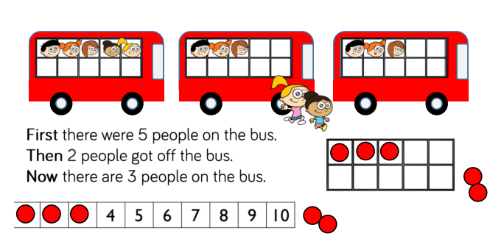Play games with the numbers cards. Organise them to create a number sentence. Write the number sentence in your book. Can you draw a picture to represent the equation. e.g.

1. **– 2 = 3**

**Try these at home too:**

* Make play dough together- recipe on the school website. This is great for fine motor development- squeeze, pinch, roll, and prod the dough. It will store well for a couple of weeks if stored in an air tight container or tightly wrapped in a plastic bag.
* Sing songs and Nursery Rhymes together- (BBC Teach website has a great selection of traditional rhymes and songs)
* Download the SUMDOG app. Log in and play maths games using the login on the front of this book.
* Go to the school website and log into the LGFL tab at the top right of the home page. Use the login on the front of the Home Learning yellow book. Search for ‘Busy Things’.
* Involve your child in cooking and baking - show them how to weigh and measure the ingredients. Look at the colours, count out quantities, talk about where different ingredients come from- milk is from cows, apples grow on trees etc. Let them pour and mix things together.
* Visit <https://abcdoes.com/> “50 Fantastic Ideas to Try at Home” for early year’s friendly ideas and activities to keep your children occupied and engaged during their time at home.
* **Most** **importantly** **of all...** **play and have fun!**