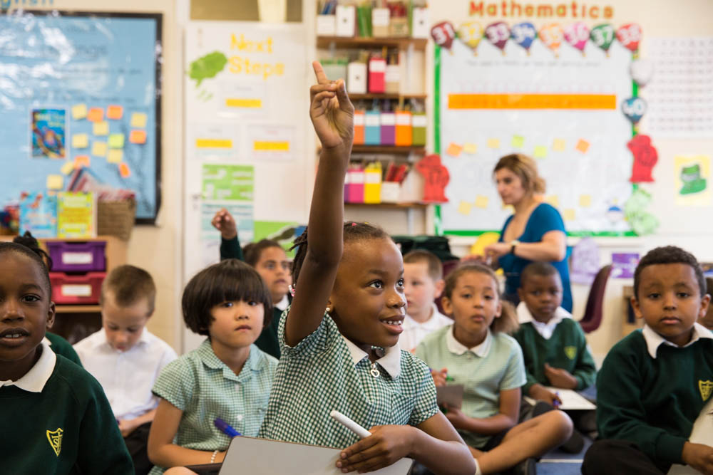

***.***

**Information Booklet for Parents**

**2018-2019**

**KEY STAFF**

Head Teacher Mr Bonner

Assistant Head Teacher Ms Curran

Assistant Head Teacher Ms Taylor

Foundation Stage Leader Ms Allan

English Co-ordinator Ms Taylor

Maths Co-ordinator Mr Whyman

Geography/ CLS Co-ordinator Ms Barlow

History / Art Co-ordinator Ms Walsh

Learning Environment Ms Hajiloizis

RE Co-ordinator Mr Masterson

PE Co-ordinator Mr Henry

SMSC Co-ordinator Ms Demetriou

Administrative Officer Mrs Hibbert

**CHILD PROTECTION AND SAFEGUARDING CHILDREN**

*St Ignatius School is committed to the protection and safety of its children*

A copy of our Child Protection and Safeguarding Procedures are available on the website and from the school office.

The school has two named Designated Safeguarding Leads. Mr Bonner and Ms Curran.

**General Information**

School Address: St. Ignatius Catholic Primary School

St Ann’s Road

South Tottenham

N15 6ND

Telephone Number: 0208 8002771

Email Address: [admin@st-igs.haringey.sch.uk](mailto:admin@st-igs.haringey.sch.uk)

Website: [www.stignatiuscatholicprimary.co.uk](http://www.stignatiuscatholicprimary.co.uk)

Term Dates 2018/2019

**Autumn Term 2018**

|  |  |
| --- | --- |
| Wednesday 5th September 2018 | Friday 19th October 2018 |
| Half Term: Monday 22nd October 2018 – Friday 26th October 2018 | |
| Monday 29th October 2018 | Friday 21st December 2018 |

**Spring Term 2017**

|  |  |
| --- | --- |
| Tuesday 8th January 2019 | Friday 15th February 2019 |
| Half Term: Monday 18th February 2019 – Friday 22nd February 2019 | |
| Monday 25th February 2019 | Friday 5th April 2019 |

**Summer Term 2017**

|  |  |
| --- | --- |
| Tuesday 23rd April 2019 | Friday 24th May 2019 |
| Half Term: Monday 27th May 2019 to Friday 31st May 2019 | |
| Monday 3rd June 2019 | Friday 19th July 2019 |

**INSET Days 2018 -2019**

Monday 3rd September 2018

Tuesday 4th September 2018

Monday 7th January 2019

Friday 5th April 2019 – FLC Day

Monday 22nd July 2019

School Uniform

We are proud of our school uniform and of the image it gives of the school. It helps us if all children come to school in correct school uniform and with all items of clothing and footwear clearly labelled with the pupil’s name.

We encourage children to become independent so please consider this when buying uniform and only buy clothing and shoes that your child can put on and take off without much assistance. Footwear should be comfortable and safe; fashion shoes NOT permitted. Coats and jackets should keep the children warm and dry and are only worn outside.

We believe strongly that children need the security of a clearly defined and consistent disciplinary structure within which their personal and intellectual growth may flourish. We attach a great deal of importance to the personal appearance of each pupil and expect school uniform to be strictly adhered to and correctly worn.

School uniform can be purchased from:

* Divine Solutions Schoolwear Ltd
* Uniform –me

Items that can be purchased from the school office are:

* School book bags- £4.00 ( Next year it will be an expectation that all children have a school book bag. This needs to be brought in daily to school).
* School PE bags- £4.00

Girls Uniform

* Dark green pinafore or skirt
* White blouse or white polo shirt
* Dark (bottle) green jumper, cardigan or school’s sweatshirt
* Green and yellow tie (optional)
* Green and white checked or striped dress in any simple style for the summer
* Black trousers (Black skirts are not allowed)
* Flat Black shoes, Dark Green Tights/White Socks

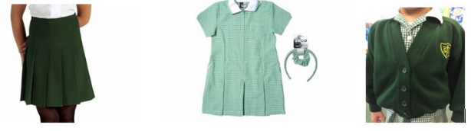

Boys Uniform

* Black school trousers, long or black shorts
* White Shirt/White polo Shirt
* Dark (bottle) Green Jumper or school sweatshirt
* Green and yellow striped tie (optional)
* Black shoes- Black or white socks (Kicker boots not allowed)

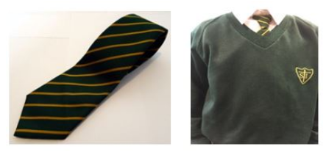

P.E Kit for Boys and Girls

From September it will be an expectation to purchase a St Ignatius PE bag. These PE bags will remain at school for the duration of the half terms (approximately 6 weeks). At the end of each half term the children will bring home the P.E kit to be washed. It will then need to be returned the first day back of the new half term.

Children **MUST** adhere to the School P.E uniform.

* **White T Shirt**
* **Navy blue shorts**
* **Plimsolls**
* **Black tracksuit bottoms are allowed in Winter.**
* **Black trainers can be worn for outdoor P.E only.**



**Please note for health and safety reasons:**

**Jewellery:**

We do not encourage the wearing of jewellery to school. If parents/carers choose to allow their child to wear earrings, these need to be small plain studs and one pair only. No other jewellery is permitted. Children MUST NOT wear nail varnish, make-up or any type of tattoos including the stick-on variety to school. Children are encouraged to wear a watch.

**Hairstyles:**

All hair must be neatly tied back and off the face. Hair accessories should be neutral or in school colours. Mohican hair styles and shaved patterns in hair are not permitted. No dyed hair, hair extensions/colourful hair extensions.  Caps with motifs/logos are not permitted. A green school cap can be purchased instead from the school shop.

**Many thanks for your cooperation in these matters. We want our children to be smart in their uniform and wear it with pride.**

The School Day

**8:45 Gates Open**

**8:50 Registration**

**8:55 Lessons begin**

**10:15 Break Time**

**12:00 Lunchtime**

**1:00 Lessons begin**

**3:15 End of school**

All children will have PE lessons as part of their timetable. Children will not be excused from regular PE or Games unless an explanation is given to the teacher.

Punctuality

Children are required to attend school on time and registration starts at 8:50 prompt. Arriving after this time will result in a late mark.

Children who arrive after 9:25 will be recorded as “late after the register closes”, this equates to an unauthorised absence and will affect their attendance figure. Teachers record lateness in the registers and persistent lateness will be referred to the Education Welfare Officer.

Breakfast Club

Breakfast Club runs daily from 8:00 until 8:45. Children are escorted to their classrooms to start morning lessons. A breakfast of cereal, fruit and soft drink is provided. There is a charge for breakfast club. Please enquire at the main office.

After School Club Sessions

These are offered daily for children to play with friends, take part in activities, arts and crafts, sports, learn new languages and enhance the curriculum taught. Sessions run from the end of the school day until 4.15 /4:30. There is a charge for after school clubs, please enquire at the main office. Places will be given a first come first served basis.

Attendance and Medical

Attendance at all school sessions is required by law. The only exceptions to this are in cases of illness or where the Head Teacher has granted special leave-of-absence.

It is essential that you contact the school before 8:50am on each day that your child is absent.

Our Attendance Officer will call you if your child is absent and we do not know the reason.

To help with the smooth running of the system, please ensure you follow the school’s procedure:

* Inform the school if your child is going to be absent from school by phone call, email or letter;
* Provide a doctor’s certificate if the illness is prolonged and/or the school requests a copy;
* Advise the school if your child is going to be late for any reason.

If a child is ill during the school day they will be taken to the school office where they will be seen by a designated member of staff. A decision will then be taken whether or not to contact parents/carers.

Please inform the school if your child contracts an infectious disease; these include chicken pox, mumps, and German measles (Rubella) which can have implications for other pupils and staff.

Guidance from NHS UK: Vomiting and diarrhoea. Children with diarrhoea and vomiting should definitely be kept off school until at least 48 hours after their symptoms have gone. Most cases of diarrhoea and vomiting in children get better without treatment, but if symptoms persist, consult your GP.

Dental and Medical Appointments

Parents/carers are asked most earnestly not to arrange these appointments during school sessions, except in cases of urgency, so that considerable interference with school work is avoided. Please do not keep children out of school for the whole day unless absolutely necessary.

Medicine



If your child requires medicine to be administered during the school day, including self-administered medication such as an inhaler, please contact the school office. We can only administer prescription only medicine (POM), prescribed by a GP. All medicine must be clearly labelled with your child’s name and dosage requirements and given into the school office by the parent/carer. Children with serious medical conditions will need a care plan. The Inclusion Leader will meet with the parent/carer to arrange a time to complete this.

Communication to Parents

Letters Letters are regularly sent home. Information letters are sent by email, letters containing a reply slip are sent home via the pupils.

Text Message Messages and reminders are sent by text message. Please inform the school if you change your mobile number.

Newsletter The Newsletter is produced each month and a copy is sent home via your child as well as being available to view on the school website and Twitter page.

Reading Record This keeps parents/carers informed of the reading progress and also enables two-way communication between home and school.

Curriculum Topic These are published each half term and are sent home via the children. It allows the parent/carer to see what is exactly being taught this half term.

Reports Continuous assessment of skills and achievements take place throughout the term. Parent consultation evenings are held each term. Parent/carers receive a full written report at the end of the Summer Term.

Website The school website holds a host of information. The website address is stignatiuscatholicprimary.co.uk

Parents/carers can write to the school [admin@st-igs.haringey.sch.uk](mailto:admin@st-igs.haringey.sch.uk),



Complaints

All of the staff at St. Ignatius are determined to make sure your child is happy and enjoys learning here.

Sometimes, things go wrong and we would like to work with you to put them right.

If you need to speak to the Head Teacher urgently, please leave a message in the school office and he will do everything he can do ring you back within the next working day. If you would like to take the matter directly to the governing body you can email or write to them via the school office, marking it for the Chair of Governors.

# Aims, Vision and Mission

## ****Our Aims****

Our aims are to:

* + Nurture our children to be active and productive members of the Catholic community and wider world
  + Equip our children to be independent, resilient and lifelong learners
  + Set ambitious and challenging targets for our children to reach outcomes good academic
  + Engage and inspire our children to be spirited, expressive, inquisitive learners
  + Prepare our children for life in to secondary school and the world of employment with the knowledge and confidence they need to be successful.
  + Build positive relationships, encouraging in our pupils a sense of self-respect, respect for others and for all life which is reflected in their conduct.

## ****Our Vision****

**‘God freely created us so that we might know, love and serve him in this life and be happy with him forever.’**(St Ignatius of Loyola)

**‘I have come that they may have life, and have it to the full.**’  (John 10:10)

Our vision is of a rich and caring learning community guided by our Catholic faith and the Gospel values.

We value the diversity our children and families bring to our school community and celebrate the culturally and linguistically rich environment in which we learn together.

We celebrate the uniqueness of the individual and believe each child is created in the image and likeness of God and has a spiritual destiny to fulfil.

We embrace inclusivity to ensure our school community flourishes.

Our vision is of happy, safe, secure children who flourish and achieve highly.

## ****Our Mission****

Our mission is to live by our  **PEARL** values:

**P**rayer     **E**quality      **A**chievement    **R**espect     **L**ove

These values are underpinned by our understanding and teaching of British Values and our commitment to our Prevent Duty.

**‘To give and not to count the cost  ….  save that of knowing that we do thy will’**

(St Ignatius of Loyola)

Our mission is to live by our PEARL Values of:



Special Educational Needs & Disabilities

If your child is developing needs then often the child’s teacher, the Inclusion leader and parents discuss the child’s strengths and weaknesses and suggest appropriate strategies or learning programmes. This may include giving a child extra support on a 1 to 1 or small group basis.

If the child’s progress is still very slow, with the agreement of the parents, we may call upon the advice of another professional such as an advisory teacher, education psychologist, speech therapist, occupational therapist and educational welfare officer.

Children whose learning is more severely hindered due to visual or hearing impairment, specific learning difficulties, emotional/behavioural difficulties or poor coordination may be recommended for a formal assessment.

Parents are always involved in discussions from the beginning and no decisions are made without parental agreement.

Home Learning

Children should be encouraged to develop a sense of responsibility for their learning and to think independently. Home learning should provide a regular three-way link between child, parent and class teacher.

Home learning should enhance, consolidate and support the children’s learning in school. Homework is given out weekly and needs to be accomplished by the child.

School Library

Your child will be offered the opportunity to borrow a special library book from our school library. Each class will visit the library each week to select their book.

The children will sign out their book so we are able to keep record of which books have been borrowed. The books will be handed back the next time we visit the library.

Please note that our library books must be cared for at home as well as at school. We will implement a ‘Damage or Loss’ policy if a book is lost or damaged. There will be a replacement fee based on the cost of the book.

Catering Arrangements

A hot school meal will be provided each day. Meals are free for children in Key Stage 1. If you wish to provide your own packed lunch please note:

* No sweets of any kind are allowed at school
* No fully coated chocolate biscuits
* No fizzy drinks should be brought into school
* We have several children with severe allergies; therefore the school is a nut free zone. No products containing nuts should be brought into school; this includes chocolate spreads such as Nutella.

Fruit and Vegetable Scheme

The school takes part in the Fruit and Vegetable Scheme which enables each child from Nursery to Year 2 to receive a piece of fruit or vegetable each day free of charge. Years 3-6 may bring in a piece of fruit as a snack.

Trips and Visits

Trips and visits enrich the curriculum for all children and add to their personal and social development. We organise different trips and visits throughout the year for all our year groups.

Details will be communicated to you via letters sent home approximately 3 weeks before each planned trip. Small voluntary contributions are requested to fund these activities.

All trips are risk assessed prior to the day of the activity and health and safety procedures are strictly adhered to. If transport is required we abide by their health and safety regulations. Please see our trips coordinator for further details.

We do not publish trip information on our website prior to the activities to comply with our safeguarding policy. However, we love to share photographs and an account of the visit on our website once the activity has been completed.

Pupil Premium

Pupil Premium is funding allocated to schools by the DfE to increase social mobility and reduce the gap in performance between pupils of disadvantaged backgrounds and their peers. Where applicable its purpose is to raise attainment, accelerate progress and fulfil the achievement potential of all children. School receive funding for each eligible pupil and can use the funding flexibly, in the best interests of entitled pupils. It is up to the school to decide how to spend the funding because they are best placed to assess what additional education provision should be put in place to ensure maximum progress for all children in their care.

Dogs

Dogs are not permitted on school premises. Some children are not used to dogs and get very anxious when dogs are in their vicinity and the behaviour of dogs when in close proximity to small children can be unpredictable. Dog fouling is also an issue.

School Photographs

Individual photographs are taken during the year. Parents/carers have the opportunity to purchase a package of photographs from the school. The school utilises photography and video clips of the children on a regular basis. If you do not wish your child to be seen in photos please contact the main office.

Parent Helpers

We welcome any parents or carers, including grandparents, to get involved with our school community. This may be through attending meetings, taking part in workshops, and volunteering to accompany children on outings and visits.

All regular helpers require a DBS check prior to helping out.

What Ofsted has said about our school

Our latest Ofsted inspection report can be found online or through the school’s website. At the last Ofsted in 2015 we were rated Good.

Some key quotes from the document are:

***“Pupils continue to make good progress at Key Stage 2 and are well prepared for moving to secondary schools.”***

***“Teaching is consistently good to outstanding. Classrooms are bright, inspiring and support learning effectively. Teachers make lessons interesting and fun so pupils learn well.”***

***“Pupils have very positive attitudes to learning. They are keen to learn subjects and topics which are made interesting for them; they try hard and do well.”***

***“Pupils’ spiritual, moral, social and cultural development is a particular strength. The school’s values of prayer, equality, achievement, respect and love are fundamental to all of its work. These result in a caring community and positive, supportive relationships.”***



What do parents say about our school?

***“My child is very happy coming to school and is looked after well by staff and other pupils.”***

***“The school has a lovely feel and the children behave well.”***

***“The children have lots of opportunities to have fun, through clubs, music and sport.”***



Head Teacher Statement



The staff and I would like this opportunity to welcome you to St. Ignatius Catholic Primary School.

We are a caring community that reflects the multicultural society in which our school is set.

All our children are individuals, each with talents and interests which we seek to develop.

We believe that our school provides a secure and happy environment which enables children to fulfil their potential and achieve high standards in personal and social development as well as academic achievement.

We encourage parental involvement as we consider that a close partnership between home and school is essential for children to gain maximum benefit from their time at school.

I hope this Information booklet has been useful to give you a snapshot of our school.

We welcome visitors to come and see us in action!

Con Bonner

Head Teacher