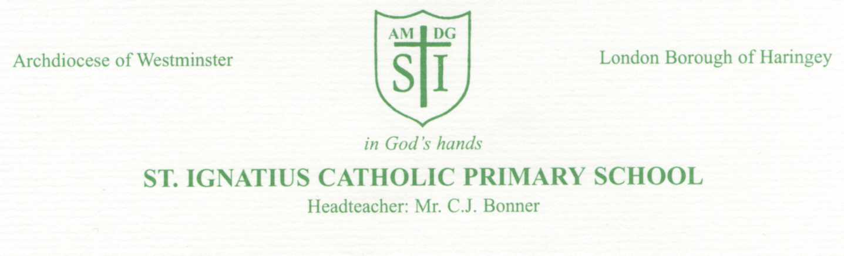

4th March 2021

Dear Parents and Carers,

Re-opening school to all pupils on Monday 8th March 2021.

I hope that this letter finds you all well.
Thank you once again to all of you for your hard work and dedication, supporting your children with their online learning during this term so far. We know that it has not been an easy time for anyone.
But moving forward, we are happy to finally be able to open school to all our pupils.

Our priority, as always, is the health and safety of your children, our staff and the broader school community.
Pupils who are unwell, in any way, must not return to school.
If any members of your household display any symptoms, they must continue to follow current government guidance.
If you are returning from a country that requires you to self-isolate, you must not return to school until this period of time is complete.

Below, are the arrangements we are putting in place to do our best to achieve a safe return.
We ask that you support us by adhering to our requests.

It is important that two key practices we had in place in the autumn term, remain:
- Social distancing to be maintained between parents and staff on school premises
- Face coverings to be worn by parents and staff while on school premises

Arrangements:
School start: 8.45am - 9.00am
School finish : 3.00pm - 3.15pm
These 15 minute timeframes will allow for parents and pupils to stagger their entrance and exit, encouraging social distancing and minimising gathering.
Please ensure you maintain social distancing outside the school gates as you wait to enter school.

Our one way system, entering and exiting school, will be re-instated as school opens to all pupils once again.
All pupils are to enter via the Nursery gate entrance and follow the one way system to exit via Anne Line gate. Please ensure you follow this simple rule.
We especially ask that parents of Y3 and Y4 pupils do not attempt to collect their children from the Anne Line exit gate – this area needs to be left clear for free movement of families leaving school.
Please do not ask your children to leave their class line to go to the gate, as their teachers will not allow them to do this and it is not fair to put your child in this position.

Communication with staff – We ask that you continue to keep face to face contact to a minimum.
If you would like to discuss any issues with your child’s teacher, please first message them via Dojo.

Key arrangements in place in school:
Sanitisers and hand-washing to be available throughout the school day for pupils and staff
Cleaning of classrooms and communal areas to be a key priority
Rooms to be ventilated
Pupils and staff to be kept in ‘buildings bubbles’
Staff to socially distance within bubbles as much as possible
Pupils to be sent home if they have any symptoms of COVID-19
Staff to conduct Lateral Flow Tests (LFT), twice weekly, to test for COVID – 19.

Expectations for pupil return
There is an expectation that your child returns to school on Monday 8th March 2021 – provided they, and household members, are well.
If you wish to discuss this, should you have any concerns, please contact your child’s teacher or Senior Leadership via Dojo or call the school office.
It is important that, if your child is absent from school, you inform your class teacher and/or the school office as to the reasons for their absence, on the first day of their absence.

School Uniform and personal items
Pupils are to wear their school uniform – If they have outgrown these and you are having difficulty getting access to new items, please contact Ms. Curran/ Ms. Taylor via Dojo and we will try to help.
Only bring items to school that are necessary, such as a coat and/ or a packed lunch if you are having one. Please do not bring any other bags or equipment.

Breakfast Club
Breakfast Club will resume on Monday 8th March from 8am.

PE
Pupils will have their PE session during their first week back to school.
On PE day, please ensure your child wears their PE kit to school for the whole day – they do not need
to wear their school uniform.
Reception | Thursday |  | Year 3 | Tuesday
Year 1 | Friday |  | Year 4 | Tuesday
Year 2 | Thursday |  | Year 5 | Wednesday
 |  |  | Year 6 | Wednesday

Online Learning
For some pupils who are unable to be at school, whether due to ill-health or other circumstances, there will continue to be some element of online learning available, in a similar format to those systems that have been used during lockdown. There will be no live Zoom sessions but a daily plan will be uploaded, with the relevant resources, PowerPoints and worksheet activities.
Please contact your child’s class teacher directly via Dojo to discuss any online learning issues.

School meals
Our school kitchen will be opening again from Monday 8th March 2021.
Universal Free School Meals will again be available to all Reception Year 1and Year 2 pupils.
Free School Meals (FSM) will be provided to any pupils in Year 3 – Year 6 who have a FSM certificate.
Parents of pupils who require school dinners are requested to pay for these via ParentMail.
All other pupils are expected to bring a packed lunch. Please be mindful of our Healthy Meals policy and that our school is a Nut free zone.

Bubble lockdowns
It is important to keep in mind that, once school is open to all pupils, there is a potentially greater risk, that members of our school community may test positive for COVID-19.
Testing of staff may potentially reduce the need to self –isolate, however, if a member of staff or a pupil tests positive, we will notify Haringey’s Public Health Officer and follow their advice. This may result in pupils and staff having to self-isolate at home.
Although we hope this does not happen, we need to be prepared for it.
In the event that it does, the bubble will again return to a programme of online learning.
If you have any questions or concerns, please contact us via phone or email.

We look forward to a happy and safe return for all our school community.

God Bless,

C.J. Bonner

Head teacher

