

**St Ignatius Primary School**

**Prayer and Liturgy Policy**

|  |  |
| --- | --- |
| Status | Statutory |
| Date of policy adoption | September 2025 |
| Date of policy review | September 2027 |

**Mission Statement**

**‘To give and not to count the cost ... save that of knowing that we do your will’**

**St. Ignatius of Loyola**

**At St. Ignatius we invite our community to do God’s will by living by our PEARL values:** 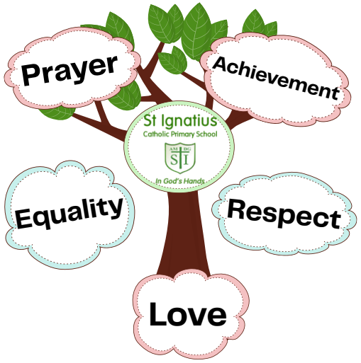

**1. The context of this prayer and liturgy policy**

‘The celebration of Catholic liturgies and prayers as an integral part of the learning and teaching should enable the school community to become reflective, experience the presence of God and should develop a mature spiritual life.’ (Marcus Stock (2012), Christ at the Centre, Catholic Truth Society, 23.)

***Understanding Prayer and Liturgy (From the Prayer and Liturgy Directory- To love You more dearly-published October 2023)***

In any school there will be a range of prayer and liturgy: classroom prayer, meditation, assemblies, devotions, special services for times in the school year, celebrations of Mass and the Sacrament of Reconciliation. Each form of prayer and liturgy will have its own character dependent on the circumstances, size and age of the group, the place of celebration and its content. Definition of Terms Prayer, Liturgical Prayer, and Liturgy form a continuum with silent meditation at one end and a celebration of Mass on a Solemnity of the Church (e.g., Ascension of the Lord) at the other. Of course, there are areas of overlap between the categories.

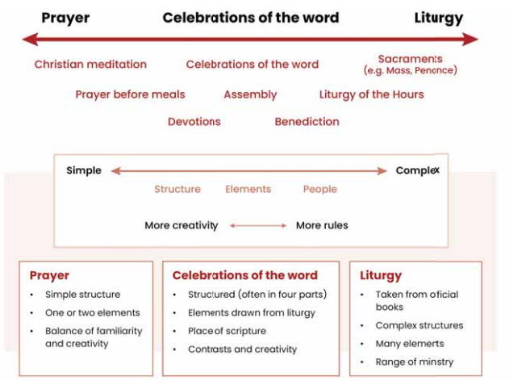

**2. Statement of requirement**

The law requires all maintained Catholic schools to provide **an act of daily collective worship (prayer and liturgy) for all pupils** (Section 70, 1988 Education Act) that is in accordance with the rites, practices, disciplines, and liturgical norms of the Catholic Church (School Standards and Framework Act 1998, schedule 20; 70 Instrument of Government, clause 2). Academies in England are required by their funding agreement and Articles of Association to comply with similar requirements (The Mainstream Academy and Free School: Supplemental Funding Agreement, December 2020; Model Articles for Catholic Academies, February 2019).

The law requires all maintained schools to recognise and respect that parents have the legal right to withdraw their children up to the age of 16 from prayer and liturgy (School Standards and Framework Act 1998, s.71(1A)). The school’s provision for prayer and liturgy will fulfil pupils’ entitlement to experience the range of liturgical treasures of the Church, including a shared repertoire of prayers and liturgical music with which pupils in the school will be familiar. Prayer and liturgy are not designated curriculum time. In the context of the Catholic school, this means that times of prayer and liturgy are not considered to be part of the allocation of curriculum time for Religious Education.

**3. Responsibility**

(a) Governance

The governors, as guardians of the Catholic school’s life and mission, have a responsibility to ensure that:

• prayer and liturgy are central to the Catholic life of the school and therefore are in line with the guidance set out by the Prayer and Liturgy Directory

• there is a named person(s) who is responsible for prayer and liturgy in the school (the Prayer and Liturgy Coordinator)

* the prayer and liturgy policy is updated regularly and shared with all stakeholders
* there is a budget for prayer and liturgy that reflects its centrality to the life of a

Catholic school.

(b) Headteacher

The headteacher, as the spiritual leader of the school as a Catholic community, ensures that:

• prayer and liturgy are central to the Catholic life of the school and therefore are in line with the guidance set out by the Prayer and Liturgy Directory

* they work in partnership with the leader(s) for prayer and liturgy
* those responsible for prayer and liturgy in the school have been given appropriate

training and formation to ensure that all guidance is followed and adhered to

• there are suitable resources for prayer and liturgy in the school.

(c) Prayer and Liturgy Coordinator

Those responsible for prayer and liturgy ensure that:

• prayer and liturgy are central to the Catholic life of the school and therefore are in line with the guidance set out by the Prayer and Liturgy Directory

• there is an Annual Plan of Provision for prayer and liturgy across the school year which

identifies liturgical seasons and key celebrations, as well as opportunities for the celebration of the Sacraments

• there is daily planned prayer for all pupils, appropriate to age and ability, as outlined in the Prayer and Liturgy Directory

• pupils are supported in their liturgical formation to take an active role in the planning, preparation, and delivery of prayer and liturgy according to their age and capacity, and in a manner which facilitates their progressive participation

• resources to support the planning of prayer and liturgy are appropriate and readily available to staff and pupils

* induction on prayer and liturgy takes place for new members of staff as required
* staff have access to effective training and formation opportunities
* monitoring and evaluation of prayer and liturgy take place regularly and feed back into

planning for future liturgies

• monitoring of prayer and liturgy is reported to the headteacher and governing body to support whole-school development and the Catholic life of the school

* there is collaboration with local clergy and parishes
* liaison with the Diocesan Advisory Service and others is maintained to ensure they keep

updated with best practice.

**4. Overview of prayer and liturgy provision**

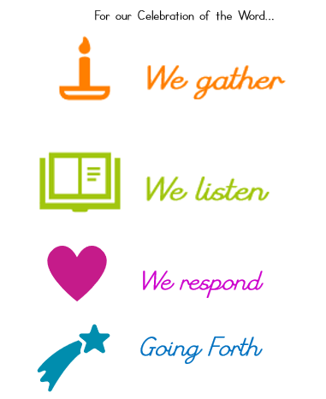At the heart of Catholic life is the practice of starting each day, or beginning any meeting, with prayer. We make a point of dedicating our day and work to God, who is at the heart of all we do as a school. We pray as a school at least **four times per day**. We follow the four-part structure of ***gather, listen, respond and going forth*** for all of our Prayer and Liturgy Sessions.

We hold a daily act of collective worship in our school either through our Whole School Assemblies which are held at least **3 times a week** (**Mondays, Thursdays and Fridays**). And **twice** during the week in class, which takes place at a convenient time for the class teacher.

We worship through our Singing Assemblies and Hymn practices for Mass and Special Celebrations, through our Class Assemblies, Masses, Feast Day and Prayer services with our RE Team leading and supporting throughout. We conduct assemblies in a dignified and respectful way. We model for our children the fact that assembly time is a period for calm reflection and joyful praise. We regard it as a special time and expect children to behave in an appropriate way. We ask them to be quiet and thoughtful and to listen carefully to the teachings and participate fully in prayer and hymns.

We create an appropriate atmosphere by using music and sometimes candles or other objects that act as a focal point for the attention of the children. We take the themes of our assemblies from the traditions of the Christian faith and we often reflect the festivals, feast days and events of the Church’s calendar. We also have a Celebration Assembly which focuses on how our children live our mission statement by displaying our PEARL Values. We also include all the pupil’s special gifts and talents to enrich our Prayer and Liturgy provision. Our gatherings and Masses include singing, dramatisation of the Gospels or Scripture Readings to bring our praise and worship alive and filled with joyful expression of our faith.

**5. Resourcing**

Prayer and liturgy are central to the school’s understanding of itself as a Catholic school, and this is reflected in the annual budget allocation and available resources, including staff time, chaplaincy provision, and dedicated spaces for prayer and liturgy. The Catholic character of the school is reflected in religious artefacts and images on display throughout the building. Dedicated spaces for prayer and liturgy will be furnished and maintained as such, and updated to reflect the Church’s liturgical season. Staff training and formation costs will be funded separately to ensure that all staff are able to fulfil their responsibility to contribute to the prayer and liturgical life of the school.

**6. Training and formation**

All new staff will be supported during induction and beyond, so that they fully understand the responsibility they carry within their individual role for leading prayer and liturgy in the school. Any individual training needs will be identified and addressed through training and formation. There will also be the opportunity for whole-staff professional development at least once a year, so that all staff understand the importance of prayer and liturgy and relevant staff are well supported to lead as required.

**7. Monitoring and evaluation**

Monitoring and evaluation of the quality and impact of prayer and liturgy will take place regularly, and at least annually, and involve all key stakeholders: pupils, parents, staff, clergy, and governors. Areas for development will be identified and issues raised will be actioned and evidenced as appropriate.

**8. Review**

The policy will be reviewed as part of the regular cycle of policy review conducted by the governors.