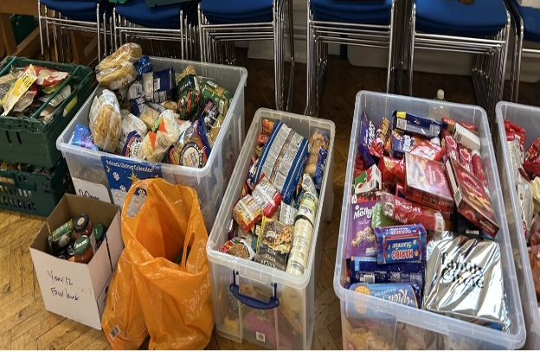
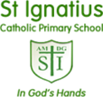
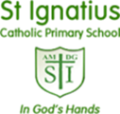
Thank you!
Thank you so much for all of the donations made towards our Social Apostolate’s Food Collection at Christmas for the mos. We were very grateful for the generosity that had been shown, as were the members of the Social Apostolate.
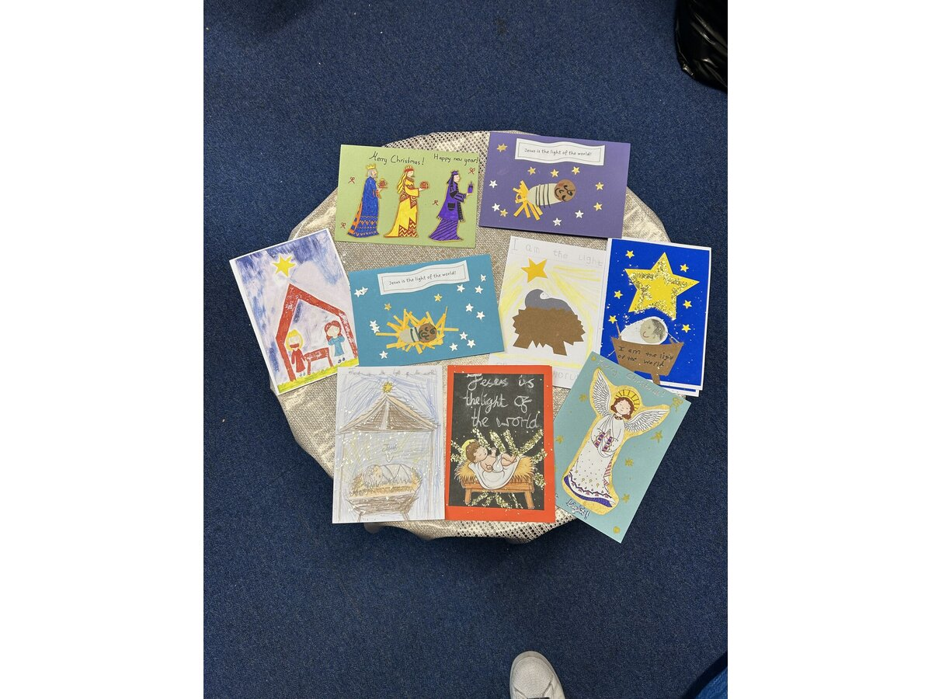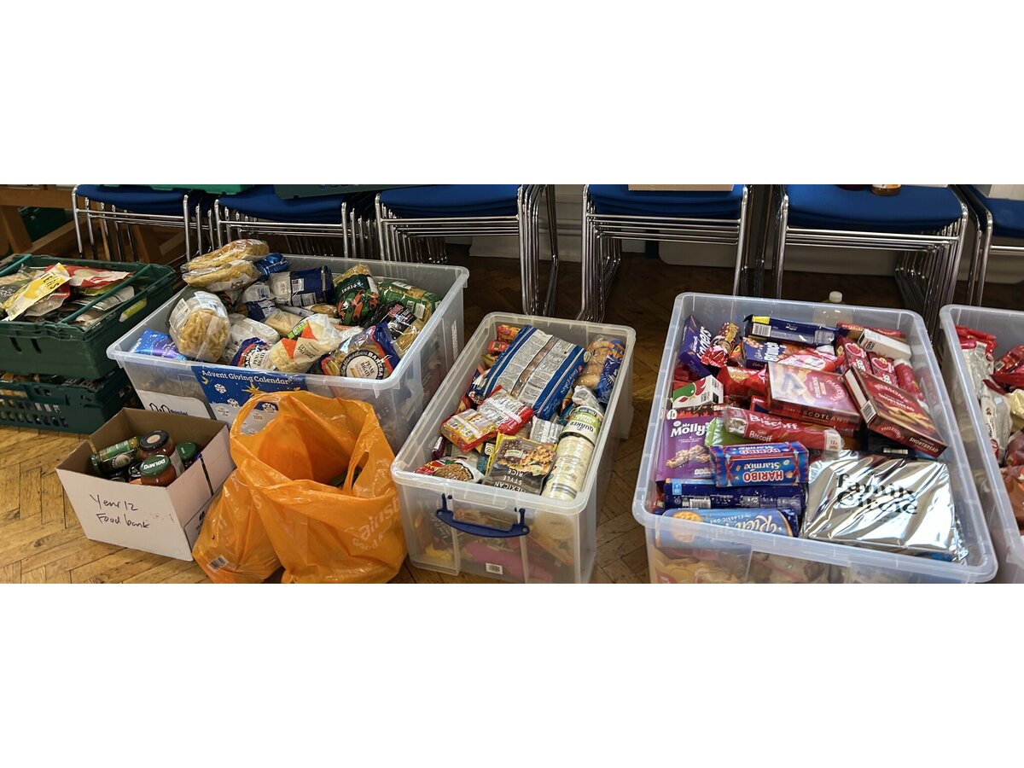
Catholic Life at St. Ignatius Newsletter: Spring Term 1
We would like to share with you some dates for your diary of upcoming Catholic Life dates for this term.
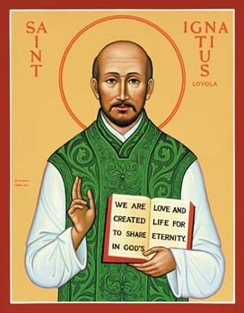
Epiphany
On Tuesday 6th January 2026 Years 5 and 6 attended mass in the church for Epiphany and for Father Andrew’s farewell mass and for the Feast of the Epiphany. We then had a whole school Celebration of the Word
for the Epiphany in the afternoon.

Candlemas
Please join us on Monday 2nd February 2026 at 10am in St. Ignatius Church for mass to celebrate the Feast of the Presentation of our Lord.


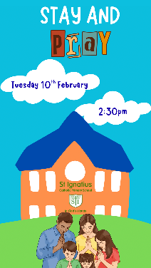
Spring Stay and Pray

Please join us for our Spring Stay and Pray session on Tuesday 10th February 2026 at 2:30pm. You and your child will be led through a prayer session by Ms McGinty.

Liturgical Year Key Dates
January 6th- Epiphany
Baptism of our Lord
January 24th- St Francis de Sales
January 28th- St Thomas Aquinas
January 31^{st-} St John Bosco
February 1st- St Brigid
February 2nd-Presentation of our Lord
February 8th- St Josephine Bakhita
February 11th- Our Lady of Lourdes

