St George’s Day – 23rd April
April 23rd is the feast day of St George who is the patron saint of England. A patron saint is a saint who protects or guides a particular person or place. We can ask St George to guide us and give us strength as we face challenges in our lives.
St George
Not very much is known about St George, but there are many stories told about him which are full of myth and legend. One of these myths is that he defeated a dragon to save a princess. You can find out about this story on the BBC website: https://www.bbc.co.uk/cbeebies/watch/lets-celebrate-st-georges-day.
He also showed a huge amount of bravery in a story that we know to be true. St George lived about 1800 years ago and he was a Christian and a Roman soldier. He didn’t like the way the Romans treated Christians, so he bravely spoke out and stood up for them. Because of this he was put in prison, but he refused to turn away from God. He kept on praying, worshipping God and loving God and he was eventually killed because of this. The courage he showed in keeping his faith in God, even when his life was in danger, is one of the reasons why he was made into a saint.
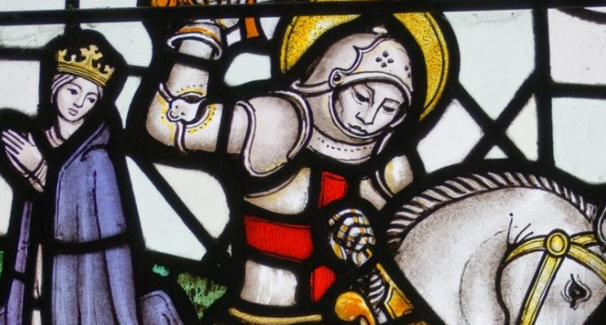
Activity:
Draw a picture of St George and write some words to describe him around your picture. Underneath, write down one thing you find difficult that you will try to achieve this week. Maybe St George will help you!

Prayer:
Challenge
Today take some time to think about something you find difficult. It might be learning to spell ‘because’, tying your shoe lace or counting in 5s. Be brave, keep trying – you can do it!

Dear Lord,
Please help us to learn from St George’s bravery. When we are faced with things that are difficult or things that scare us, please give us the courage to try our best to overcome them.
Amen

